AGREEMENT BETWEEN
LAKE COUNTY WATER AUTHORITY AND
[FIRM NAME] FOR
ON-CALL LEGAL Services

RSQ # 27-W410

This is an Agreement between Lake County Water Authority, a dependent special taxing district of the State of Florida (the LCWA) and [Entity Name], a [Entity type], LCWA its successors and assigns, (CONSULTANT or CONTRACTOR), (each a “Party” and collectively, the “Parties”).

WITNESSETH:

WHEREAS, the LCWA has publicly submitted a Request for Statement of Qualifications (RSQ) #27-W410, for procurement of an attorney or firm to perform legal services for LCWA; and

WHEREAS, the CONSULTANT desires to perform such services subject to the terms of this Agreement.
WHEREAS, the provision of such services will benefit the Parties and the residents of Lake LCWA, Florida.

NOW, THEREFORE, IN CONSIDERATION of the mutual terms, understandings, conditions, promises, covenants and payment hereinafter set forth, and intending to be legally bound, the parties hereby agree as follows:

Legal Findings of Fact

1.1 The foregoing recitals are hereby adopted as legislative findings of the Board and are ratified and confirmed as being true and correct and are hereby made a specific part of this Agreement upon adoption hereof.

Purpose
  - Purpose. The purpose of this Agreement is for the CONSULTANT to provide on call real estate and closing services (“the Service”) for the LCWA as detailed in the Scope of Services, attached hereto and incorporated herein as Exhibit A (Composite). This is an indefinite quantity contract with no guarantee of a volume of services or expenditure.

Scope of Professional Services
- Scope.
  - On the terms and conditions set forth in this Agreement, LCWA hereby engages CONSULTANT and CONSULTANT agrees to provide specialized, on-call closing attorney services and real estate services inclusive of all labor, materials, and equipment necessary to complete the Service in accordance with the Scope of Work, as modified or clarified by any addendums, along with CONSULTANT’S Submittal Form, attached hereto and incorporated herein as Exhibit A (Composite). It is understood that the Scope of Services may be modified by change order or written Amendment, as applicable, as the Service progresses, but to be effective and binding, any such agreement must be in writing, executed by the Parties, and in accordance with the LCWA’S Purchasing Policies and Procedures. A copy of these policies and procedures will be made available to the CONSULTANT upon request.
  - Services provided by CONSULTANT under this Agreement will be provided to LCWA on an as-needed basis.
  - CONSULTANT shall be governed by the Pricing Schedule, set forth in Exhibit B, attached hereto and incorporated herein by reference, unless such schedule is amended by mutual, written agreement of the Parties. The LCWA reserves the right to negotiate for additional services/items similar in nature not known at time of solicitation. The CONSULTANT shall provide all deliverables in format(s) specified by LCWA and shall complete work in the timeframes provided for by LCWA specific to each Service.
  - All work must be performed in accordance with good commercial practice and in accordance with the project-specific scope of work, including any project documents, and exhibits or attachments thereto; the CONSULTANT’S project proposal; and this Agreement. The work schedule and completion dates as set forth in each Project-specific scope and proposal must be adhered to by the CONSULTANT except in such cases where the completion date will be delayed due to acts of God, strikes, or other causes beyond the control of CONSULTANT. In these cases, the CONSULTANT shall notify the LCWA of the delays in advance of the original completion date so that a revised delivery schedule can be appropriately considered by the LCWA, as provided for herein. CONSULTANT will be solely responsible for obtaining all necessary approvals and permits to complete the Service. CONSULTANT shall not initiate awarded Projects without an agreed upon scope, proposal, and express direction from the LCWA in writing.
- Effective Date and Term.
  - This Agreement shall be effective immediately upon approval and execution by the LCWA (the “Effective Date”).
  - The Term of this Agreement will be for an initial thirty-six (36) month term with the option for two (2) subsequent twelve (12) month renewal terms. Renewals are contingent upon written mutual agreement of the Parties. CONSULTANT shall maintain, for the entirety of the stated additional period(s), if any, the same prices, terms, and conditions included within this Agreement. Continuation of this Agreement beyond the initial period is a prerogative of the LCWA and not a right of CONSULTANT. This prerogative may be exercised only when such continuation is in the best interest of the LCWA.
- Consultant Personnel.
  - Key Personnel and Attorney Services. CONSULTANT has represented to the LCWA that Services to be provided under this Agreement will be performed or supervised, as applicable by [Firm]. The LCWA has relied on this representation as an inducement of entering into this Agreement. CONSULTANT agrees that each person listed or referenced in CONSULTANT’S proposal package provided in response to RSQ # 27-W410, shall be available to perform the services described herein for the LCWA barring illness, accident, or other unforeseeable events of a similar nature, in which case CONSULTANT must be able to promptly provide a qualified replacement. In the event CONSULTANT desires to substitute personnel, CONSULTANT shall propose a person with equal or higher qualifications; each replacement person is subject to prior written approval of the LCWA. In the event the requested substitute is not satisfactory to the LCWA and the matter cannot be resolved to the satisfaction of the LCWA, the LCWA reserves the right to terminate this Agreement. A list of CONSULTANT’S Key Personnel under this Agreement are attached hereto and incorporated herein as part of Exhibit B (Composite).
  - Personnel. CONSULTANT will provide competent, careful, and reliable personnel to perform the Services under this Agreement. All personnel must have sufficient skill and experience to perform their assigned task properly and satisfactorily and will make do and proper effort to execute the work in the manner prescribed in the agreement documents. When the LCWA determines that any person is incompetent, unfaithful, intemperate, disorderly, or insubordinate, such person will be immediately discharged from the Service and will not again be employed on the Service without the written consent of the LCWA. Should the CONSULTANT fail to remove such person or persons, the LCWA may withhold all payments which are or may become due or may suspend the work with approval of the LCWA until such orders are complied with. No alcoholic beverages or drugs are permitted on any LCWA properties; evidence of alcoholic beverages or drug use by an individual will result in immediate termination from the job site.
  - E-Verify. CONSULTANT shall utilize the U.S. Department of Homeland Security’s E-Verify system in accordance with the terms governing use of the system to confirm the employment eligibility of all new persons hired by CONSULTANT during the term of this Agreement. CONSULTANT shall include in all contracts with subcontractors performing work pursuant to any contract arising from this Agreement an express requirement that the subcontractors utilize the U.S. Department of Homeland Security’s E-Verify system in accordance with the terms governing use of the system to confirm the employment eligibility of all new employees hired by the subcontractors during the term of the Agreement.
  - The CONSULTANT shall coordinate, cooperate, and work with any other consultants retained by the LCWA.
- Continuation of Work. Any work that commences prior to and will extend beyond the expiration date of the current Agreement period shall, unless terminated by mutual written agreement between LCWA and CONSULTANT, continue until completion at the same prices, terms and conditions.
- Contract Extension. The LCWA has the unilateral option to extend this Agreement for up to ninety (90) calendar days beyond the current term of the Agreement. In such an event, the LCWA will notify the CONSULTANT in writing of such extensions. The Agreement be extended beyond the initial ninety (90) day extension upon mutual agreement between the LCWA and the CONSULTANT.
- Open Quantity Contract. CONSULTANT acknowledges and agrees that this Agreement is an open quantity contract. The LCWA does not guarantee to CONSULTANT any minimum or maximum amount of work throughout the term of this Agreement. Furthermore, CONSULTANT agrees and acknowledges that in the event CONSULTANT cannot meet the LCWA’S specifications, including, but not limited to, time for completion or cost for individual project, that the LCWA reserves the sole right to offer the individual project to the LCWA’S other contractor(s) or to procure needed services separately utilizing the LCWA’S procurement procedures.
- Ownership of Deliverables. Upon completion of and payment for a task CONSULTANT agrees all tasks and/or deliverables under this Agreement, and other data generated or developed by CONSULTANT under this Agreement or furnished by LCWA to CONSULTANT shall be and/or remain the property of LCWA. CONSULTANT shall perform any acts that may be deemed necessary or desirable by LCWA to more fully transfer ownership of all tasks and/or deliverables to LCWA. Additionally, CONSULTANT hereby represents that it has full right and authority to perform its obligations specified in this Agreement.
- Intent of the Contract Documents.
- For purposes of this Agreement, the term “contract documents” includes all bid documents, drawings, the Scope of Work, attachments to this Agreement, and provisions within this Agreement, and amendments to this Agreement, along with any project specific scopes of work.
- It is the intent of the contract documents to describe a functionally complete Service which defines the Scope of Work. Any work, materials, or equipment that may reasonably be inferred from the contract documents as being required to produce the intended result must be supplied whether or not specifically called for. When words which have a well-known technical or trade meaning are used to describe work, material or equipment, such words must be interpreted in accordance with that meaning. Reference to standard specifications, manuals or codes of any technical society, organization or association or to the laws or regulations of any governmental authority having jurisdiction over the Service, whether such reference be specified or by implication, will mean the latest standard specification, manual, code, law or regulation in effect at the time the work performed, unless specifically stated otherwise in this Agreement.
- The contract documents and all referenced standards cited in the contract documents are essential parts of the contract requirements. A requirement occurring in one is binding as though occurring in all.

Payment
- Pricing. Payment shall be arrived at utilizing the rates set forth in CONSULTANT’S Pricing Schedule, attached hereto and incorporated herein as part of Exhibit B (Composite). LCWA will pay, and CONSULTANT will accept as full and complete payment for the timely and complete performance of its obligations hereunder, compensation as provided in the Pricing Schedule, attached hereto and incorporated herein as Exhibit B (Composite). Agreement prices will prevail for the full duration of the Agreement.
- Invoicing.
- CONSULTANT shall submit an accurate invoice to LCWA. The invoices must reflect the type of service provided to the LCWA and must include: the contract number; purchase order number, date and location of delivery or service, confirmation of acceptance of goods and/or services by the appropriate LCWA representative, details of the costs incurred for services performed, and a detailed progress report for each specified task. Failure to submit invoices in the prescribed manner will delay payment.
- Other than the fees and rates set forth in Exhibit B, CONSULTANT shall not be entitled to payment for LCWA will pay, and CONSULTANT will accept as full and complete payment for the timely and complete performance of its obligations hereunder, compensation as provided in the Pricing Schedule, attached hereto and incorporated herein as Exhibit B. Invoice submission shall not exceed ten (30) calendar days beyond the date the work was completed. Under no circumstances shall the invoices be submitted to LCWA in advance of delivery and acceptance of the work. The LCWA reserves the right to request any other pertinent backup documentation in LCWA’S discretion. Agreement prices will prevail for the full duration of the Agreement. All incidental parts and materials that have a cost of $25.00 or less, need to complete the work as specified within the Scope of Service, will be considered part of overhead and will be included in CONSULTANT’S hourly labor rate.
- LCWA will make payment on all undisputed invoices in accordance with the Florida Prompt Payment Act, Part VII, Chapter 218, Florida Statutes. Failure to submit invoices in the prescribed manner will delay payment and CONSULTANT may be considered in default, and this Agreement may be terminated. LCWA will pay interest not to exceed one percent (1%) per month on all undisputed invoices not paid within thirty (30) days after the due date. CONSULTANT must invoice LCWA for any interest accrued in order to receive the interest payment.
- Payment.
- The LCWA will make payment on all invoices in accordance with the Florida Local Government Prompt Payment Act, Chapter 218, Part VII, Florida Statutes; payment will be made within forty-five (45) days, as specified in § 218.73, Fla. Stat. Failure to submit invoices in the prescribed manner will delay payment and CONSULTANT may be considered in default, and this Agreement may be terminated. LCWA will pay interest not to exceed one percent (1%) per month on all undisputed invoices not paid within thirty (30) days after the due date. CONSULTANT must invoice LCWA for any interest accrued in order to receive the interest payment. No interest will accrue when payment is delayed because of a dispute between the LCWA and the CONSULTANT, or a dispute as to the accuracy or completeness of any request for payment received; this exception to the accrual of interest will apply only to that portion of a delayed payment which is the subject of the dispute and will apply only for the duration of such disagreement.
- LCWA shall reimburse CONSULTANT for required services timely submitted and approved and accepted by LCWA in accordance with the terms of this Agreement.
- Other than the approved total hours and related direct expenses composing the negotiated lump sum fee, based on the fees and rates set forth in Exhibit B (Composite), the CONSULTANT shall not be entitled to payment for any expenses, fees, or other costs it may incur at any time and in any connection with its performance hereunder. The CONSULTANT hereby agrees that its hourly billing rates are fully loaded and include all overhead and administrative expenses.
- Improper Payment Requests and Invoice Disputes. Improper payment requests or invoices submitted by the CONSULTANT shall be resolved as provided for in the Florida Local Government Prompt Payment Act, Section 218.76, Florida Statutes.
- Compensation of Consultant’s Subconsultants and Suppliers. Upon receipt of payment from the LCWA, the CONSULTANT shall pay each of its subconsultants and suppliers out of the amount received by the CONSULTANT on account of such subconsultant’s or supplier’s portion of the Service, the amount to which each entity is entitled. The LCWA will have no obligation to pay, and will not be responsible for payments to, the CONSULTANT’S subconsultants or suppliers. However, the LCWA reserves the right, but has no duty, to make payment jointly to the CONSULTANT and to any of its subconsultants or suppliers if the LCWA becomes aware that the CONSULTANT fails to pay or unreasonably withholds payment from one or more of those entities. Such joint check procedure, if employed by the LCWA, will create no rights in favor of any person or entity beyond the right of the named payees to payment of the check and will not be deemed to commit the LCWA to repeat the procedure in the future.
- Compliance with Federal Funding Requirements. In the event any part of this Agreement is to be funded by federal, state, or other local agency monies, CONSULTANT agrees to comply with all requirements of the funding entity applicable to the use of the monies, including full application of requirements involving the use of minority firms, women’s business enterprises, and labor surplus area firms. CONSULTANT is advised that payments under this Agreement may be withheld pending completion and submission of all required forms and documents required of CONSULTANT pursuant to the grant funding requirements. A copy of the requirements will be supplied to CONSULTANT by the LCWA upon request.

LCWA Responsibilities
- LCWA shall pay in accordance with the provisions set forth in this Agreement.
- LCWA retains the right to inspect all work to verify compliance with the contract documents. LCWA will promptly review the deliverables and other materials submitted by CONSULTANT and provide direction to CONSULTANT as needed.
- LCWA shall promptly review the deliverables and other materials submitted by CONSULTANT and provide direction to CONSULTANT as needed.
- LCWA will provide to the CONSULTANT all necessary and available data, photos, and documents the LCWA possesses that would be useful to the CONSULTANT in the completion of the required services.

General Terms and Conditions
- Termination.
  - Termination for Convenience. This Agreement may be terminated by the LCWA upon thirty (30) days advance written notice to the other party; but if any service under this Agreement is in progress but not completed as of the date of termination, then this Agreement may be extended upon written approval of the LCWA until said service is completed and accepted. In the event this Agreement is terminated or cancelled upon the request and for the convenience of the LCWA with the required thirty (30) day advance written notice, LCWA shall reimburse CONSULTANT for actual work satisfactorily completed and reasonable expenses incurred.
  - Termination for Cause. This Agreement may be terminated by the LCWA due to the CONSULTANT’S breach of a material term of this Agreement, but only after the LCWA has provided CONSULTANT with ten (10) calendar days’ written notice for the CONSULTANT to cure the breach and the CONSULTANT’S failure to cure the breach within that ten (10) day time period; but, if any work, service, or task under this Agreement is in progress but not completed on the date of termination, then this Agreement may be extended upon written approval of the LCWA until the work, service, or task is completed and accepted. Termination costs, if any, shall not apply. The thirty (30) day advance notice requirement is waived in the event of termination for cause.
  - Termination Due to Unavailability of Funds in Succeeding Fiscal Years. When funds are not appropriated or otherwise made available to support continuation of performance in a subsequent fiscal year, this Agreement shall be canceled, and CONSULTANT shall be reimbursed for services satisfactorily performed and the reasonable value of any non-recurring costs incurred but not amortized in the price of the services delivered under this Agreement.
- Assignment of Agreement. This Agreement shall not be assigned or sublet except with the written consent of the LCWA. No such consent shall be construed as making the LCWA a party to the assignment or subcontract or subjecting the LCWA to liability of any kind to any assignee or subcontractor. No assignment or subcontract shall under any circumstances relieve CONSULTANT of liability and obligations under this Agreement and all transactions with the LCWA must be through CONSULTANT. In the event CONSULTANT is acquired in whole or in part by another entity, including any takeovers effectuated by a stock buyout, or similar acquisition process, CONSULTANT shall notify the LCWA immediately, and in no case more than thirty (30) days after the effective date of the acquisition. The LCWA shall have the option of terminating this Agreement in the event the acquiring entity does not meet with the LCWA’S approval. Any acquisition or hostile takeover may result in termination of this Agreement for cause. Any acquisition or hostile takeover may result in termination of this Agreement for cause. Failure to submit timely notification to the LCWA may result in a material breach of this Agreement and termination by the LCWA or assessment of a processing fee.
- Insurance. CONSULTANT will purchase and maintain at all times during the term of this Agreement, without cost or expense to the LCWA, policies of insurance as indicated in Exhibit C, attached hereto and incorporated herein, with a company or companies authorized to do business in the State of Florida, and which are acceptable to the LCWA, insuring the CONSULTANT against any and all claims, demands, or causes of action, for injuries received or damage to property relating to the performance of duties, services, or obligations of the CONSULTANT under the terms and provisions of this Agreement.
- Indemnification. To the extent permitted by law, the CONSULTANT shall indemnify and hold harmless the LCWA and its officers, employees, agents and instrumentalities from any and all liability, losses or damages, including attorneys’ fees and costs of defense, which the LCWA or its officers, employees, agents or instrumentalities may incur as a result of claims, demands, suits, causes of actions or proceedings of any kind or nature arising out of, relating to or resulting from the performance of the Contract by the CONSULTANT or its employees, agents, servants, partners, principals or subcontractors. The CONSULTANT shall pay all claims and losses in connection with those claims and losses, and shall investigate and defend all claims, suits or actions of any kind or nature in the name of the LCWA, where applicable, including appellate proceedings, and shall pay all costs, judgments, and attorneys’ fees which may be incurred. This indemnification obligation shall not be construed to negate, abridge, or reduce any other rights or remedies which otherwise may be available to an indemnified party or person described in this paragraph or be deemed to affect the rights, privileges, and immunities of LCWA as set forth in Section 768.28, Florida Statutes.
- Non-Collusion. CONSULTANT, by entering into this Agreement, further certifies that the offer made during the solicitation process, the prices provided to the LCWA were arrived at independently, without collusion, communication, or agreement, for the purpose of restricting competition with any other consultant, bidder, or potential bidder, and in good faith and not pursuant to any agreement or discussion with, or inducement from, any firm or person to submit a complementary bid. No attempts were made to solicit, cause, or introduce any other firm or person to refrain from bidding on this project, or to submit a bid higher than the bid of this firm, or any intentionally high or non-competitive bid or other form of complementary bid. Should the LCWA, at any time during the term of this Agreement, become aware of collusive acts by the CONSULTANT in submitting their bid, the LCWA reserves the right to terminate this Agreement without cost or penalty to the LCWA.
- Prohibition against contingent fees. CONSULTANT, by entering this Agreement, warrants that they have not employed or retained any company or person, other than a bona fide employee working solely for the CONSULTANT, to solicit or secure this Agreement and that they have not paid or agreed to pay any person, company, corporation, individual, or firm, other than a bona fide employee working solely for the CONSULTANT, any consideration contingent upon or resulting from the award or making of this Agreement.
- Contracting with LCWA Employees. Any LCWA employee or immediate family member seeking to contract with the LCWA shall seek a conflict-of-interest opinion from the LCWA Attorney prior to submittal of a Proposal. The affected employee shall disclose the employee’s assigned function within the LCWA and interest or the interest of his or her immediate family in the proposed contract and the nature of the intended contract. Failure to disclose any conflicts of interest may result in termination of this Agreement.
- Conflict of Interest. CONSULTANT agrees that it will not engage in any action that would create a conflict of interest in the performance of its obligations pursuant to this Agreement, or which would violate or cause others to violate the provisions of Part III, Chapter 112, Florida Statutes, relating to ethics in government. Further, CONSULTANT hereby certifies that no officer, agent, or employee of the LCWA has any material interest either directly or indirectly in the business of the CONSULTANT conducted here and that no such person may have any such interest at any time during the term of this Agreement unless approved by the LCWA.
- State Registration Requirements. CONSULTANT shall be registered with the Florida Department of State in accordance with the provisions of the Florida Business Corporation Act, Chapter 607, Florida Statutes.
- Consultant as Prime. CONSULTANT shall act as the prime consultant for all required items and services and shall assume full responsibility for the procurement and maintenance of such items and services. CONSULTANT shall be considered the sole point of contact regarding all stipulations, including payment of all charges and meeting all requirements of this Agreement. All sub-consultants will be subject to advance review by the LCWA in terms of competency, security concerns, and compliance with applicable laws. No change in sub-consultants shall be made without the consent of the LCWA. CONSULTANT shall be responsible for all insurance, professional certifications, licenses and related matters for any and all sub-consultants. Even if the sub-consultant is self-insured, the LCWA may require the CONSULTANT to provide any insurance certificates required by the work to be performed.
- Subcontracting. CONSULTANT shall not subcontract any portion of the work without the prior written consent of the LCWA. Subcontracting without the prior consent of the LCWA may result in termination of the Agreement for default.
- Disadvantaged Businesses. The LCWA has adopted policies which assure and encourage the full participation of Disadvantaged Business Enterprises (DBE) in the provision of goods and services. The LCWA encourages joint ventures between majority-owned firms and qualified disadvantaged/minority/women-owned firms.
- Additional Services & Non-Exclusivity. Services not specifically identified in this Agreement may be added to the Agreement upon execution of a written amendment. The LCWA reserves the right to award any additional services to the CONSULTANT or to acquire the items from another vendor through a separate solicitation. LCWA reserves the right to perform, or cause to be performed, all or any of the work and services described in this Agreement in the manner deemed to represent its best interests. In no case will the LCWA be liable for billings in excess of the quantity of goods or services provided under the Agreement.
- Other Departments. Although this Agreement is specific to a Department of the LCWA, it is agreed and understood that any department of the LCWA may avail itself of this Agreement and purchase any and all items specified in this Agreement at the contract prices established in this Agreement. A contract modification will be issued by the LCWA identifying the requirements of the additional
- Other Agencies. Other governmental agencies may make purchases in accordance with the terms of this Agreement with CONSULTANT consent and upon providing notice to the LCWA’S Office of Procurement Services. Purchases are governed by the Agreement’s terms and conditions except for the change in agency name. Each agency will be responsible and liable for its own purchases for materials or services received.
- Warranties. All warranties express and implied, must be made available to the LCWA for goods and services furnished under this Agreement. All goods furnished must be fully guaranteed by the CONSULTANT against factory defects and workmanship. They will be covered by the most favorable commercial warranty given for comparable quantities of products or services and the rights and remedies provided herein will be in addition to the warranty and do not limit any right afforded to the LCWA by any other provision of a solicitation. CONSULTANT shall correct any and all apparent and latent defects that may occur within the manufacturer’s standard warranty period at no expense to the LCWA. Any special conditions within the Scope of Work supersede the manufacturer’s standard warranty where such conditions are most favorable to the LCWA.
- Deficiencies in Work. CONSULTANT shall promptly correct all apparent and latent deficiencies or defects in work, or any work that fails to conform to the Agreement documents regardless of project completion status. All corrections must be made within seven (7) calendar days after such rejected defects, deficiencies, or non-conformances are verbally reported to the CONSULTANT by the LCWA’S Project Manager. CONSULTANT must bear all costs of correcting such rejected work. If CONSULTANT fails to correct the work within the period specified, LCWA may, at its discretion, notify the CONSULTANT, in writing, that the CONSULTANT is subject to contractual default provisions if the corrections are not completed to the satisfaction of the LCWA within seven (7) calendar days of receipt of the notice. If the CONSULTANT fails to correct the work within the period specified in the notice, the LCWA may place the CONSULTANT in default, obtain the services of another CONSULTANT to correct the deficiencies, and charge the incumbent CONSULTANT for these costs, either through a deduction from the final payment owed to CONSULTANT or through invoicing. If the CONSULTANT fails to honor this invoice or credit memo, the LCWA may terminate the contract for default.
- LCWA is Tax Exempt. When purchasing on a direct basis, the LCWA is generally exempt from Federal Excise Taxes and all State of Florida sales and use taxes (85-8013874700C-1). Visit Lake LCWA Tax Exemption Certificate page to print a copy of the certificate. (https://bccnet.lakeLCWAfl.gov/documents/finance/forms/Tax_Exemption_Form.pdf). Except for items specifically identified by the CONSULTANT and accepted by the LCWA for direct LCWA purchase under the Sales Tax Recovery Program, CONSULTANT is not exempt from paying sales tax to its suppliers for materials to fulfill contractual obligations with the LCWA, nor will CONSULTANT be authorized to use any of the LCWA’S Tax Exemptions in securing such materials.
- Shipping Terms, F.O.B. Destination. The F.O.B. point for any product ordered will be F.O.B.: DESTINATION – Inside Delivery, FREIGHT ALLOWED.
- Acceptance of Goods or Services. The work delivered and services rendered under this Agreement will remain the property of the CONSULTANT will remain the property of the CONSULTANT and will not be deemed complete until a physical inspection and actual usage of the products or services is accepted by the LCWA and is in compliance with this Agreement.
Any goods or services purchased under this Agreement may be tested/inspected for compliance with specifications. In the event that any aspect of the goods or services provided is found to be defective or does not conform to the specifications, the LCWA reserves the right to terminate this Agreement or initiate corrective action on the part of the CONSULTANT, to include return of any non-compliant goods to the CONSULTANT at CONSULTANT’S expense, requiring the CONSULTANT to either provide a direct replacement for the item, or a full credit for the returned item. CONSULTANT shall not assess any additional charges for any conforming action taken by the LCWA under this clause. LCWA will not be responsible to pay for any product or service that does not conform to the Agreement specifications. In addition, any defective product or service or any product or service not delivered or performed by the date specified in a purchase order or Agreement, may be procured by the LCWA on the open market, and any increase in cost may be charged against the CONSULTANT. Any cost incurred by the LCWA in any re-procurement, plus any increased product or service cost, will be withheld from any monies owed to the CONSULTANT by the LCWA for any Contract or financial obligation.
- Estimated Quantities. CONSULTANT acknowledges that any estimated quantities or dollar amounts provided by LCWA as part of the LCWA’S solicitation for services provided under this Agreement are for guidance only and are not part of this Agreement; LCWA makes no express or implied guarantees as to quantities or dollar value that will be used during the Contract period and is not obligated to purchase any goods or services under this Agreement. In no event will the LCWA be liable for payments in excess of the amount due for quantities of goods or services actually ordered.
- Additional Locations. While this Agreement may identify specific locations to be serviced, it is hereby agreed and understood that any LCWA department or facility may be added or deleted to the Contract at the option of the LCWA. The location change will be addressed by formal Contract modification. The LCWA may obtain price quotes for the additional facilities from other vendors if fair and reasonable pricing is not obtained from CONSULTANT, or for other reasons at the LCWA’S sole discretion. It is hereby agreed and understood that the LCWA may delete service locations when such service is no longer required, upon fourteen (14) calendar days’ written notice to the CONSULTANT.
- Similar or Ancillary Items. While the LCWA has listed all major items which are utilized by LCWA departments in conjunction with their operations, there may be similar or ancillary items that must be purchased by the LCWA during the term of this Agreement. Under these circumstances, a LCWA representative will contact the CONSULTANT to obtain a price quote for the similar or ancillary items. The LCWA may request price quotes from all contractors under contract if there are multiple contracts awarded for the Service. The LCWA reserves the right to award these ancillary items to the CONSULTANT, another vendor based on the lowest price quoted, or to acquire the items through a separate solicitation.
- Accuracy and Standard of Care. CONSULTANT is responsible for the professional quality, technical accuracy, timely completion, and coordination of all the Services furnished under this Agreement. CONSULTANT shall, without additional compensation, correct or revise any errors, omissions, or other deficiencies resulting from the Services provided in this Agreement. The standard of care for all professional consulting and related services performed or furnished by CONSULTANT and its employees under this Agreement will be the care and skill ordinarily used by members of CONSULTANT’S profession practicing under the same or similar circumstances at the same time and in the same locality.
- Safety. Intentionally Omitted.
- Safety Data Sheets. Intentionally Omitted.
- Tobacco Products. Tobacco use, including both smoke and smokeless tobacco, is prohibited on LCWA owned property.
- Cleanup. Intentionally Omitted.
- Protection of Property. Intentionally Omitted.
- Certificate of Competency, Licensure, Permits, and Fees.
  - CONSULTANT shall, at the time it submits any offer to LCWA in response to a solicitation and for the duration of this Agreement hold a valid Certificate of Competency or appropriate current license issued by the State or LCWA Examining Board qualifying CONSULTANT to perform the Service under this Agreement. If work for other trades is required and such work will be performed by subcontractors hired by CONSULTANT, CONSULTANT shall provide LCWA with each subcontractor’s applicable Certificate of Competency/license.
  - CONSULTANT will be solely responsible for obtaining all necessary approvals and permits to complete the service, unless specifically agreed otherwise in the Scope of Services. The CONSULTANT shall remain appropriately licensed throughout the course of the Service. If the CONSULTANT employs the services of a subcontractor, the CONSULTANT shall ensure that any subcontractor is appropriately licensed throughout the course of the Service. Failure to maintain all required licenses will entitle the LCWA, at its option, to terminate this Agreement. Damages, penalties, or fines imposed on the LCWA or CONSULTANT for failure to obtain required licenses, permits, inspections, or other fees, or inspections, will be borne by the CONSULTANT.
  - CONSULTANT shall maintain sufficient financial support and organization to ensure satisfactory delivery of the Services provided under this Agreement. In the event CONSULTANT subcontracts any part of its work or will obtain the goods specifically offered under this Agreement from another source of supply, CONSULTANT is responsible for verifying the competency of its subcontractor or supplier.
- Truth in Negotiation Certificate. For contracts awarded under the Consultant’s Competitive Negotiation Act, under Section 287.055, Florida Statutes, for all lump-sum or cost-plus fixed fee agreements exceeding the threshold amount provided for in Section 287.017 for Category Four, CONSULTANT must execute a truth in negotiation certificate stating that the wage rates and other factual unit costs are accurate, complete, and current, at the time of contracting. Any agreement requiring this certificate shall contain a provision that the original agreement price and any additions shall be adjusted to exclude any significant sums by which the LCWA determines the Agreement price was increased due to inaccurate, incomplete, or non-current wage rates and other factual unit costs. All such Agreement adjustments shall be made within one (1) year following the end of the Agreement.
- Independent Contractor. CONSULTANT, and all its employees, agree that they will be acting as independent contractors and will not be considered or deemed to be an agent, employee, joint venturer, or partner of the LCWA. CONSULTANT will have no authority to contract for or bind the LCWA in any manner and shall not represent itself as an agent of the LCWA or as otherwise authorized to act for or on behalf of the LCWA.
- Responsibility as Employer. CONSULTANT shall provide employees capable of performing the work as required. The LCWA may require the CONSULTANT to remove any employee it deems unacceptable. All employees of the CONSULTANT may be required to wear appropriate identification.
- Retaining Other Contractors. Nothing in this Agreement will be deemed to preclude the LCWA from retaining the services of other persons or entities undertaking the same or similar services as those undertaken by the CONSULTANT or from independently developing or acquiring materials or programs that are similar to, or competitive with, the services provided under this Agreement.
- Minimum Wage. The wage rate paid to all laborers, mechanics, and apprentices employed by the CONSULTANT for the work under the Agreement may not be less than the prevailing wage rates for similar classifications of work as established by the Federal government and enforced by the U.S. Department of Labor, Wages and Hours Division, and Florida’s Minimum Wage requirements in Article X, Section 24(f) of the Florida Constitution and enforced by the Florida Legislature by statute or the State Agency for Workforce Innovation by rule, whichever is higher
- Price Redeterminations. Intentionally Omitted.
- Fraud, misrepresentation, and material misstatements. Any individual, corporation, or other entity that attempts to meet its contractual obligations with the LCWA through fraud, misrepresentation or material misstatement, may be debarred for up to five (5) years. The LCWA as a further sanction may terminate or cancel any other contracts with such individual, corporation, or entity. Such individual or entity will be responsible for all direct or indirect costs associated with termination or cancellation, including attorney’s fees.
- Right to Audit. The LCWA reserves the right to require the CONSULTANT to submit to an audit by any auditor of the LCWA’S choosing. The CONSULTANT shall provide access to all of its records, which relate directly or indirectly to this Agreement at its place of business during regular business hours. CONSULTANT shall retain all records pertaining to this Agreement and upon request make them available to the LCWA for ten (10) years following expiration of the Agreement, as required by 47 CFR 54.516 or for such time as set forth in the Florida Department of State, Division of Library and Information Services, General Records Schedule GS1-SL, a copy of which can be found at this link: https://dos.fl.gov/library-archives/records-management/general-records-schedules/, whichever is longer. CONSULTANT agrees to provide such assistance as may be necessary to facilitate the review or audit by the LCWA to ensure compliance with applicable accounting and financial standards.
- If the CONSULTANT provides technology services, the CONSULTANT must provide Statement of Standards for Attestations Engagements (SSAE) 16 or 18 and System and Service Organization Control (SOC) reports upon request by the LCWA. The SOC reports must be full Type II reports that include the CONSULTANT’S description of control processes, and the independent auditor’s evaluation of the design and operating effectiveness of controls. The cost of the reports will be paid by the CONSULTANT.
- If an audit inspection or examination pursuant to this section discloses overpricing or overcharges of any nature by the CONSULTANT to the LCWA in excess of one percent (1%) of the total contract billings, in addition to making adjustments for the overcharges, the reasonable actual cost of the LCWA’S audit must be reimbursed to the LCWA by the CONSULTANT. Any adjustments or payments which must be made as a result of any such audit or inspection of the CONSULTANT’S invoices or records must be made within a reasonable amount of time, but in no event may the time exceed ninety (90) calendar days, from presentation of the LCWA’S audit findings to the CONSULTANT.
This provision is hereby considered to be included within, and applicable to, any subcontractor contract entered into by the CONSULTANT in performance of any work under this Agreement.
- Public Records.
- All electronic files, audio and video recordings, and all papers pertaining to any activity performed by the CONSULTANT for or on behalf of the LCWA will be the property of the LCWA and will be turned over to the LCWA upon request. In accordance with Chapter 119, Florida Statutes, each file and all papers pertaining to any activities performed for or on behalf of the LCWA are public records available for inspection by any person even if the file or paper resides in the CONSULTANT’S office or facility. The CONSULTANT will maintain the files and papers for not less than three (3) complete calendar years after the Service has been completed or terminated, or in accordance with any grant requirements, whichever is longer. Prior to the close out of this Agreement, the CONSULTANT will appoint a records custodian to handle any records request and provide the custodian’s name and telephone numbers to the LCWA.
- Pursuant to Section 119.0701, Florida Statutes, CONSULTANT will comply with the Florida Public Records’ laws, and will:
    - Keep and maintain public records required by the LCWA to perform the services identified herein.
    - Upon request from the LCWA’S custodian of public records, provide the LCWA with a copy of the requested records or allow the records to be inspected or copied within a reasonable time at a cost that does not exceed the cost provided for by law.
3. Ensure that public records that are exempt or confidential and exempt from public records disclosure requirements are not disclosed except as authorized by law for the duration of the contract term and following completion of the contract if the CONSULTANT does not transfer the records to the LCWA.
- Upon completion of this Agreement, transfer, at no cost, to the LCWA all public records in possession of the CONSULTANT or keep and maintain public records required by the LCWA to perform the service. If CONSULTANT transfers all public records to the LCWA upon completion of the contract, CONSULTANT will destroy any duplicate public records that are exempt, or confidential and exempt, from public records disclosure requirements. If CONSULTANT keeps and maintains public records upon completion of the Agreement, CONSULTANT will meet all applicable requirements for retaining public records. All records stored electronically must be provided to the LCWA, upon request from the LCWA’S custodian of public records, in a format that is compatible with the information technology systems of the LCWA.
- IF CONSULTANT HAS QUESTIONS REGARDING THE APPLICATION OF CHAPTER 119, FLORIDA STATUTES, TO CONSULTANT’S DUTY TO PROVIDE PUBLIC RECORDS RELATING TO THIS AGREEMENT, CONTACT THE CUSTODIAN OF PUBLIC RECORDS AT LAKE LCWA OFFICE OF PROCUREMENT SERVICES, 315 WEST MAIN STREET, P.O. BOX 7800, TAVARES, FL 32778 OR AT 352-343-9424 OR VIA EMAIL AT purchasing@lakeLCWAfl.gov.
- Failure to comply with this subsection will be deemed a breach of the contract and enforceable as set forth in Section 119.0701, Florida Statutes.
- Unless otherwise provided, CONSULTANT shall maintain substantiating records as required by the State of Florida, General Records Schedule GS1-SL (“Schedule”) for State and Local Government Agencies, a copy of which can be found at: https://dos.fl.gov/library-archives/records-management/general-records-schedules/. If CONSULTANT receives notification of a dispute or the commencement of litigation regarding the Project within the time specified in the Schedule, the CONSULTANT shall continue to maintain all service records until final resolution of the dispute or litigation.
- Confidential and/or Exempt Information. CONSULTANT must maintain the confidential and/or exempt nature of all confidential and/or exempt documents received under this Service. Upon completion of the Service, CONSULTANT will return to LCWA all confidential and/or exempt project documents including, but not limited to, designs, files, photos, reports, maps, drawings, specifications, schematics, diagrams, shop drawings, construction documents and electronic files. CONSULTANT will provide written certification to LCWA that all documents designated as confidential and/or exempt have been returned to the LCWA or destroyed.
- Copyrights. Any copyright derived from this Agreement will belong to the author. The author and the CONSULTANT shall expressly assign to the LCWA nonexclusive, royalty free rights to use any and all information provided by the CONSULTANT in any deliverable or report for the LCWA’S use which may include publishing in LCWA documents and distribution as the COUTY deems to be in its best interests. If anything included in any deliverable limits the rights of the LCWA to use the information, the deliverable will be considered defective and not acceptable and the CONSULTANT will not be eligible for any compensation.
The LCWA owns and retains all proprietary rights in its logos, trademarks, trade names, and copyrighted images (Intellectual Property). As such, nothing in any solicitation permits or shall be construed as authorizing Vendor or CONSULTANT to use or display LCWA'S Intellectual Property. Use of any LCWA Intellectual Property requires express written consent from the LCWA.
- Sovereign Immunity. LCWA expressly retains all rights, benefits, and immunities of sovereign immunity in accordance with Section 768.28, Florida Statutes. Nothing will be deemed as a waiver of immunity or the limitations of liability of LCWA beyond any statutory limited waiver of immunity or limits of liability. Nothing will inure to the benefit of any third party for the purpose of allowing any claim against LCWA, which would otherwise be barred under the law.
- Compliance with Federal Standards. All items to be purchased under a Contract must be in accordance with all governmental standards to include, but not be limited to, those issued by the Occupational Safety and Health Administration (OSHA), the National Institute of Occupational Safety Hazards (NIOSH), and the National Fire Protection Association (NFPA).
- Force Majeure. The parties will exercise every reasonable effort to meet their respective obligations under this Agreement, but will not be liable for delays resulting from force majeure or other causes beyond their reasonable control, including, but not limited to, compliance with any Government law or regulation, acts of nature, acts or omissions of the other party, Government acts or omissions, fires, strikes, national disasters, wars, riots, transportation problems and any other cause whatsoever beyond the reasonable control of the parties. Any such cause will extend the performance of the delayed obligation to the extent of the delay so Incurred.
- Claims and Disputes.
- Claims by the CONSULTANT must be made in writing to the LCWA within two (2) business days, unless another provision of this Agreement sets forth a different time frame, after the commencement of the event giving rise to such claim or the CONSULTANT will be deemed to have waived the claim.
- The CONSULTANT shall proceed diligently with its performance as directed by the LCWA, regardless of any pending claim, action, suit, or administrative proceeding, unless otherwise agreed to by the LCWA in writing. The LCWA shall continue to make payments on the undisputed portion of the contract in accordance with the contract documents during the pendency of any claim.
- Claims by the CONSULTANT will be resolved in the following manner: (1) Upon receiving the claim and supporting data, the LCWA will within fifteen (15) calendar days respond to the claim in writing stating that the claim is either approved or denied. If denied, the LCWA will specify the grounds for denial. The CONSULTANT will then have fifteen (15) calendar days in which to provide additional supporting documentation, or to notify the LCWA that the original claim stands as is. (2) If the claim is not resolved, the LCWA may, at its option, choose to submit the matter to mediation. A mediator will be mutually selected by the Parties and each party will pay one-half (1/2) the expense of mediation. If the LCWA declines to mediate the dispute, the CONSULTANT may bring an action in a court of competent jurisdiction in and for Lake LCWA, Florida.
- Claims by the LCWA against the CONSULTANT must be made in writing to the CONSULTANT as soon as the event leading to the claim is discovered by the LCWA. Written supporting data will be submitted to the CONSULTANT. The CONSULTANT shall respond in writing within fifteen (15) calendar days of receipt of the claim. If the claim cannot be resolved, the LCWA may submit the matter to mediation as set forth above.
- Arbitration will not be considered as a means of dispute resolution.
- NO CLAIM FOR DAMAGES OR ANY CLAIM OTHER THAN FOR AN EXTENSION OF TIME MAY BE MADE OR ASSERTED AGAINST THE LCWA BY REASON OF ANY DELAYS. No interruption, interference, inefficiency, suspension or delay in the commencement or progress of the work will relieve the CONSULTANT of its duty to perform or give rise to any right to damages or additional compensation from the LCWA. The CONSULTANT expressly acknowledges and agrees that the CONSULTANT will receive no damages for delay. However, this provision will not preclude recovery or damages by the CONSULTANT for hindrances or delays due solely to fraud, bad faith, or active interference on the part of the LCWA. Otherwise, the CONSULTANT will be entitled to extensions of the contract time as the sole and exclusive remedy for such resulting delay, in accordance with and to the extent specifically provided above.
- Return of Materials. Upon the request of the LCWA, but in any event upon termination of this Agreement, the CONSULTANT shall surrender to the LCWA all memoranda, notes, records, drawings, manuals, computer software, and other documents or materials pertaining to the services under this Agreement, that were furnished to the CONSULTANT by the LCWA pursuant to this Agreement.
- Public Entity Crimes. Pursuant to Section 287.133, Florida Statutes, a person or affiliate who has been placed on the convicted vendor list following a conviction of a public entity crime may not be awarded or perform work as a CONSULTANT, supplier, subcontractor, or consultant under a contract with any public entity in excess of the threshold amount provided in Section 287.017, Florida Statutes, for Category Two for a period of thirty-six (36) months from the date of being placed on the convicted vendor list.
- Florida Convicted/Suspended Vendor Lists. By executing this Agreement CONSULTANT affirms that it is not currently listed on the Florida Department of Management Services Convicted Vendor (Section 287.133, Florida Statutes) or Suspended Vendor (Section 287.1351, Florida Statutes) Lists.
- Discriminatory Vendor List (State funded projects). As provided by Section 287.134, Florida Statutes, a contractor who has been placed on the discriminatory vendor list may not submit a bid, proposal, or reply on a contract to provide any goods or services to a public entity; may not submit a bid, proposal, or reply on a contract with a public entity for the construction or repair of a public building or public work; may not submit bids, proposals, or replies on leases of real property to a public entity; may not be awarded or perform work as a contractor, supplier, subcontractor, or consultant under a contract with any public entity; and may not transact business with any public entity. By entering into this Agreement, CONSULTANT affirms that CONSULTANT is not on the Discriminatory Vendor List and will ensure that any subcontractors retained for performance under this Agreement are not listed on the Discriminatory Vendor List.
- Antitrust Violator Vendor List (State funded projects). As provided by Section 287.137, Florida Statutes, a contractor who has been placed on the antitrust violator vendor list following a conviction or being held civilly liable for an antitrust violation may not submit a bid, proposal, or reply for any new contract to provide any goods or services to a public entity; may not submit a bid, proposal, or reply for a new contract with a public entity for the construction or repair of a public building or public work; may not submit a bid, proposal, or reply on new leases of real property to a public entity; may not be awarded or perform work as a contractor, supplier, subcontractor, or consultant under a new contract with a public entity; and may not transact new business with a public entity. By entering into this Agreement, CONSULTANT affirms that CONSULTANT is not on the Antitrust Violator Vendor List and will ensure that any subcontractors retained for performance under this Agreement are not listed on the Antitrust Violator Vendor List.
- Foreign gifts and contracts. Pursuant to Section 286.101, Florida Statutes, CONSULTANT shall disclose to the LCWA any current or prior interest of, any contract with, or any grant or gift received by a foreign country of concern if such interest, contract, or grant or gift (1) had a value of $50,000 or more and (2) such interest existed at any time or such contract or grant or gift was received or in force at any time during the previous five (5) years. Foreign country of concern is defined in Section 286.101(1)(b), Florida Statutes, as the People’s Republic of China, the Russian Federation, the Islamic Republic of Iran, the Democratic People’s Republic of Korea, the Republic of Cuba, the Venezuelan regime of Nicolás Maduro, or the Syrian Arab Republic, including any agency of or any other entity under significant control of such foreign country of concern. CONSULTANT’S disclosure must include the amount of the contract or grant or gift or the value of the interest disclosed, the applicable foreign country of concern and, if applicable, the date of termination of the contract or interest, the date of receipt of the grant of gift, and the name of the agent or controlled entity that is the source or interest holder. The LCWA may request records relevant to a reasonable suspicion that a disclosure has not been made and the CONSULTANT shall provide the required records within thirty (30) days of the LCWA making such request, or at a later time as agreed to by the Parties.
- Contracting with foreign entities of concern. Pursuant to Section 287.138, Florida Statutes, for contracts where CONSULTANT may have access to personal identifying information, CONSULTANT certifies to the LCWA by submitting its bid that (1) CONSULTANT is not owned by a government of a foreign country of concern; (2) a government of a foreign country of concern does not have a controlling interest in CONSULTANT; and (3) CONSULTANT is not organized under the law of nor has its principal place of business in a foreign country of concern. For the purposes of this section, foreign country of concern means the People’s Republic of China, the Russian Federation, the Islamic Republic of Iran, the Democratic People’s Republic of Korea, the Republic of Cuba, the Venezuelan regime of Nicolás Maduro, or the Syrian Arab Republic, including any agency of or any other entity of significant control of such foreign country of concern, as defined in Section 287.138(1)(c), Florida Statutes.
- Social, political, or ideological interests. Per Section 287.05701, Florida Statutes, the LCWA will not request documentation of or consider a vendor’s social, political, or ideological interests when determining if the vendor is a responsible vendor.
- Compliance with Human Trafficking Laws. Per Section 787.06, Florida Statutes, the Florida Legislature has enacted laws to prevent and prosecute human trafficking. CONSULTANT agrees to comply with laws related to human trafficking and has provided the LCWA with a signed affidavit, attached hereto as part of Exhibit A (Composite) affirming compliance with human trafficking laws.
- Certification Regarding Scrutinized Companies. By executing this Agreement, CONSULTANT hereby certifies that, pursuant to Section 287.135, Florida Statutes, it is not listed on the Scrutinized Companies that Boycott Israel and is not participating in a boycott of Israel. CONSULTANT understands that pursuant to Section 287.135, Florida Statutes, the submission of a false certification may subject it to civil penalties, attorneys’ fees, and costs. CONSULTANT further understands that any contract with the LCWA for goods or services may be terminated at the option of the LCWA if the CONSULTANT is found to have submitted a false certification or has been listed on the Scrutinized Companies that Boycott Israel list or is participating in a boycott of Israel.
CONSULTANT, by entering this Agreement, hereby certifies that, pursuant to Section 287.135, Florida Statutes, it is not listed on the Scrutinized Companies with activities in the Iran Petroleum Energy Sector List, or the Scrutinized Companies with Activities in Sudan List, is not listed on the Scrutinized Companies that Boycott Israel and is not participating in a boycott of Israel, and is not engaged in business operations in Cuba or Syria. CONSULTANT understands that pursuant to Section 287.135, Florida Statutes, the submission of a false certification may subject it to civil penalties, attorneys’ fees, and costs. The CONSULTANT further understands that any contract with the LCWA for goods or services of $1 million or more may be terminated at the option of the LCWA if the CONSULTANT is found to have submitted a false certification or has been listed on the Scrutinized Companies with activities in the Iran Petroleum Energy Sector List or the Scrutinized Companies with Activities in Sudan List, is listed on the Scrutinized Companies that Boycott Israel list or is participating in a boycott of Israel, or is engaged in business operations in Cuba or Syria.
- Anti-Trafficking Related Activities. The U.S. Government has adopted a policy prohibiting trafficking in persons including the trafficking-related activities listed below. These prohibitions specifically apply to some federally funded contracts and prohibit CONSULTANT, CONSULTANT employees, and their agents from:
- Engaging in severe forms of trafficking in persons during the period of performance of the contract;
- Procuring commercial sex acts during the period of performance of the contract;
- Using forced labor in the performance of the contract;
- Destroying, concealing, confiscating, or otherwise denying access by an employee to the employee’s identity or immigration documents, such as passports or drivers’ licenses, regardless of issuing authority;
- Using misleading or fraudulent practices during the recruitment of employees;
- Charging employees or potential employees recruitment fees;
- Failing to provide return transportation or paying for the cost of return transportation upon the end of employment for certain employees;
- Providing or arrange housing that fails to meet the host country housing and safety standards; or
- Failing to provide an employment contract, recruitment agreement, or other required work documents in writing, as required by law or contract.

Miscellaneous Provisions
- Governing Law, Venue, and Waiver of Jury Trial. This Agreement is made under, and in all respects shall be interpreted, construed, and governed by and in accordance with, the laws of the State of Florida. Venue for any legal action resulting from this Agreement shall lie in Lake LCWA, Florida. The CONSULTANT, by entering into this Agreement, knowingly and voluntarily waives any right it may have to a jury trial in any civil litigation matter arising from or relating to this Agreement.
- Captions. The captions utilized in this Agreement are for the purposes of identification only and do not control or affect the meaning or construction of any of the provisions of this Agreement.
- This Agreement will be binding upon and will inure to the benefit of each of the parties and of their respective successors and permitted assigns.
- This Agreement may not be amended, released, discharged, rescinded or abandoned, except by a written instrument duly executed by each of the parties.
- No Waiver. The failure of any party at any time to enforce any of the provisions of this Agreement will in no way constitute or be construed as a waiver of such provision or of any other provision of this Agreement, nor in any way affect the validity of, or the right to enforce, each and every provision of this Agreement.
- Civil Rights Act. During the term of this Agreement the CONSULTANT assures the LCWA that it is in compliance with Title VII of the 1964 Civil Rights Act, as amended, and the Florida Civil Rights Act of 1992, in that the CONSULTANT does not on the grounds of race, color, national origin, religion, sex, age, disability or marital status, discriminate in any form or manner against the CONSULTANT’S employees or applicants for employment. The CONSULTANT understands and agrees that this Agreement is conditioned upon the veracity of this statement of assurance.
- Compliance with Applicable Laws. The CONSULTANT must at all times comply with all Federal, State and local laws, rules and regulations.
- Severability. The invalidity or unenforceability of any particular provision of this Agreement will not affect the other provisions of this Agreement, and this Agreement must be construed in all respects as if such invalid or unenforceable provisions were omitted.
- Notices.
  - Wherever provision is made in this Agreement for the giving, service, or delivery of any notice, statement or other instrument, such notice must be in writing and will be deemed to have been duly given, served, and delivered, if delivered by hand or mailed by United States registered or certified mail, addressed as follows:
If to CONSULTANT: | If to LCWA:
 | Lake County Water Authority
 | 27351 SR 19
 | Tavares, Florida 32778
 | With a Copy to:
 | Lake LCWA Attorney
 | 315 West Main Street, Suite 335
 | P.O. Box 7800
 | Tavares, Florida 32778

  - All Notices required, or which may be given hereunder, shall be considered properly given if (1) personally delivered, (2) sent by certified United States Mail, return receipt requested, (3) sent by Federal Express or other equivalent overnight letter delivery company.
  - The effective date of such notices shall be the date personally delivered, or if sent by certified mail, the date the notice was signed for, or if sent by overnight letter delivery company, the date the notice was delivered by the overnight letter delivery company.
  - Each party may change its mailing address by giving to the other party, by hand delivery, United States registered or certified mail, notice of election to change such address.

Scope of Agreement
- This Agreement is intended by the parties to be the final expression of their Agreement, and it constitutes the full and entire understanding between the parties with respect to the subject of this Agreement, notwithstanding any representations, statements, or agreements to the contrary previously made. Any items not covered under this Agreement will need to be added via written addendum.
- This Agreement includes the following exhibits, all of which are incorporated in this Agreement:
Exhibit A (Composite) Scope of Services, Addenda, Submittal Forms (7 pages).
Exhibit B (Composite) Pricing Schedule and Key Personnel (2 pages).
Exhibit C Insurance Requirements (2 pages).
IN WITNESS WHEREOF, the parties hereto have made and executed this Agreement on the respective dates under each signature: the LCWA through its Board of LCWA Commissioners, signing by and through its Chairman, and by CONSULTANT, through its duly authorized representative.

CONSULTANT
CONSULTANT

__________________________________________
Kaely S. Frye, Manager
This ________ day of ______________________, 2025.

LCWA
LAKE LCWA COUNTY WATER AUTHORITY, through its BOARD OF TRUSTEES

_____________________________________________
Robert Hendrick, Board Chairman
This ________ day of ______________________, 2026.
ATTEST:

________________________________
Gary Cooney, Clerk
Lake County Water Authority,
A dependent Special District

Approved as to form and legality:

_________________________________
Melanie Marsh
LCWA Attorney

EXHIBIT A (Composite)
Scope of Services, Addenda, Submittal Forms

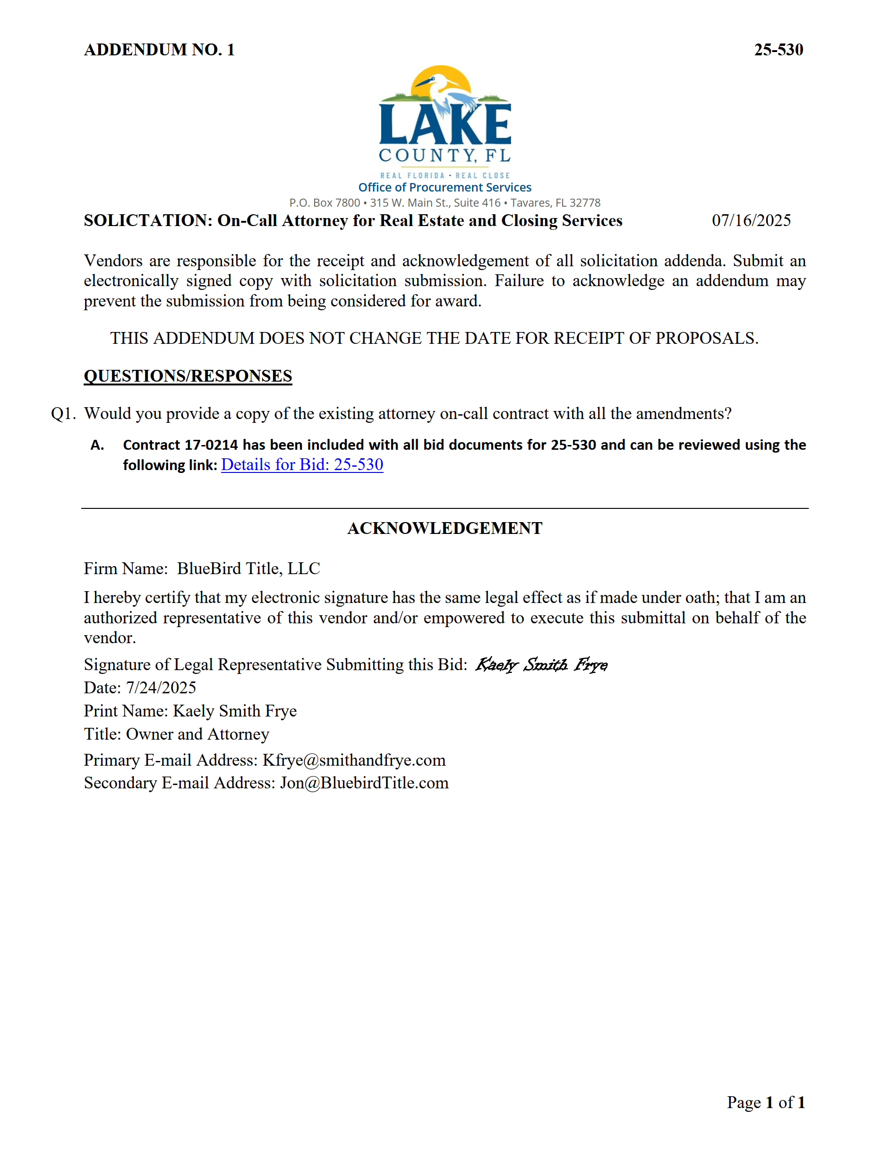

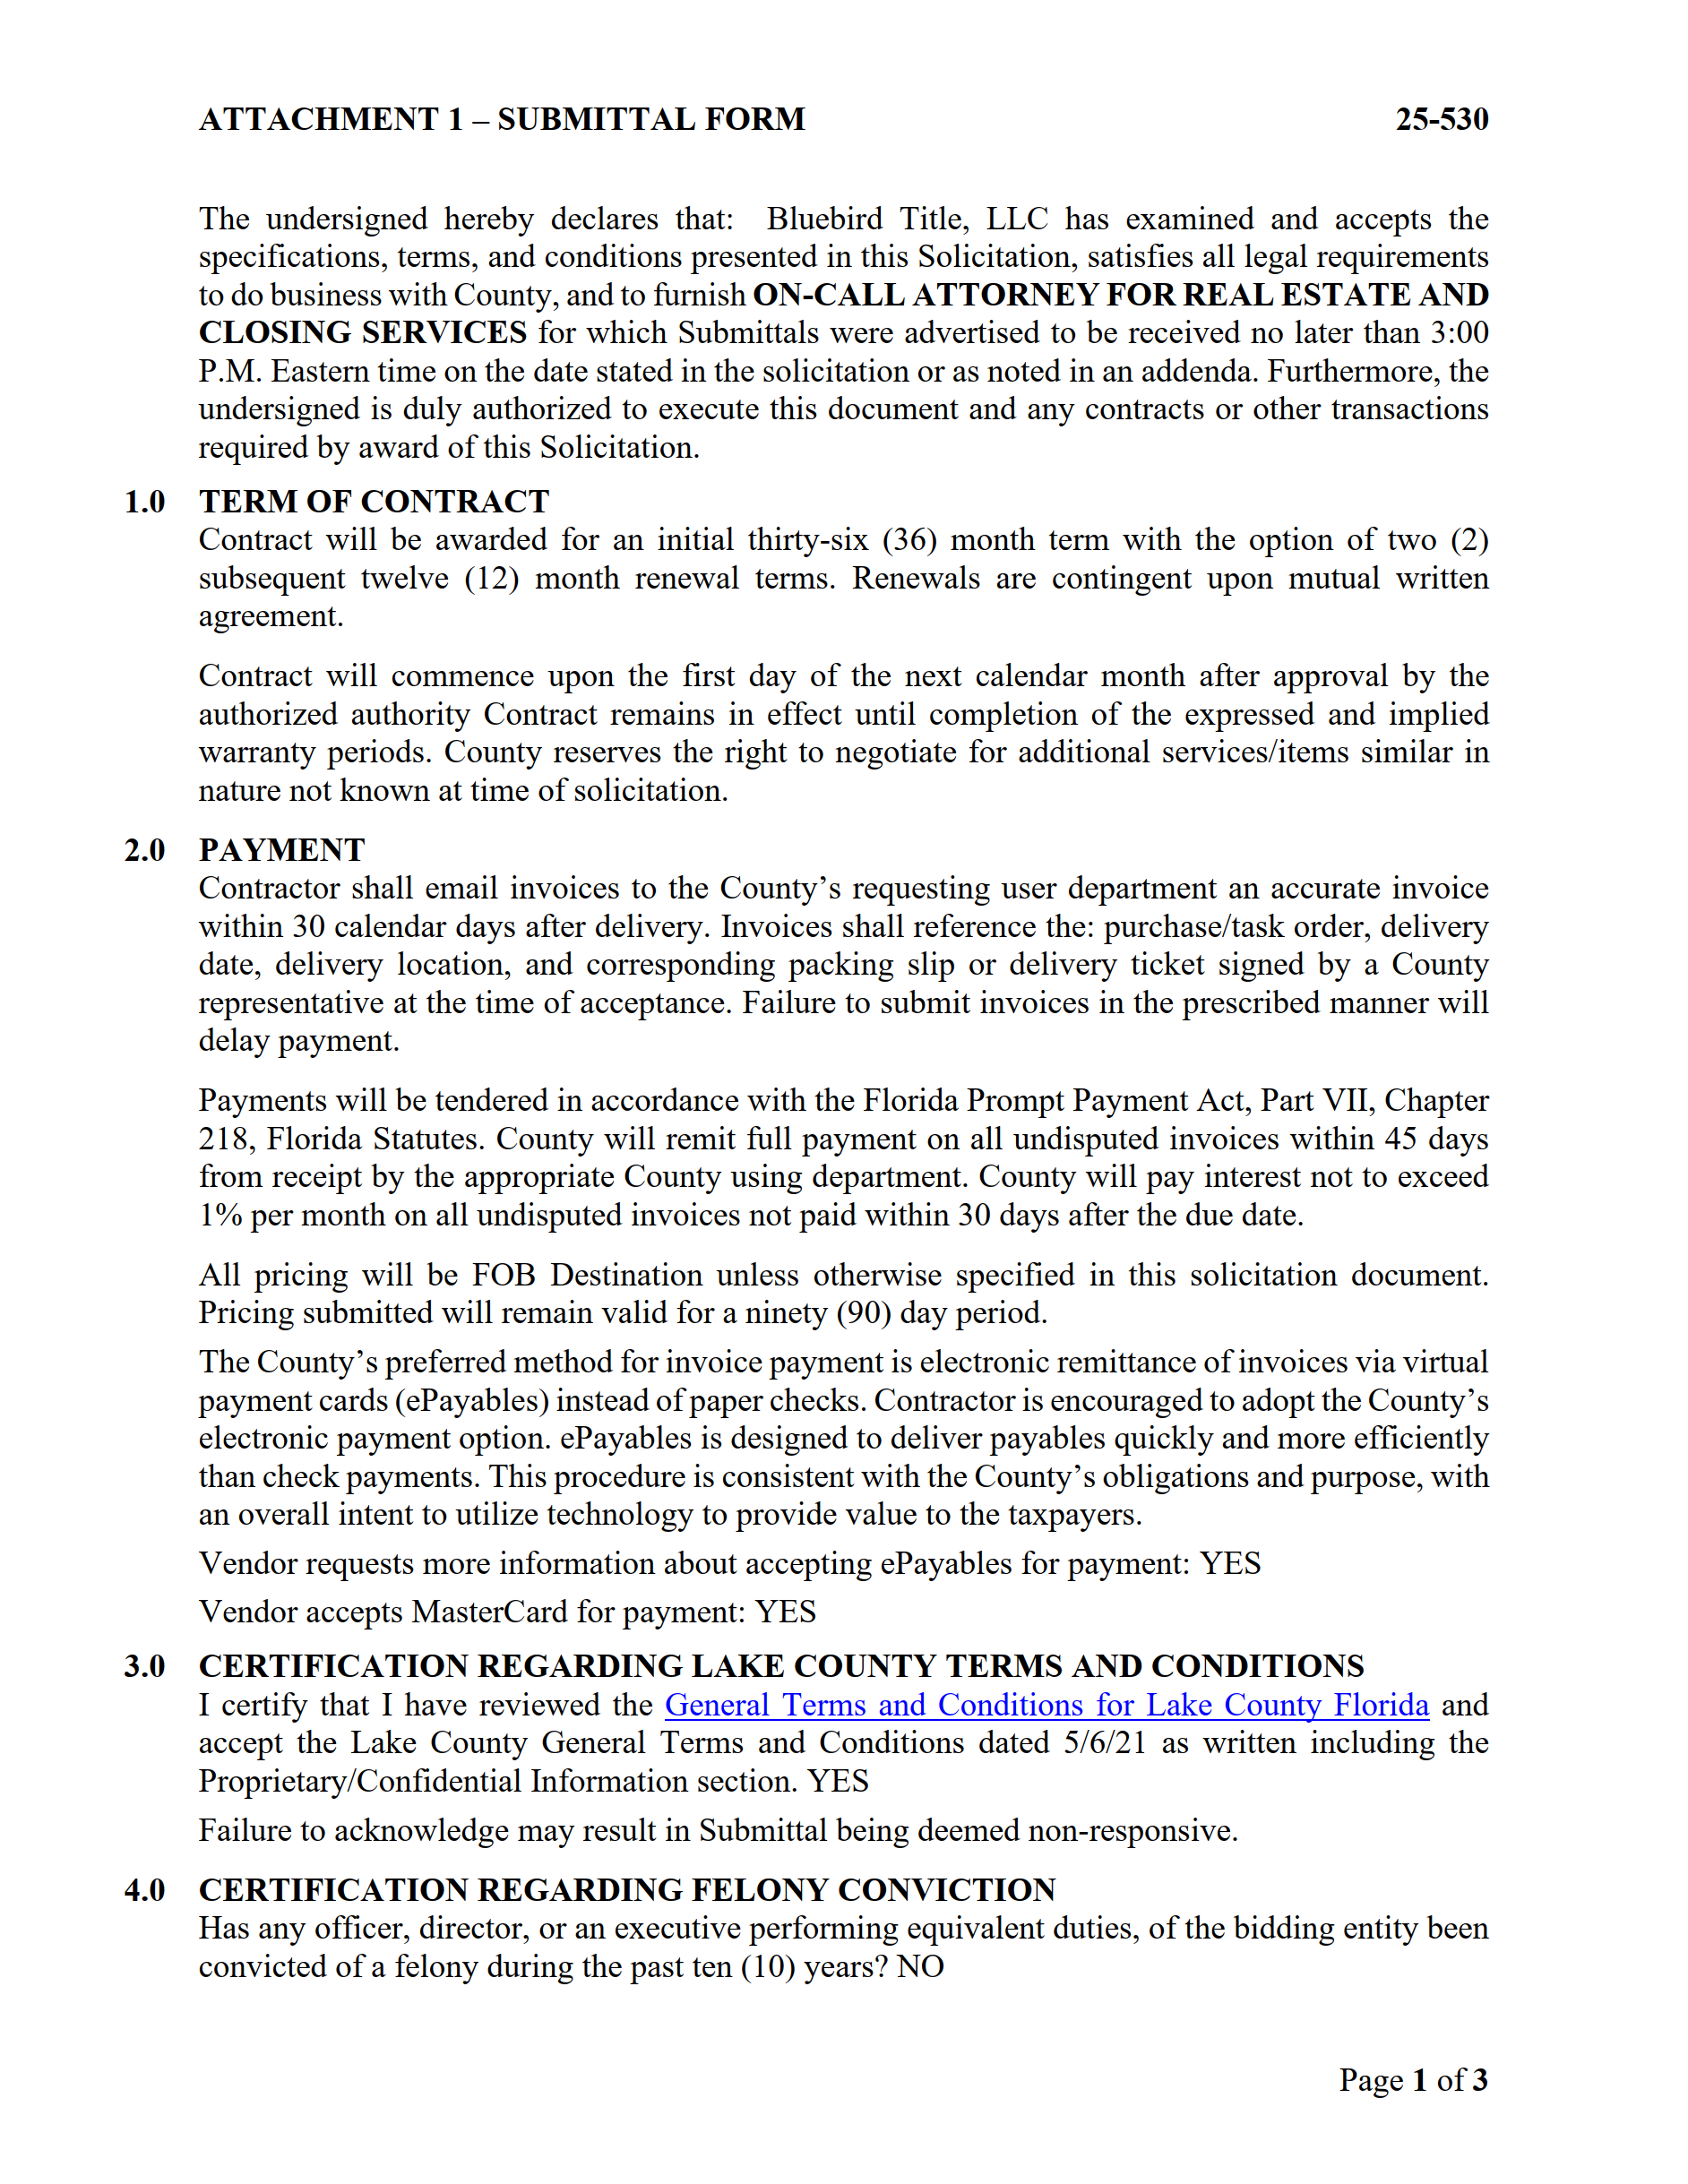

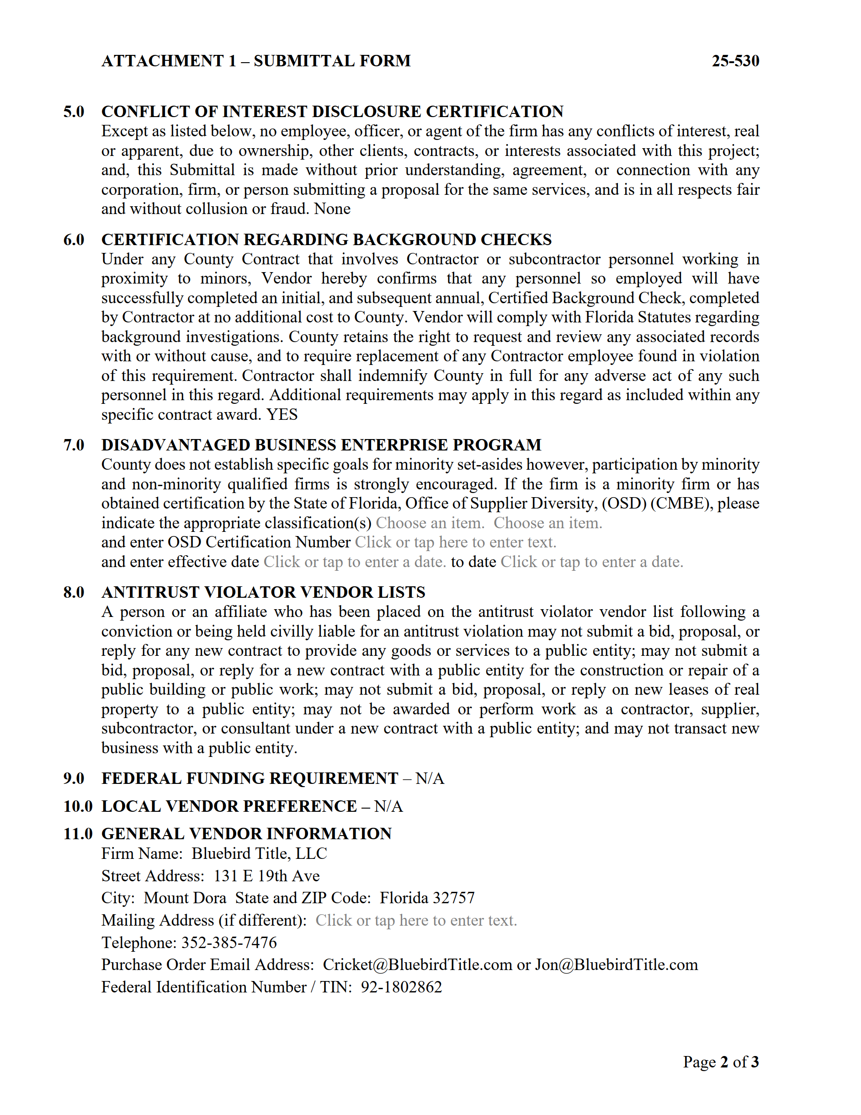

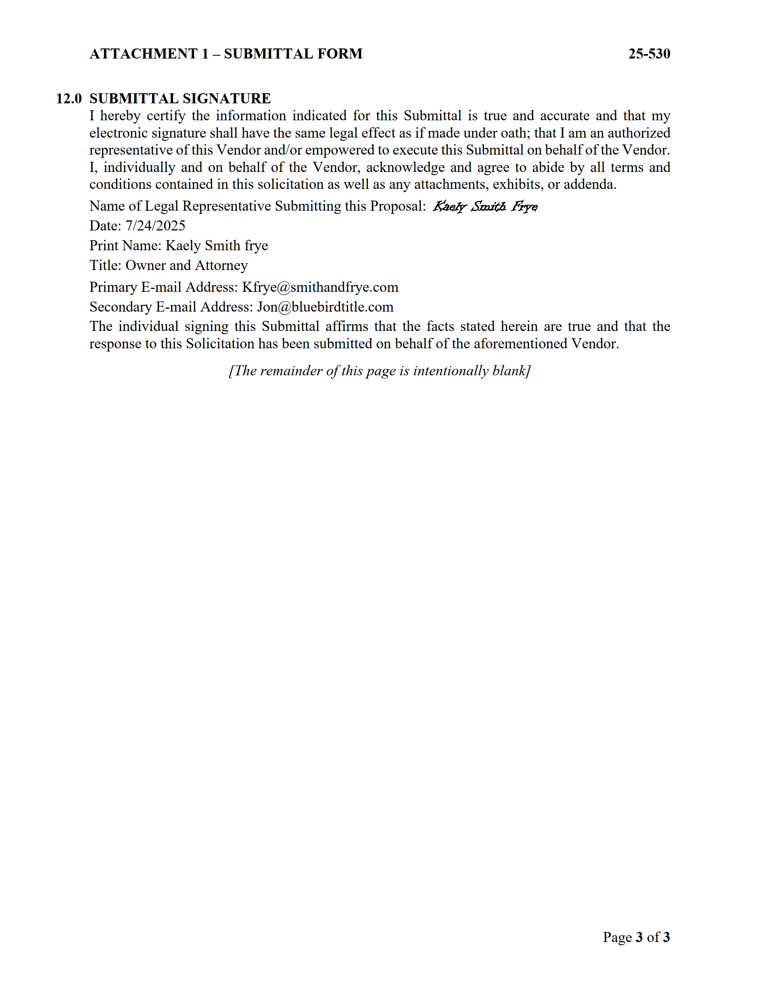

EXHIBIT B (Composite)

Pricing, Consultant’s Key Personnel

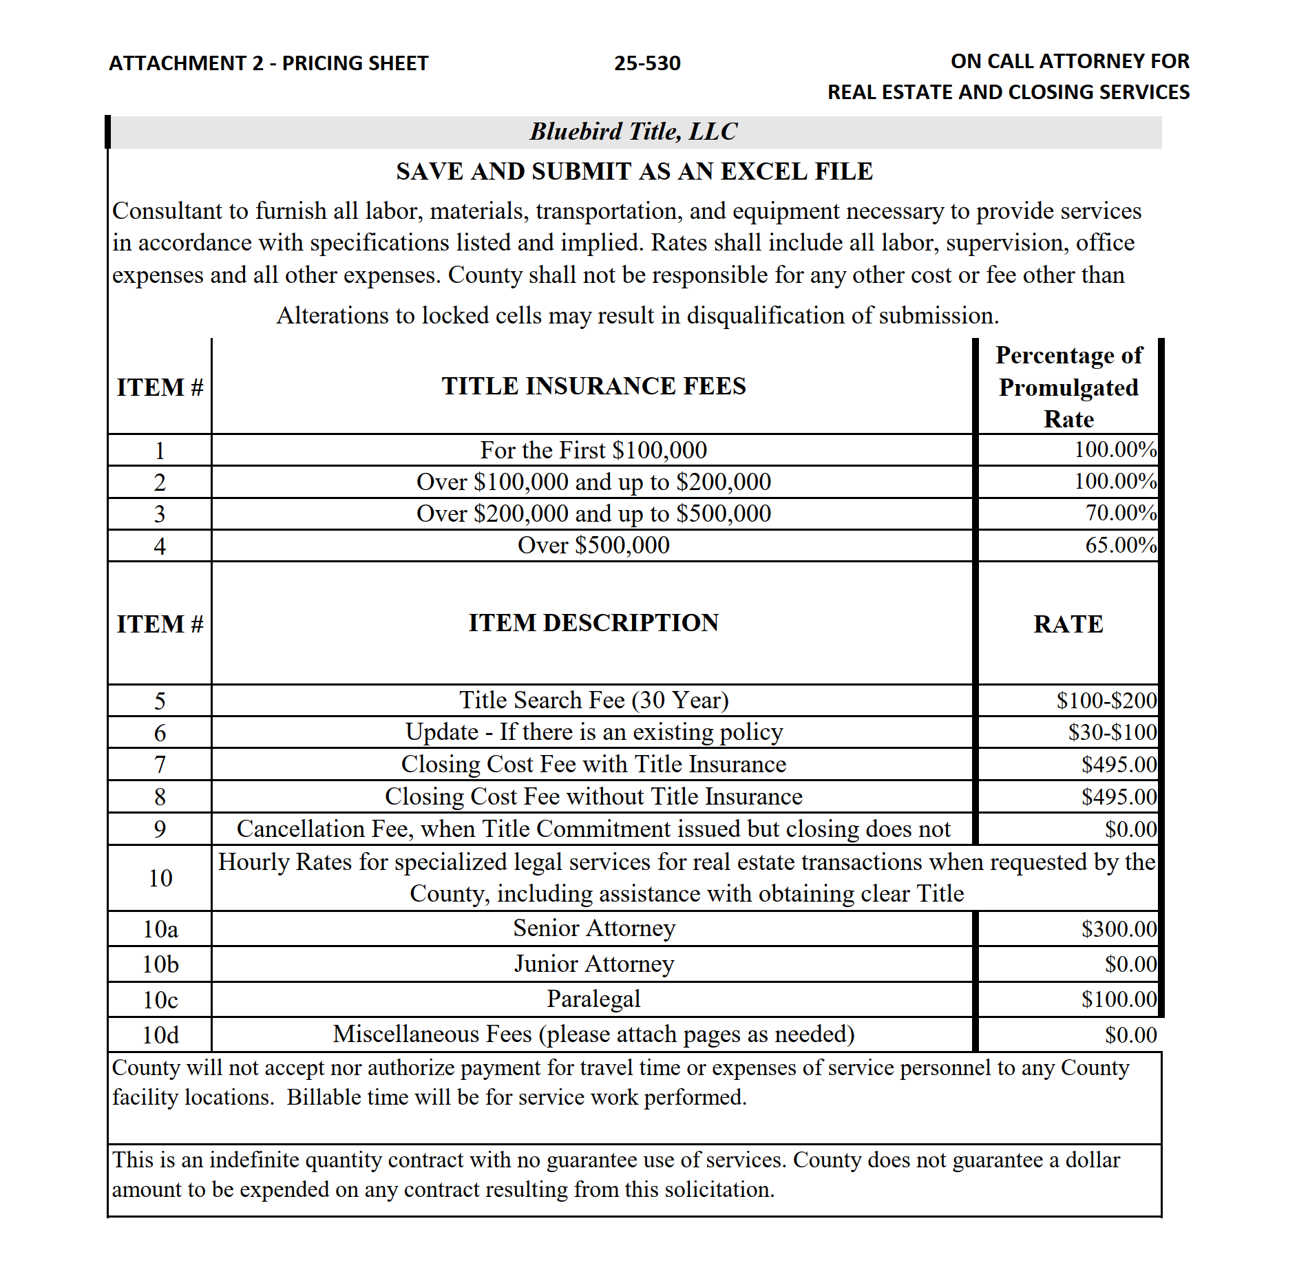

Exhibit C

Insurance Requirements

