- BACKGROUND
Lake County owns 68 acres of vacant property (parcels Alt Key 1032024 & 3915422; PID 07-20-26-0002-000-02000 & 07-20-26-0001-000-02200) in Tavares, Florida, and desires to develop it to serve as the new Lake County Event Center and Fairgrounds (LCEC).
- PROJECT SCOPE
  - Proposed design should be an attractive and cost-efficient mix of open and enclosed, conditioned spaces meeting the needs of the community. Design must include, at minimum, each of the following elements:
    - 30,000 SF enclosed conditioned expo hall
    - 20,000 SF arena
    - 15,000 SF open pavilions
    - Public restrooms
    - Carnival area
    - Livestock loading area.
    - Vendor parking and overnight RV spaces
    - Parking area
  - Consultant may be asked to develop a phased project to accommodate different areas to be constructed when permissible (i.e. the expo hall and common areas built first with the arena and pavilions constructed later).
- CONSULTANT
Consultant shall provide Architectural, Engineering (A/E) services. Pre-Construction design assessment services shall include but are not limited to:
  - Surveys and Topographic plans
  - As-builts
  - Utilities locates and assessments
  - Utilities plans
  - Traffic study
  - Storm Drain
  - Road improvement plans
  - Maintenance of Traffic
  - Soil borings
  - Environmental assessments and requirements
  - Tree mitigation
  - Planning and Zoning Site Plan
  - Development of a complete set of construction documents including but not limited to plans, and specifications for:
    - Civil
    - Site
    - Surveying
    - Roads and access
    - Storm water
    - Life Safety
    - Accessibility
    - Architectural
    - Structural
    - Mechanical
    - Plumbing
    - Fire alarm
    - Fire suppression
    - Electrical
    - Data (Low Voltage)
    - Landscape and irrigation
    - Project specifications
    - Project Manual
- CONSTRUCTION MANAGEMENT
Consultant shall provide Construction Management services to the County during the bid process, pre-construction, permitting, and construction, until final acceptance and project turnover. Services shall include, at a minimum, the following, without limitation:
  - Value engineering recommendations
  - Client data survey and assessment
  - Field visits
  - Construction cost estimates
  - Scheduling services
  - Response to requests for information
  - Attending public hearings
  - Board presentations
  - Plans, and specifications revisions
  - Permitting process responses
  - Construction bid assistance
  - Review and approval of submittals
  - Review pay-applications
  - Review change orders
  - Review requests for substitution
  - Monitoring progress
  - Attending meetings throughout the life of the project.
- QUALITY ASSURANCE
  - Consultant shall periodically provide the County with field inspection reports and ensure that all materials and equipment used and installed are new, unused, and in compliance with all codes and regulations of any governing body.
  - Consultant shall perform a substantial completion punch inspection with the County and or subcontracted engineering representatives.
  - Consultant shall conduct a final acceptance walk with the County and contractor within 30-days of substantial completion being achieved to address any outstanding punch items and produce a final acceptance document.
- PROJECT TURNOVER
  - Consultant shall produce a final set of revised drawings (red line drawings) with the assistance of the contractor, showing any changes or deviations from the signed and sealed documents from the information gathered throughout the project’s life.
  - Consultant will produce and turnover a “warranty book” with all approved submittals showing materials, equipment, and technical specifications to the owner for record-keeping.
  - A “closeout book” with all RFI’s, pay applications, change orders, inspection reports, substantial completion punch list, signed-off punch list, and final acceptance document shall be turnover to the County upon completion.
- PROPOSED PROJECT SITE
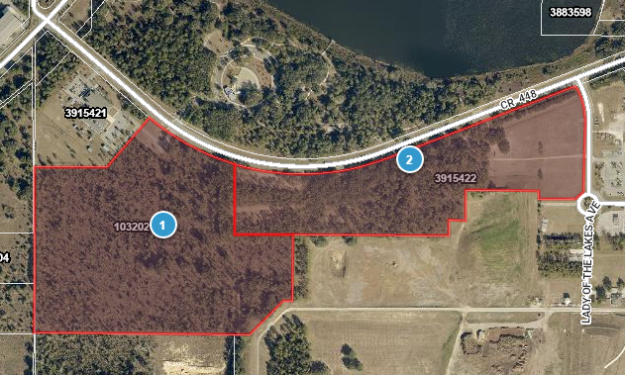

[End of Exhibit A.]

