
Office of Procurement Services
P.O. Box 7800 • 315 W. Main St., Suite 416 • Tavares, FL 32778
SOLICTATION: Construction of LCSO Marine Facility and Existing Pole Barn Expansion 07/22/26

Vendors are responsible for the receipt and acknowledgement of all solicitation addenda. Submit an electronically signed copy with solicitation submission. Failure to acknowledge an addendum may prevent the submission from being considered for award.
THIS ADDENDUM DOES NOT CHANGE THE DATE FOR RECEIPT OF PROPOSALS.
QUESTIONS/RESPONSES
- We would like to conduct a subcontractor site walk. Is that acceptable?
Yes, this is a public park, however, entering the pole barn is not acceptable due to the equipment and machinery.
- Regarding Exhibit A, section 1.4.4.12.3, please clarify the definition of installation only; a) No warranty or maintenance requirements? b) No transporting or logistics for plants and trees provided by LCWA?
The LCWA with purchase and deliver the landscaping plants to the project site based on the construction schedule provided by the contractor. It will be the responsibility of the contractor to store, install, and provide water to keep those plants alive until the close of the project.
- Regarding Exhibit A, section 1.6, as understood the LCWA is the “Permittee”, will the Contractor be responsible for any of the Conditions for Issuance of Permit number 19283-11; 1 through 23?
Yes, for the duration of the project. Once the project is complete and final payment has been made, the LCWA will submit all closeout documentation to SJRWMD that was submitted to the LCWA by the contractor (i.e. Certified As-Builts).
Regarding Exhibit A, section 1.9.2 and Project Manual - page 02280-1; section 02280; part 3 "Execution"; paragraph 3.01 "Application"; subparagraph "I" states: " Concrete must be poured within 24 hours of soil treatment." Obviously there is a conflict between the SOW and the Project Manual (specifications), will this form be just a notification to County staff of pending concrete pour, or does the form need to be completely filled out with approval?
There is no conflict. Notifying within 2 days of pouring only permits the project manager time to schedule the inspection. The 2 days is the minimum requirement. Inspections can be performed many days in advance to validate the locations of the foundational utilities. The contractor will still have the ability to pour the concrete within 24 hours of treatment along with notifying the project manager, minimally, the day before the treatment is applied.
- Regarding Exhibit O, section 3.10, will the verbiage of this paragraph remain the same as in sample agreement?
A major change to the language in section 3.10 is not expected.
- The plans indicate a storefront system. Would aluminum or vinyl picture windows that match the intended appearance be acceptable as an approved alternative?
Please provide for the aluminum framed storefront system specifications identified in the Construction Documents.
- Elevation Keynote #5 on Sheet A4.3 calls for an aluminum plaque. Please provide a representative image and dimensions for the decorative plaque for pricing purposes.
For Keynote #5 on detail 2/A4.1: the intended graphic is for the Lake County Sherriff’s Office “badge” (similar to the colored rendering shown on sheet A1.0 Cover sheet); see below image pasted to this word response file. For bidding purposes, please provide a 3’-8” wide x 3’-6” high size “badge” at detail 2/A4.1. For Keynote #5 on details 1/A4.3 and 2/A4.3 curved wall: the intended graphic is for the Lake County Sherriff’s Office “badge” (similar to the colored rendering shown on sheet A1.0 Cover sheet); see below image pasted to this word response file. For bidding purposes, please provide a 2’-0” wide x 1’-10” high size “badge”, black and white graphic for details 1/A4.3 and 2/A4.3 curved wall. In addition, provide 8” high x 2” thick pre-finished aluminum lettering on standoffs with concealed studs (color TBD); with messaging to read: Blessed are the Peacemakers, Master Deputy Bradley Link Fallen Officer Memorial (graphic intent to match the Details 1/A4.3 and 2/A4.3 curved wall – rendering screenshot). Contractor to obtain the “badge” logo artwork from the Owner after bid has been awarded. Contractor to include any costs associated with preparation of said artwork as required for the decorative plaques.
Detail 2/A4.1 – rendering screenshot
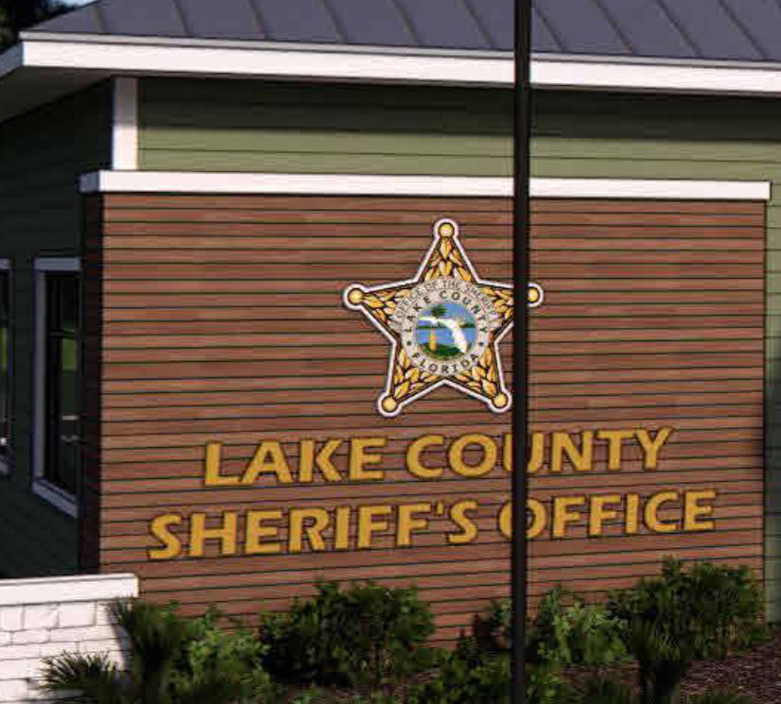

Details 1/A4.3 and 2/A4.3 curved wall – rendering screenshot
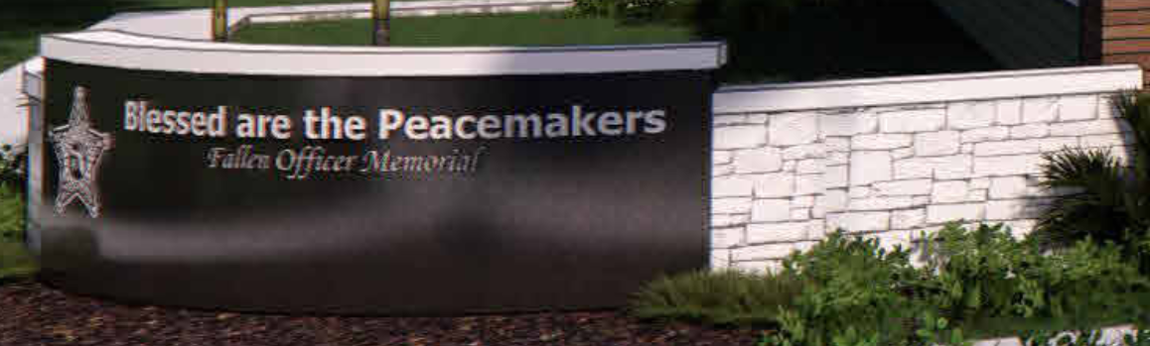
A low quality image is provided as a sample (Exhibit Q – Sheriff Logo) for estimates. A high-quality vector graphic with a chromatic key will be provided for the actual manufacturing of the plaque.
- The specified .032 aluminum metal panels are difficult to source in the required profile and will result in increased costs and lead times. Would the Owner/Engineer approve the use of 26-gauge metal panels as an acceptable alternative for the pole barn expansion? This is the standard gauge for this type of application and is readily available.
Please provide the specified .032 aluminum material form one of the acceptable manufacturers as called out on spec section 074213.13 Formed Metal Wall Panels and also on spec section 07610 Metal Roofing.
- Is there an engineer’s estimate or hand budget that can be provided?
There is no engineer’s estimate for this project. An Architects Opinion of Probable Cost was performed with a range of $2,941,600 (low) to $3,595,300 (high).
- Is there a hard deadline for substantial/final compilation?
No. Substantial Completion will be based on the project timeframe provided by the awarded contractor’s bid. Preferentially, from the County’s perspective, the quicker the LCSO can move into their new offices, the better.
- For the temporary fence with privacy screening, can you provide a sketch of the area that we are allowed to block off?
Please see Exhibit P – HP Privacy Fencing. The privacy screening will mainly need to be used in the area to the east and south of the Marine Facility Building to prevent patrons and players from wandering into the construction area and to prevent the construction site “look” from hampering the experience of the same. The request is an 8 ft privacy screen. Images of the standard screen used by the County in past projects are included in the aforementioned Exhibit P.
- For the section of sidewalk that needs to be blocked off, are we required to install a temporary sidewalk, or is signage adequate?
Signage would be adequate to direct patrons around the area. The closure of the sidewalk should be scheduled in a way that provides the least amount of interruption to the park’s pedestrian circulation routes.
- For the demolition permit, can you provide the estimated fees, or provide an allowance amount for those fees?
This will be answered in Addendum 3.

ADDITIONAL INFORMATION
Additional questions have been submitted. Addendum 3 will be posted and available to the public once all questions have been answered.

ACKNOWLEDGEMENT

Firm Name: Click or tap here to enter text.
I hereby certify that my electronic signature has the same legal effect as if made under oath; that I am an authorized representative of this vendor and/or empowered to execute this submittal on behalf of the vendor.
Signature of Legal Representative Submitting this Bid: Click or tap here to enter text.
Date: Click or tap to enter a date.
Print Name: Click or tap here to enter text.
Title: Click or tap here to enter text.
Primary E-mail Address: Click or tap here to enter text.
Secondary E-mail Address: Click or tap here to enter text.

