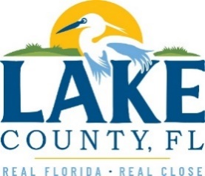
Office of Procurement Services
P.O. Box 7800 • 315 W. Main St., Suite 416 • Tavares, FL 32778
NOTICE OF INTENT TO ACCEPT AN UNSOLICITED PUBLIC-PRIVATE PARTNERSHIP (P3) PROPOSAL

PUBLIC NOTICE
Notice is hereby given that Lake County Board of County Commissioners (County), in accordance with Section 255.065 of the Florida Statutes, Public-Private Partnerships (P3), has received and accepted an unsolicited proposal for a potential public-private partnership project.
In accordance with applicable procedures, the County will now initiate a public notice and competition period. During this period, alternative or competing proposals addressing the same project purpose will be accepted for review.
All responses must be received by 3:00 P.M. Eastern on Monday, December 22, 2025. Submittals received after the specified deadline will not be considered. Any responses received will be evaluated solely to determine the existence of bona fide competition.

PRODUCT/SERVICE
The proposal concerns the design, development, construction, joint financing, operation, of a new Sports and Expo Center to be located at the Lake County Fairgrounds property at 28598 Lady of the Lakes Avenue, Tavares, Florida 32778. The unsolicited proposal has been determined to meet the criteria for consideration under the governing P3 guidelines and has been accepted for further evaluation.

POINT OF CONTACT
Interested parties may obtain additional information regarding the project and the submission process by contacting the Office of Procurement Services Director at Ronald.Falanga@LakeCountyFL.gov for submission details.

[The remainder of this page intentionally blank.]

