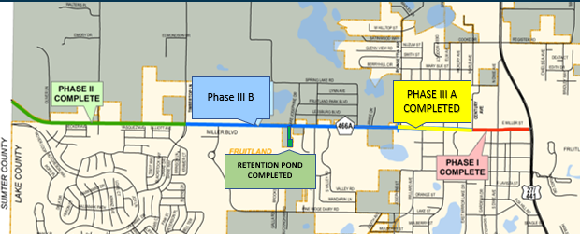

[The remainder of this page intentionally left blank]

