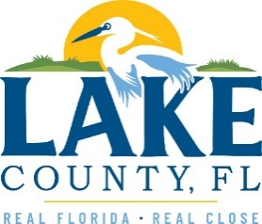
Office of Procurement Services
P.O. Box 7800 • 315 W. Main St., Suite 416 • Tavares, FL 32778
SOLICTATION: Title V Air Operation Permit Renewal 03/11/2026

Vendors are responsible for the receiving and acknowledging all solicitation addenda. An electronically signed copy of each addendum must be submitted along with the solicitation response. Failure to acknowledge any addendum may result in the submission being disqualified from award consideration.
THIS ADDENDUM DOES NOT ALTER THE PROPOSAL SUBMISSION DEADLINE.
QUESTIONS/RESPONSES
Q5. Are there any FLDEP consent orders or other correspondence requesting design and installation of specific landfill controls?
- No.
Q6. Are there any available emission monitoring and air modeling for Lake County Solid Waste Facility? How can these documents be accessed?
- See answer provided to Q3 on Addendum 1. Attachment was provided – 2022 Tier 2 NMOC Emission Rate Report.
Q7. Are there any capital improvement projects planned for the Solid Waste Facility in the next 5 years?
- No capital improvement plans are scheduled for the next 5 years.
ADDITIONAL INFORMATION
All addendums must be signed and included with submittals.

ACKNOWLEDGEMENT

Firm Name: Click or tap here to enter text.
I hereby certify that my electronic signature has the same legal effect as if made under oath; that I am an authorized representative of this vendor and/or empowered to execute this submittal on behalf of the vendor.
Signature of Legal Representative Submitting this Bid: Click or tap here to enter text.
Date: Click or tap to enter a date.
Print Name: Click or tap here to enter text.
Title: Click or tap here to enter text.
Primary E-mail Address: Click or tap here to enter text.
Secondary E-mail Address: Click or tap here to enter text.

