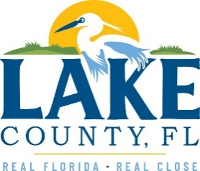
Office of Procurement Services
P.O. Box 7800 • 315 W. Main St., Suite 416 • Tavares, FL 32778
SOLICTATION: Title V Air Operation Permit Renewal 02/19/2026

Vendors are responsible for the receiving and acknowledging all solicitation addenda. An electronically signed copy of each addendum must be submitted along with the solicitation response. Failure to acknowledge any addendum may result in the submission being disqualified from award consideration.
THIS ADDENDUM DOES NOT ALTER THE PROPOSAL SUBMISSION DEADLINE.
QUESTIONS/RESPONSES
- Clarify that this scope of services is only for preparing the Title V permit renewal application that is due September 27, 2026.
- Confirmed.
- Clarify that this scope of services is to include future Title V designs, emissions evaluations, monitoring, annual reporting, evaluation, and bid services related to the Title V permit based on Section 1.4.1 and 1.4.2 of the scope of services.
- Scope of services is to prepare and submit the Title V permit renewal, including testing, evaluations, etc., related to renewing the permit.
- Provide the most recent Tier 2 test report for the Lake Count Solid Waste Management Facility.
- See attachment 2022 Tier 2 NMOC Emission Rate Report.
- What is the term of the contract?
- This is a one-time project only.
ADDITIONAL INFORMATION
All addendums must be signed and included with submittals.

ACKNOWLEDGEMENT

Firm Name: Click or tap here to enter text.
I hereby certify that my electronic signature has the same legal effect as if made under oath; that I am an authorized representative of this vendor and/or empowered to execute this submittal on behalf of the vendor.
Signature of Legal Representative Submitting this Bid: Click or tap here to enter text.
Date: Click or tap to enter a date.
Print Name: Click or tap here to enter text.
Title: Click or tap here to enter text.
Primary E-mail Address: Click or tap here to enter text.
Secondary E-mail Address: Click or tap here to enter text.

