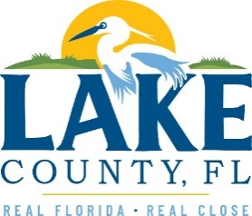
Office of Procurement Services
P.O. Box 7800 • 315 W. Main St., Suite 416 • Tavares, FL 32778
SOLICTATION: Alternate Site Disposal 04/14/2026

Vendors are responsible for the receiving and acknowledging all solicitation addenda. An electronically signed copy of each addendum must be submitted along with the solicitation response. Failure to acknowledge any addendum may result in the submission being disqualified from award consideration.
THIS ADDENDUM CHANGES THE SUBMISSION DEADLINE TO NOW CLOSE TUESDAY, APRIL 21, 2026.
QUESTIONS/RESPONSES
- What is the expected Class I Landfill annual tonnage for the disposal of the County’s Class I Waste (Municipal Solid Waste / Household Garbage) under these Alternate Disposal Services?
Depending on the scenario for use, the tonnage can reach approximately 70,000 tons per year for Class I with nominal increases for increases in population.
ADDITIONAL INFORMATION
Addendum 4 was completed to answer a question received on April 9, 2026, the last day for questions.

ACKNOWLEDGEMENT

Firm Name: Click or tap here to enter text.
I hereby certify that my electronic signature has the same legal effect as if made under oath; that I am an authorized representative of this vendor and/or empowered to execute this submittal on behalf of the vendor.
Signature of Legal Representative Submitting this Bid: Click or tap here to enter text.
Date: Click or tap to enter a date.
Print Name: Click or tap here to enter text.
Title: Click or tap here to enter text.
Primary E-mail Address: Click or tap here to enter text.
Secondary E-mail Address: Click or tap here to enter text.

