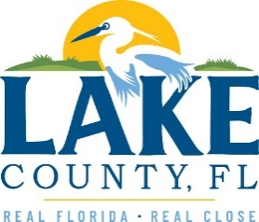
Office of Procurement Services
P.O. Box 7800 • 315 W. Main St., Suite 416 • Tavares, FL 32778
SOLICTATION: ALTERNATE DISPOSAL SITE 03/24/2026

Vendors are responsible for the receiving and acknowledging all solicitation addenda. An electronically signed copy of each addendum must be submitted along with the solicitation response. Failure to acknowledge any addendum may result in the submission being disqualified from award consideration.
THIS ADDENDUM DOES NOT ALTER THE PROPOSAL SUBMISSION DEADLINE.
QUESTIONS/RESPONSES
- Can the County provide the current rates with Heart of Florida for these disposal services?
$23.29
- Can the County provide the total tonnages taken to Heart of Florida?
For Fiscal Year 2025: 73,347 tons of waste, including bulk; 24,664 tons of yard waste; 15,009 tons of recycling.
- Can the County provide the expected tonnage for these Alternate Disposal Site Services?
Estimated 15,000 tons of Class III / C&D – factoring for distance, pricing, history and / or, Heart of Florida landfill becomes unavailable.
ADDITIONAL INFORMATION
REMINDER: All addendums must be signed and included with response.

ACKNOWLEDGEMENT

Firm Name: Click or tap here to enter text.
I hereby certify that my electronic signature has the same legal effect as if made under oath; that I am an authorized representative of this vendor and/or empowered to execute this submittal on behalf of the vendor.
Signature of Legal Representative Submitting this Bid: Click or tap here to enter text.
Date: Click or tap to enter a date.
Print Name: Click or tap here to enter text.
Title: Click or tap here to enter text.
Primary E-mail Address: Click or tap here to enter text.
Secondary E-mail Address: Click or tap here to enter text.

