
Office of Procurement Services
P.O. Box 7800 • 315 W. Main St., Suite 416 • Tavares, FL 32778

SOLICTATION: Green Mountain Scenic Overlook & Trailhead – Second Observation Tower 11/26/2025

Vendors are responsible for the receiving and acknowledging all solicitation addenda. An electronically signed copy of each addendum must be submitted along with the solicitation response. Failure to acknowledge any addendum may result in the submission being disqualified from award consideration.
THIS ADDENDUM ALTERS THE PROPOSAL SUBMISSION DEADLINE FROM 12/04/2025 TO 12/11/2025.
ADDITIONAL INFORMATION
- Revised plans were sent to all vendors that attended the mandatory pre-bid meeting and requested the original plans via Attachment 12, Procedures for Viewing Confidential Documents. See REVISED Exhibit I.
- Attachment for responses to questions 14, 15, 16 and 18: Please refer to attached revised sheets Revision #4, Pre-Bid RFI, revised date of 11-20-25. Sheets revised are as follows: A1.0, A3.2, A3.3, A3.4, A4.1, A4.3, A4.4, A5.1, A5.2, S-101 and S-103.
QUESTIONS/RESPONSES
- What is the wage determination? Reference Exhibit E, Section B, page B-30.
The Contractor is responsible for classification for US Department of Labor (USDOL) wage rates.
- Is Contractor required to obtain permit from St. John’s River Water Management District? Reference Exhibit D, Section D
No, Lake County Parks have already received St. John’s River Water Management District approval to proceed with this project.
- What are the rates to determine the cost of Lake County permits?
Building Permit fee estimate is $2,000. Contractor is responsible for permit fees. Refer to Scope of Work, Section 2.9.
- Sheet A5.1 shows the new 10’ wide aluminum walkway with a concrete topping, although the rest of the decking details show an uncovered aluminum deck. Please clarify.
There is no concrete shown at this location on the latest drawings, provide aluminum walkway decking per structural notes and architectural sheets issued.
- Can the architect prove the locations and elevations of the retaining walls?
Refer to revised Architectural sheets for clarification of retaining wall extends in plan and height requirements (in particular sheets A3.2, A4’s and A5’s).
- Is the top of elevator slab elevation to be determined by the elevator contractor’s design?
No, refer to the revised Architectural sheet A5.2 for clarification on top of elevator clearances. Also note a Lifeline steel beam has been added per the revised Structural sheets S-101 and S103.
- Are we to assume these doors are to be hurricane rated? I didn’t see much calling out the ratings.
Hurricane rated exterior doors are not required.
- Could you clarify if the steel needs to be protected with Spray fireproofing or Intumescent fireproofing.
Protection of steel is not required. However, refer to revised Architectural sheet A5.2 as well as floor plans sheets A3’s for clarification for location of the 2-HR shaftliner walls and 2-HR shaftliner ceilings encompassing the elevator vertical shaft. Note that an enlarged elevator floor plan has been added to sheet A5.2 as a clarification of the shaftliner walls to be provided on the interior face of the structural steel (avoiding protection of the steel). As a clarification, the revised Architectural drawings have clarified the location of the cold form infill framing and sheathing for the fiber cement lap siding that is to the provided surrounding the elevator vertical shaft enclosure.
- Page A3.2 detail 1, the fence line, and where my arrows point to it just ends. Is this intentional, or should the fence line be continuous to the column (blue arrow)?
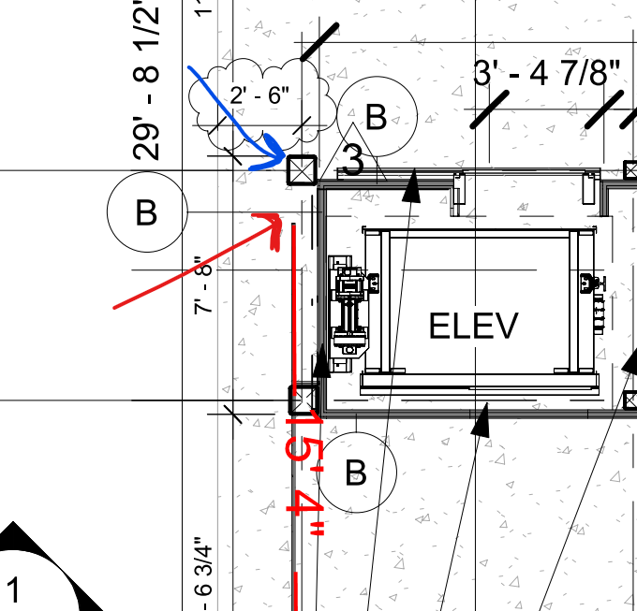

Refer to the latest revised sheet A3.2 where the fence line has been clarified and note it stops at the column grid line A.1 and 1.2. See below screenshot of the revised sheet for reference.
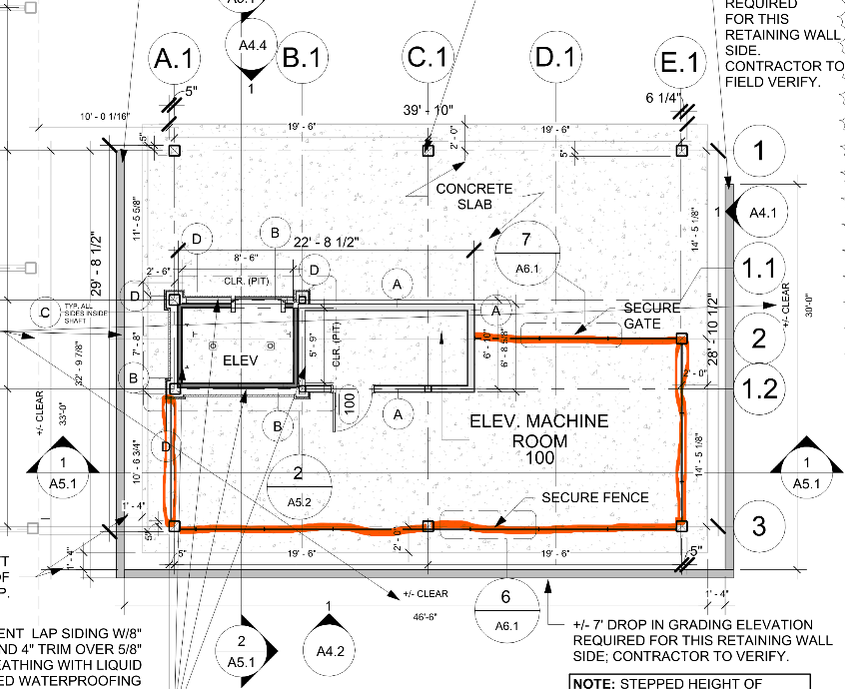
- Page A6.1 gives the details for the fence, but that style comes in 2 heights, either 8 foot or 10 foot tall. The plans only talk about “secure fence”, what height is being specified?
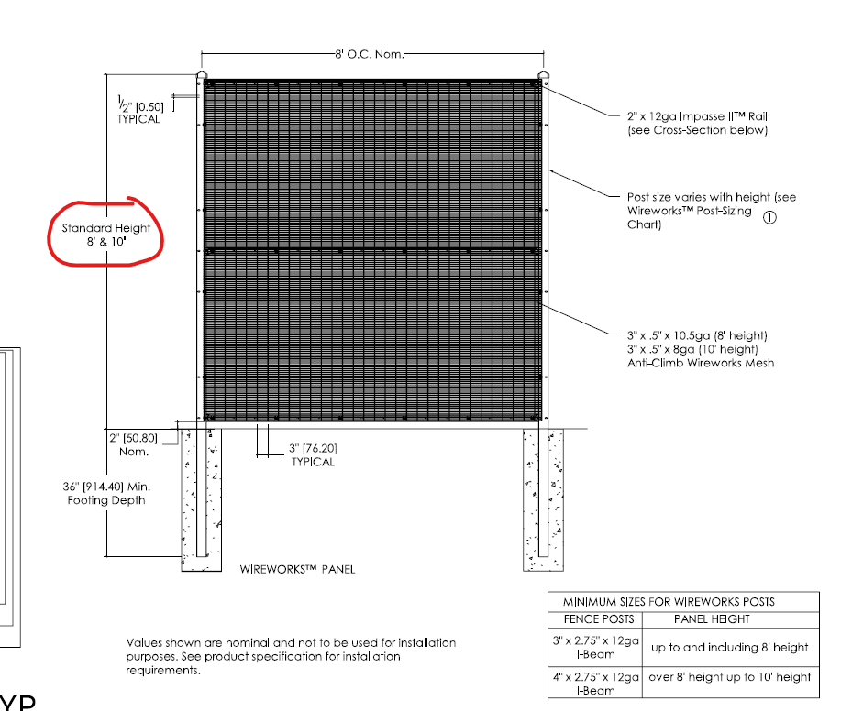
Provide 8 feet high fence and gates as graphically demonstrated on the Elevations and Section drawings.

ACKNOWLEDGEMENT

Firm Name: Click or tap here to enter text.
I hereby certify that my electronic signature has the same legal effect as if made under oath; that I am an authorized representative of this vendor and/or empowered to execute this submittal on behalf of the vendor.
Signature of Legal Representative Submitting this Bid: Click or tap here to enter text.
Date: Click or tap to enter a date.
Print Name: Click or tap here to enter text.
Title: Click or tap here to enter text.
Primary E-mail Address: Click or tap here to enter text.
Secondary E-mail Address: Click or tap here to enter text.

