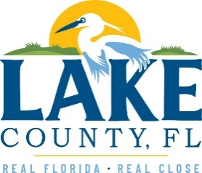
Office of Procurement Services
P.O. Box 7800 • 315 W. Main St., Suite 416 • Tavares, FL 32778
SOLICTATION: North Lake Regional Park Playground Replacement 11/5/2025

Vendors are responsible for receiving and acknowledging all solicitation addenda. An electronically signed copy of each addendum must be included with the solicitation response. Failure to acknowledge any addendum may result in disqualification from award consideration.
THIS ADDENDUM DOES NOT ALTER THE PROPOSAL SUBMISSION DEADLINE.
ADDITIONAL INFORMATION
The following products have been reviewed and accepted as equal alternatives:
- Playcraft Systems
- Miracle Playground Equipment
- Playmore

ACKNOWLEDGEMENT

Firm Name: Click or tap here to enter text.
I hereby certify that my electronic signature has the same legal effect as if made under oath; that I am an authorized representative of this vendor and/or empowered to execute this submittal on behalf of the vendor.
Signature of Legal Representative Submitting this Bid: Click or tap here to enter text.
Date: Click or tap to enter a date.
Print Name: Click or tap here to enter text.
Title: Click or tap here to enter text.
Primary E-mail Address: Click or tap here to enter text.
Secondary E-mail Address: Click or tap here to enter text.

