Soccer Field - typical
All white lines and circle marks are to be painted for the outline and marks of the field. 1 yard = 3 feet. Painted line marks will be 4” in width (typical).
A
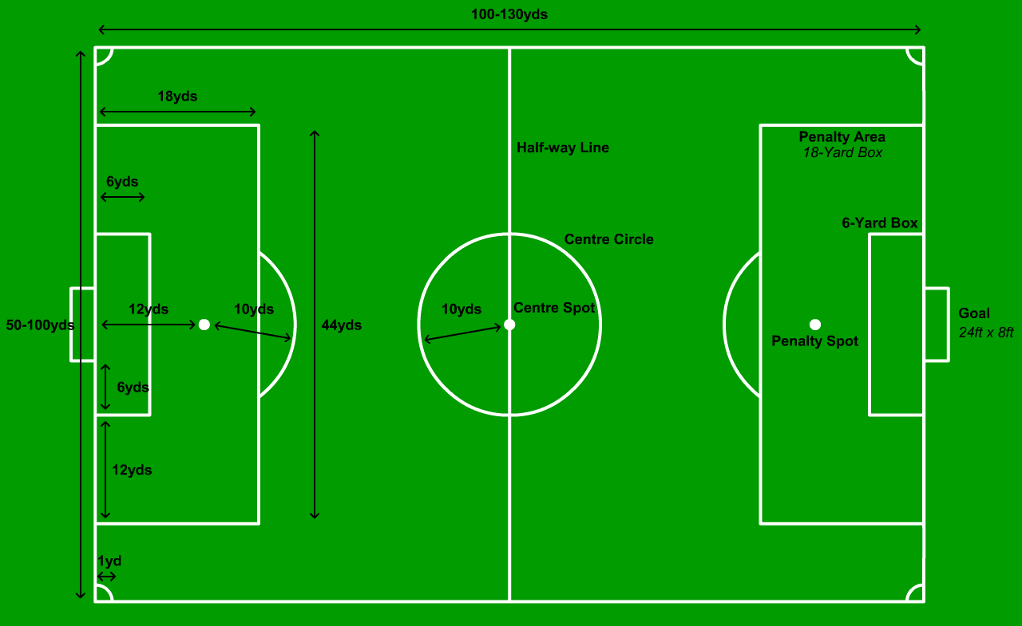
Soccer Field – variations
There are a wide variety of field variations that leagues and organizations like to use. Below are the most typical field dimension variations but there can always be additional variations not foreseen. All white lines and circle marks are to be painted for the outline and marks of the field. 1 yard = 3 feet. Painted line marks will be 4” in width (typical).
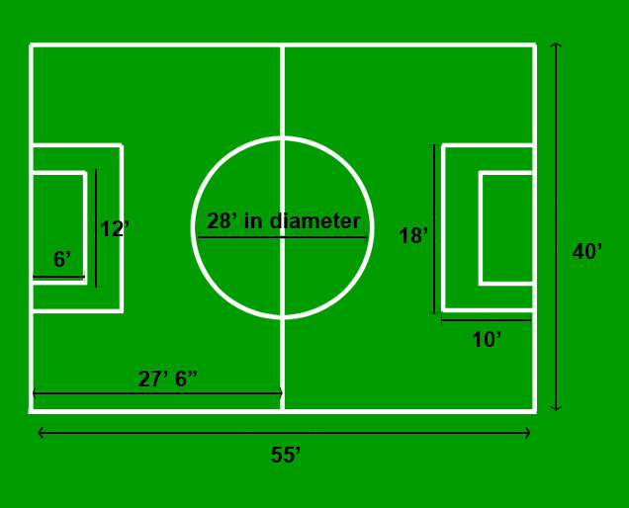
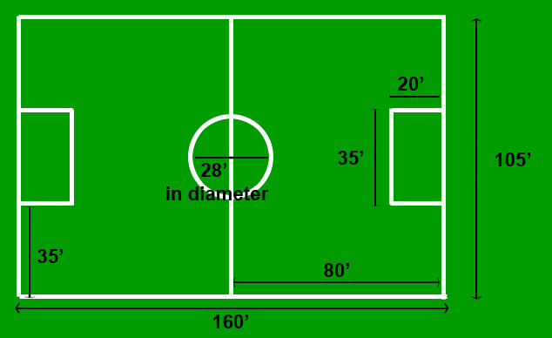
B
C
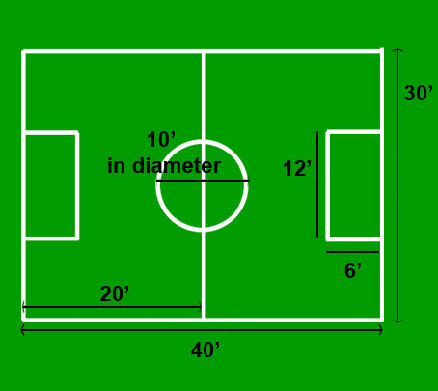
D
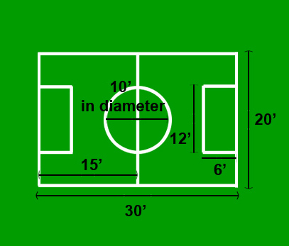
E

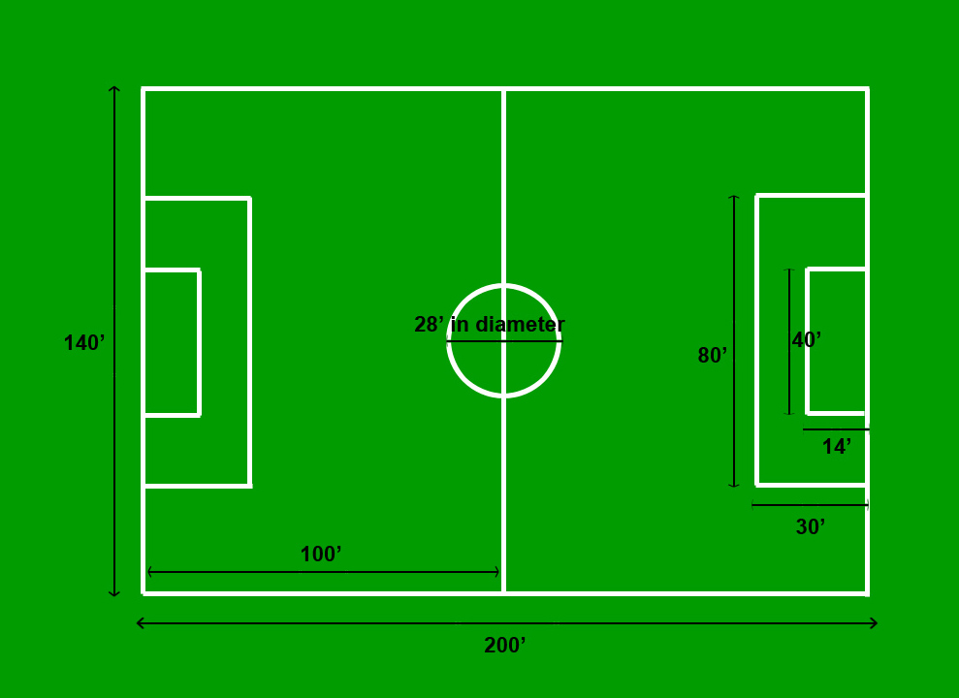
F

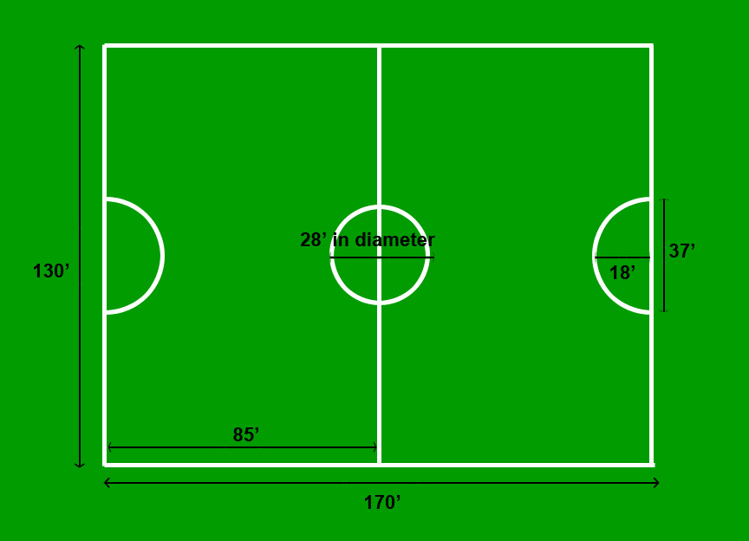
G

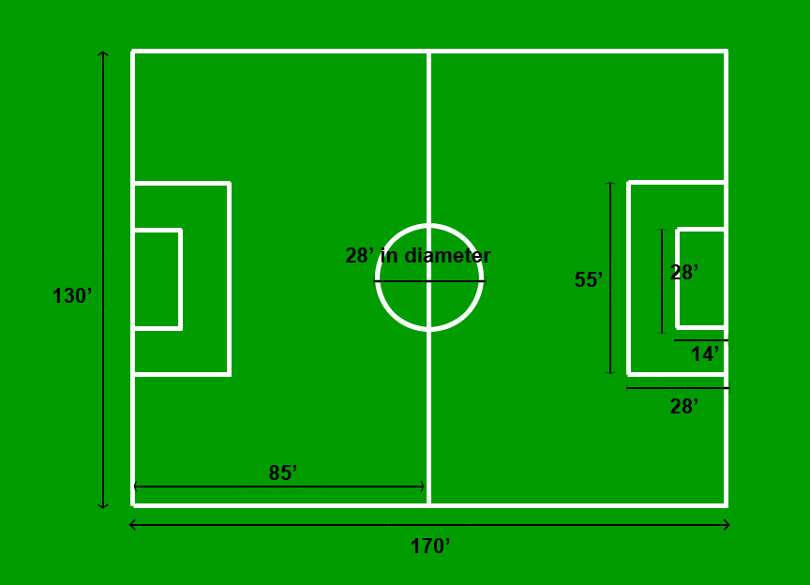
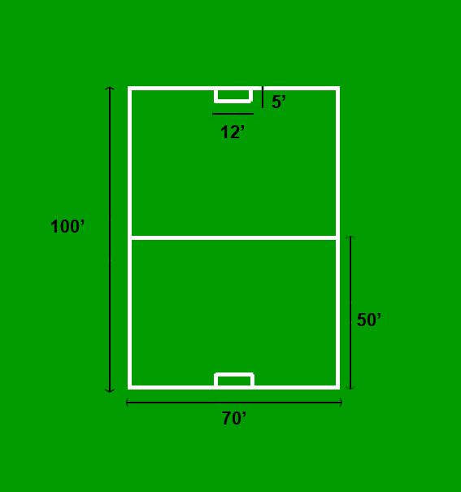
I
H
I
Typical soccer field layout at North Lake Community Park can consist of a combination of four to five fields depending on size and position.

Figure A

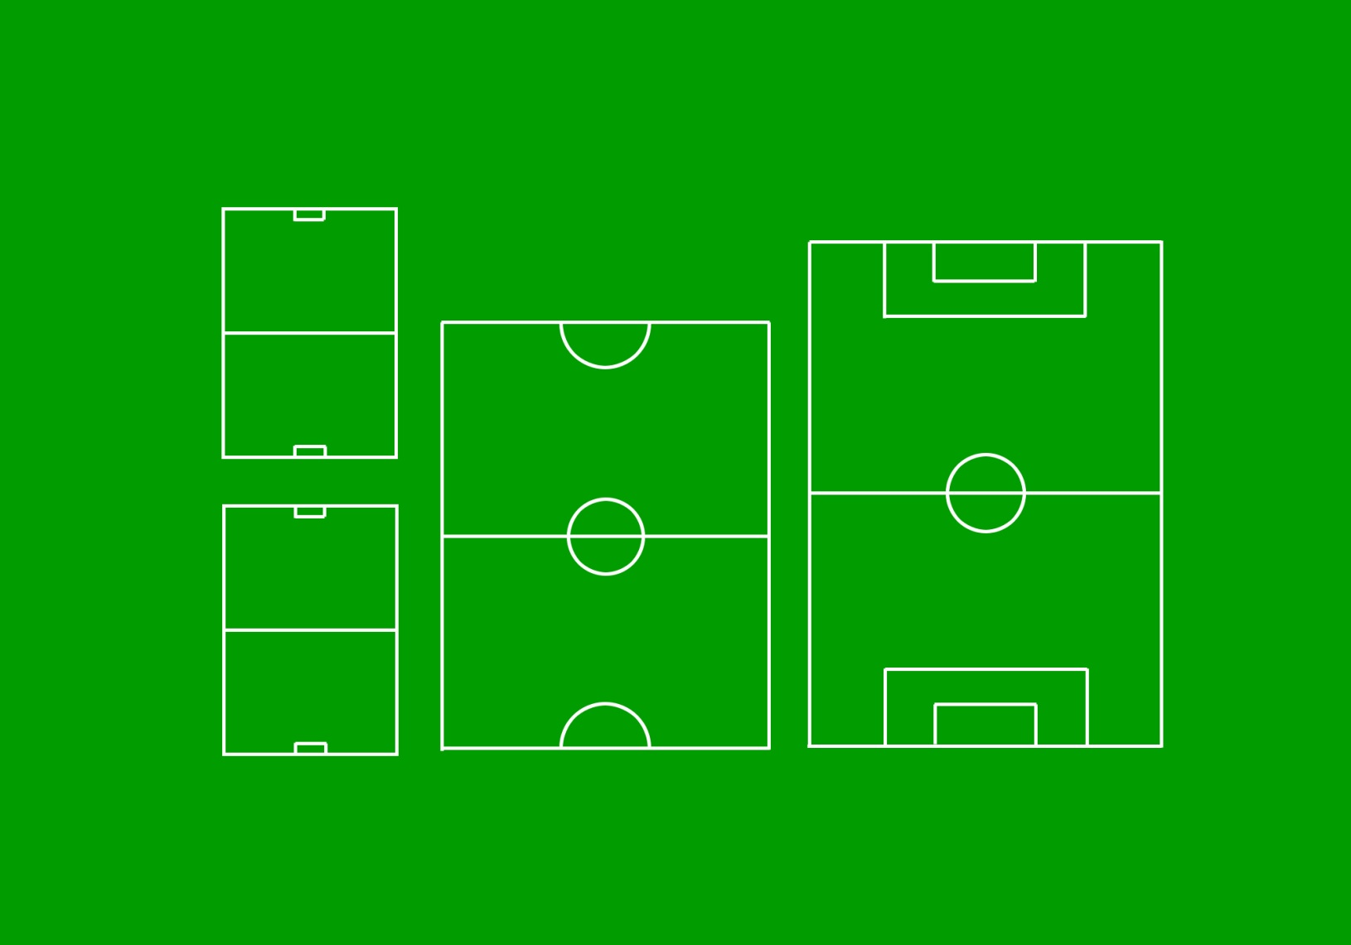
F
G
I
I
Typical soccer field layout at East Lake Community Park can consist of four to five fields depending on size and position.

Figure B
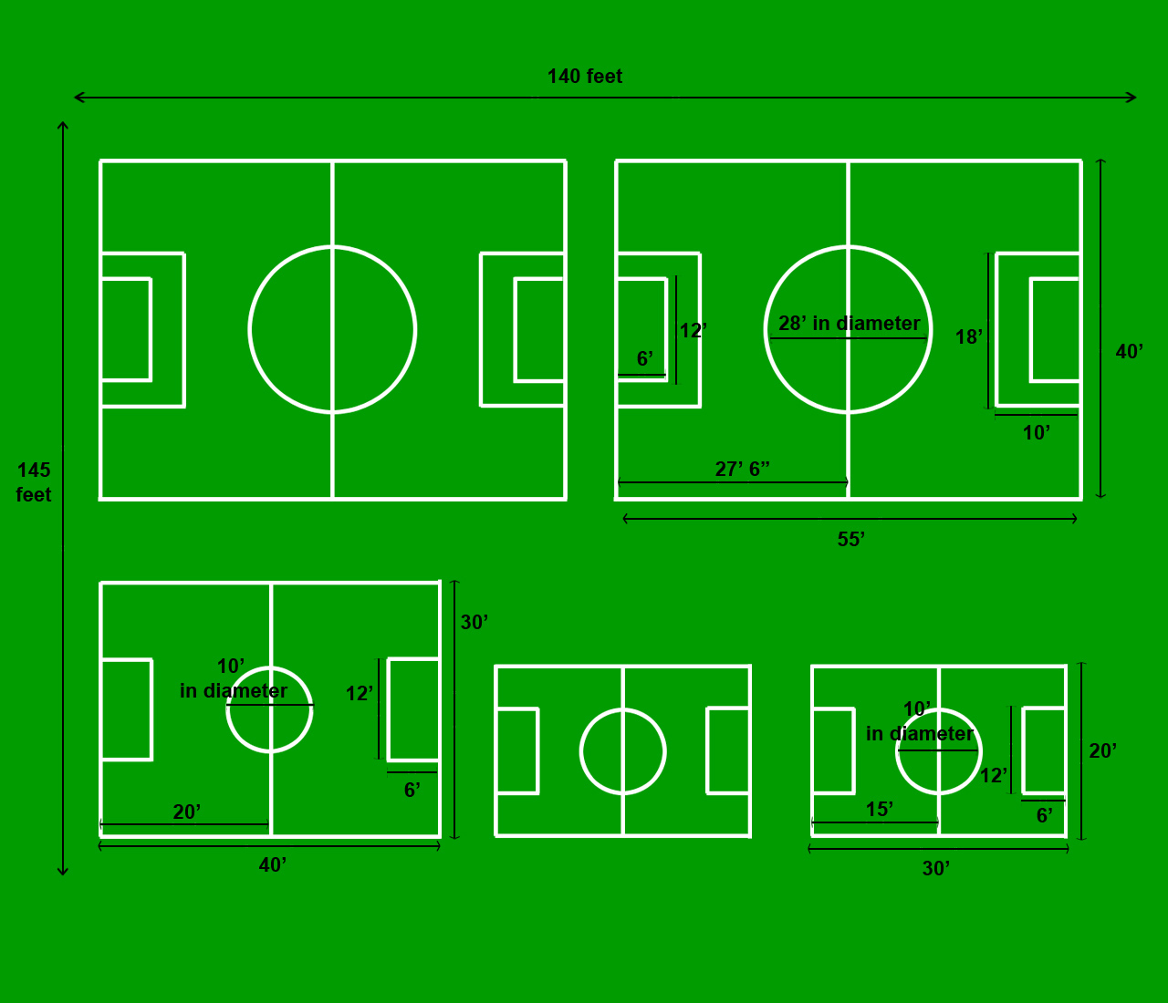
C
E
E
D
C
Typical soccer field layout at Minneola Athletic Complex can consist of a combination of four to five fields depending on size and position.

Figure C

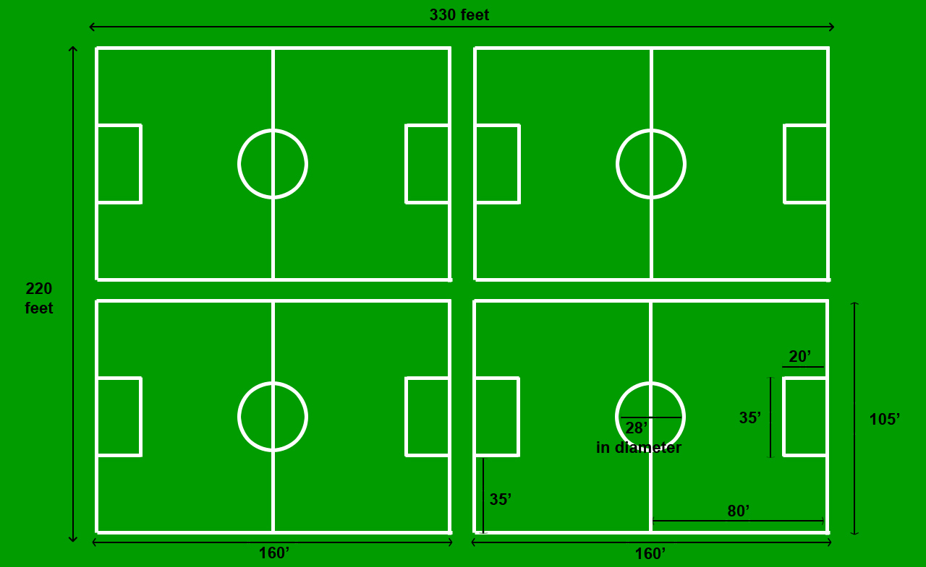
B
B

B

B
B

B

Football Field: Typical field dimension. All white lines, hashmarks, numbers and or arrows are to be painted for the outline and marks of the field. County staff will instruct which aspects of the field to paint per reservation. 1 yard = 3 feet. Painted line marks will be 4” in width (typical).

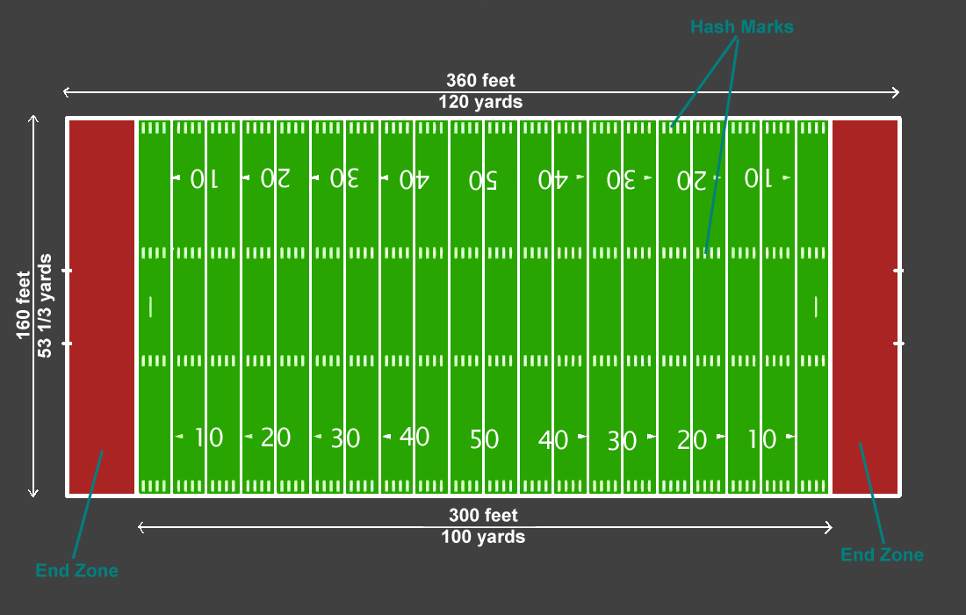
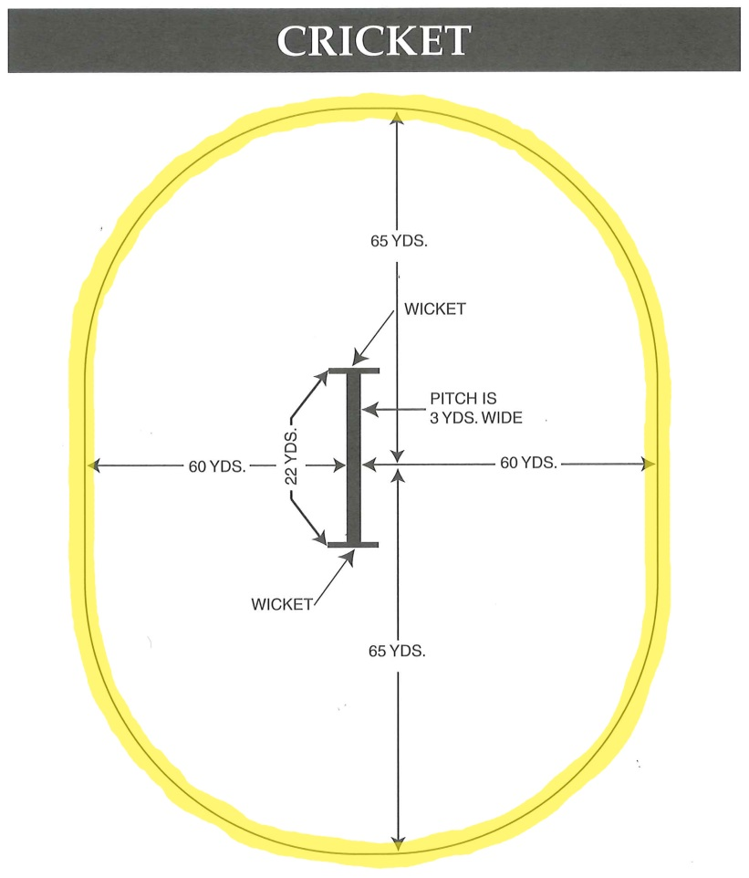
Cricket field: Field lines to be painted are on the Pitch which are highlighted in yellow and around field of play. Please see diagram below. Oval lines may be painted every 30 yards or 60 yards depending on play. Painted lines will be 4” in width (typical).

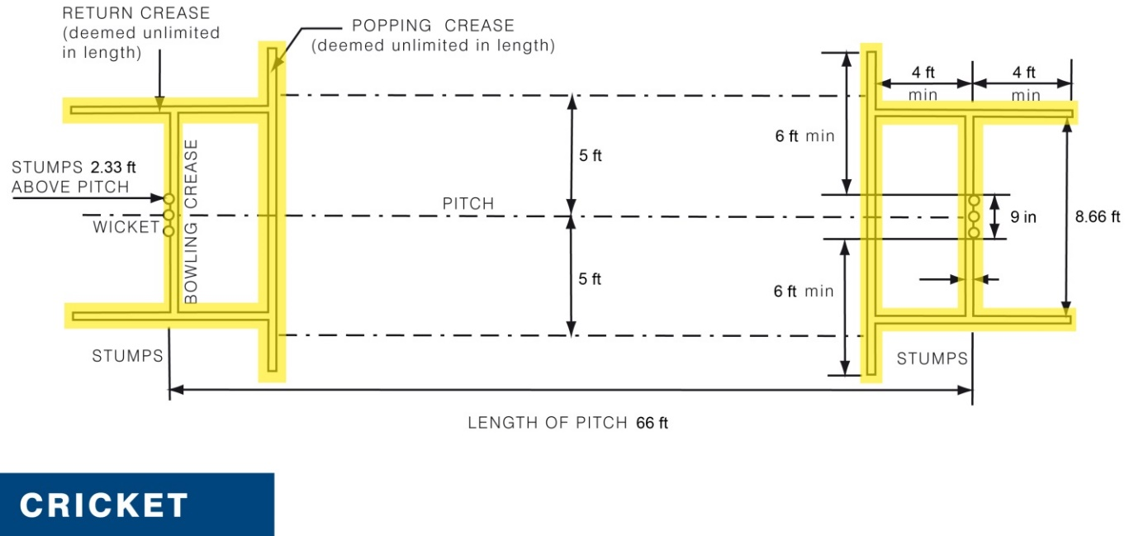

Softball field: Typical dimenisions for softball at 60 foot bases. Areas to be painted are highlighted in yellow. Same applies for any variation in base length. Painted lines will be 4” in width (typical).
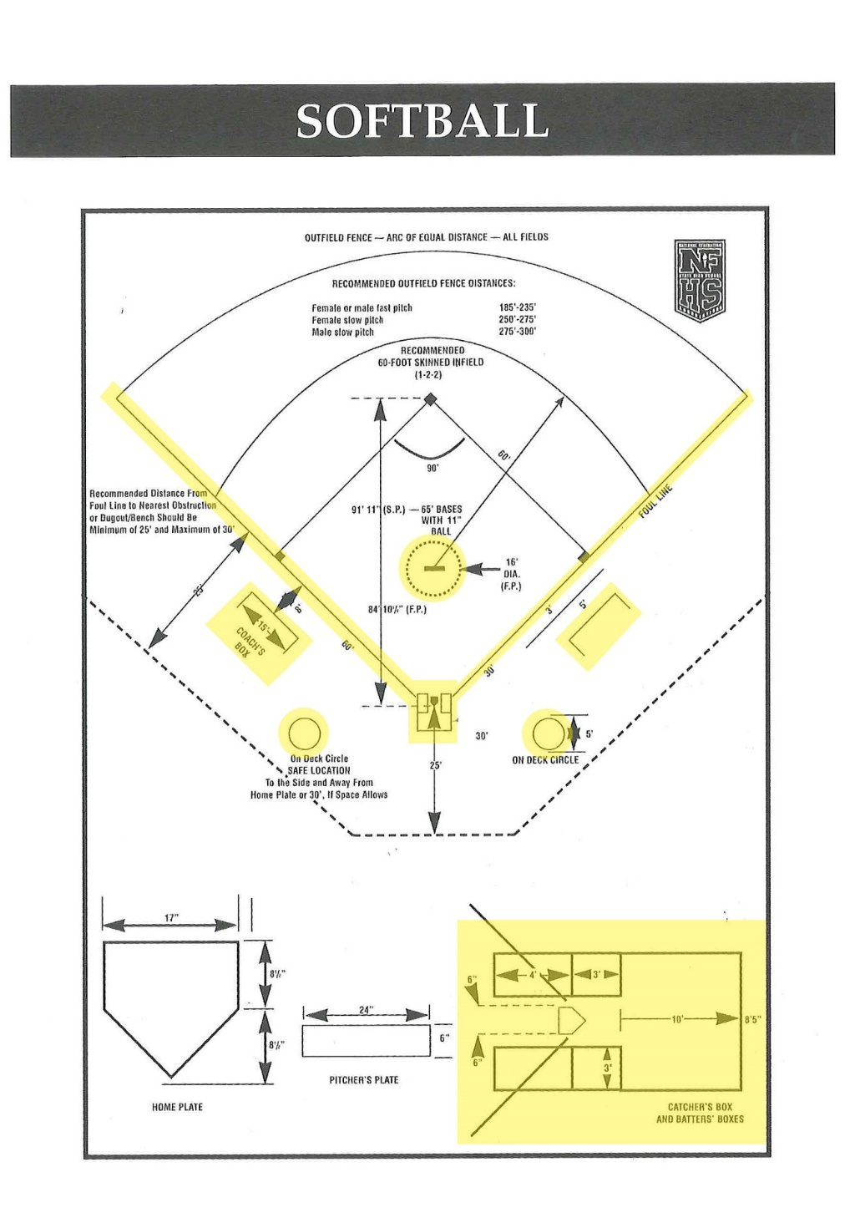

Baseball field: Typical dimenisions for softball at 60 foot bases. Areas to be chalked and painted are highlighted in yellow. Same applies for any variation in base length. Painted lines will be 4” in width (typical).
