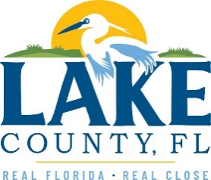
Office of Procurement Services
P.O. Box 7800 • 315 W. Main St., Suite 416 • Tavares, FL 32778
SOLICTATION: Paving and Striping Services 03/16/2026

Vendors are responsible for the receiving and acknowledging all solicitation addenda. An electronically signed copy of each addendum must be submitted along with the solicitation response. Failure to acknowledge any addendum may result in the submission being disqualified from award consideration.
THIS ADDENDUM DOES NOT ALTER THE PROPOSAL SUBMISSION DEADLINE.
QUESTIONS/RESPONSES
- What will the effective date of the contract be?
The contract start date will be after Board approval.
- On the bottom of the pricing form, percentages are required for three items, fuel, wages, and materials only. This cannot equal 100% without the equipment added somewhere. Please advise.
- Lake County is not paying for equipment. Rather, we are paying for the materials, wages, and fuel to perform the service. We will not adjust pricing for cost of equipment.

ACKNOWLEDGEMENT

Firm Name: Click or tap here to enter text.
I hereby certify that my electronic signature has the same legal effect as if made under oath; that I am an authorized representative of this vendor and/or empowered to execute this submittal on behalf of the vendor.
Signature of Legal Representative Submitting this Bid: Click or tap here to enter text.
Date: Click or tap to enter a date.
Print Name: Click or tap here to enter text.
Title: Click or tap here to enter text.
Primary E-mail Address: Click or tap here to enter text.
Secondary E-mail Address: Click or tap here to enter text.

