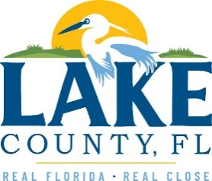
Office of Procurement Services
P.O. Box 7800 • 315 W. Main St., Suite 416 • Tavares, FL 32778
SOLICTATION: On-Call Emergency Building Restoration Services 10/29/2025

Vendors are responsible for the receiving and acknowledging all solicitation addenda. An electronically signed copy of each addendum must be submitted along with the solicitation response. Failure to acknowledge any addendum may result in the submission being disqualified from award consideration.
THIS ADDENDUM DOES NOT CHANGE THE PROPOSAL SUBMISSION DEADLINE

QUESTIONS/RESPONSES
- Exhibit A of the solicitation includes section 2.5 titled “Mold Prevention and Remediation,” describing inspection, containment, removal, disposal, and antimicrobial treatment of mold-impacted materials. However, Addendum No. 1 states that “mold remediation is not part of this Scope of Work,” and references that pre-mitigation mold assessment and protocol development are not included. Can you please provide clarification?
Response: The mold assessment is hereby removed from the Scope of Work. The mold remediation shall remain as part of the Scope of Work. The mold remediator will be responsible for the clean-up portion.

ACKNOWLEDGEMENT

Firm Name: Click or tap here to enter text.
I hereby certify that my electronic signature has the same legal effect as if made under oath; that I am an authorized representative of this vendor and/or empowered to execute this submittal on behalf of the vendor.
Signature of Legal Representative Submitting this Bid: Click or tap here to enter text.
Date: Click or tap to enter a date.
Print Name: Click or tap here to enter text.
Title: Click or tap here to enter text.
Primary E-mail Address: Click or tap here to enter text.
Secondary E-mail Address: Click or tap here to enter text.

