

**Office of Procurement Services**

P.O. Box 7800 • 315 W. Main St., Suite 416 • Tavares, FL 32778

**SOLICTATION:** JUDICIAL CENTER 2ND AND 3RD FLOOR SECURITY UPGRADES 07/09/2025

Vendors are responsible for the receipt and acknowledgement of all solicitation addenda. Submit an electronically signed copy with solicitation submission. Failure to acknowledge an addendum may prevent the submission from being considered for award.

**THIS ADDENDUM CHANGES THE DATE FOR RECEIPT OF PROPOSALS TO**

**JULY 30, 2025 @ 3:00 PM (EST).**

**QUESTIONS/RESPONSES**

1. Other than a reference to RBH in the schedule/symbol there are no other specifications for the access control. I would like clarification that the access control devices are to be RBH Access AXIOM V and be fully integrated to the existing access control system using the existing software and network.

**Response:** Yes

1. Please confirm the room for all RBH equipment for access control is to be located in the existing Court Services Court Technology room on the second floor.

**Response:** It is the Court Technology room 2-314.

1. During the walk through there was discussion about additional doors that are to be access controlled however those doors are not indicated to be in the door schedule and the RBH markings noted.

**Response:** All doors noted here, the graph and the additional one located in the following partial proposed floor plan drawing are to have RBH added.

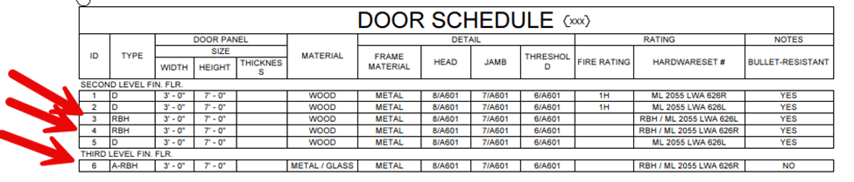

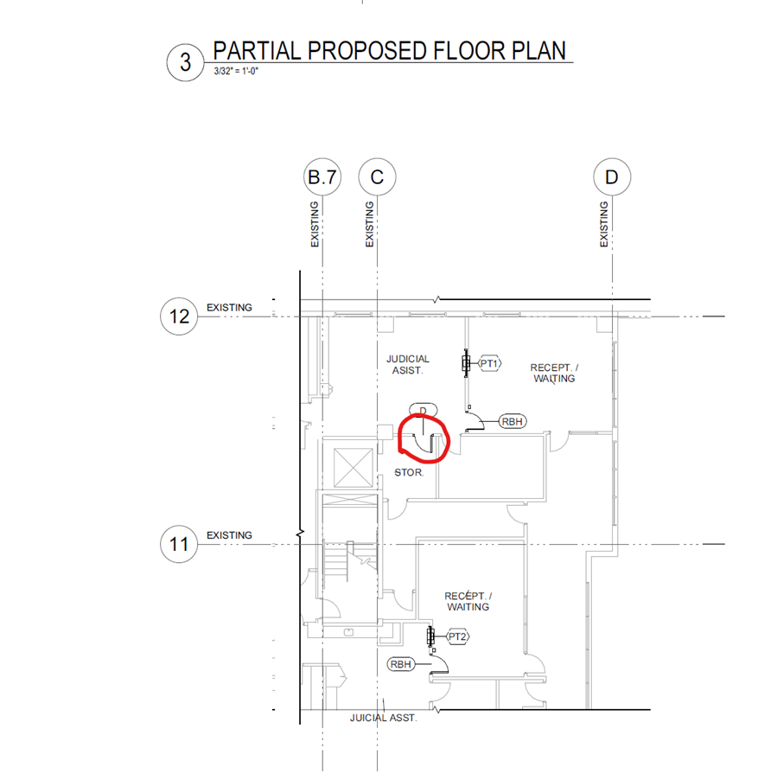

1. I did not see any electrified hardware scheduled for these doors to confirm if door position switch, request to exit devices, strikes, and electrified hinges are specified correctly. I additionally wanted to note that door hardware, including electrified hardware, are provided by the door hardware people, which should include the matching power supplies for the locks.

**Response:** The position switch, request to exit buttons at the JA’s desks, and any other hardware needed to match the operation of existing entry doors on the East Wing needs to be included.

1. Please confirm if all work can be completed during normal business hours. If not permitted, what hours will be acceptable at the facility?

**Response:** Work may be performed during regular business hours (M-F 8am – 5pm); however, any loud activities or tasks that may disrupt operations must be scheduled after hours, including nights or weekends.

1. Please confirm if the D1 & D2 doors per blow up 4 & 5 on A-102 need to have RBH access controls.

**Response:** Every door on this project is getting RBH access

1. Please confirm if permit fees can be excluded from our bid and the County will reimburse us at cost.

**Response:** Bidders shall include permit fees in the overall bid price.

1. Please provide information on the background checks and security badging requirements for workers.

**Response:** See Exhibit H – Contractor – Security Procedures, which has been added to the bid documents

1. Do any of the openings require panic device hardware?

**Response:** No

1. Please provide glass specifications for door ID 6 on the 3rd Floor

**Response:** Glass will need to be fully tempered.

1. Door ID 6 on the 3rd floor states it is metal/glass but does not specify if it is to be hollow metal or aluminum storefront. Please advise.

**Response:** Hollow metal.

1. Please confirm if the wallpaper at the walls affected is meant to remain.

**Response:** Remove wallpaper on affected walls, refinish wall, and repaint corner to corner. See Exhibit I – Paint Specifications, which has been added to the bid documents

1. It does not appear that the thickness or bullet resistance level (1-8) for the paneling is shown. Please advise.

**Response:** Level 3

1. Please confirm that all RBH wiring shall route to the 2nd Floor IT Room 244.

**Response:** Correct room is 2-314

1. Please advise what keyway is required for the permanent cylinders for the new doors.

**Response:** The contractor should include the locksets in their bid. Lake County will provide permanent cylinders. The hardware info is Corbin Russwin Mortise ML2051 LWA 626 finish locksets and Yale 5220 26D ZG Keyway 7 pin High Security LFIC cores zero bitted.

1. Please provide specifications for the bullet resistant doors. What Level Resistance (1-8) is required? Are the doors required to be factory pre-finished?

**Response:** Yes, on the pre-finish, The ballistic protection is Level 3.

1. Will the contractor be provided space for a dumpster and storage unit within the adjacent gated parking area for the duration of the project?

**Response:** Yes

1. Note in Exhibit F – Project Drawings, A-102 states that the Bullet Resistant Paneling shall be installed from the floor to the sill height of the pass thru window (3’-6” per window schedule). Please confirm this is accurate. Or is the intent for the paneling to go from floor to ceiling?

**Response:** Bullet resistant paneling should go from floor to ceiling.

1. Per the data sheets for the TSS NVR transaction window, the finish of the window frame is available in clear, dark bronze or custom paint/anodizing. Please advise which is required.

**Response:** The goal would be to match the existing windows on the 5th floor.

1. Per the data sheets for the TSS NVR transaction window, there is an option for black plastic laminate or stainless-steel counter. Please advise which is required.

**Response:** The goal would be to match the existing counters on the 5th floor.

**Additional Information**

Exhibit H – Contractor – Security Procedures is hereby added to the solicitation documents

Exhibit I – Painting Specifications is hereby added to the solicitation documents

**ACKNOWLEDGEMENT**

Firm Name: Click or tap here to enter text.

I hereby certify that my electronic signature has the same legal effect as if made under oath; that I am an authorized representative of this vendor and/or empowered to execute this submittal on behalf of the vendor.

Signature of Legal Representative Submitting this Bid: Click or tap here to enter text.

Date: Click or tap to enter a date.

Print Name: Click or tap here to enter text.

Title: Click or tap here to enter text.

Primary E-mail Address: Click or tap here to enter text.

Secondary E-mail Address: Click or tap here to enter text.