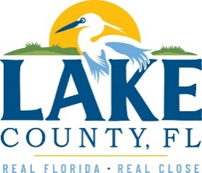

**Office of Procurement Services**

P.O. Box 7800 • 315 W. Main St., Suite 416 • Tavares, FL 32778

**SOLICTATION:** Analytical Laboratory Services 03/10/2025

Vendors are responsible for the receipt and acknowledgement of all solicitation addenda. Submit an electronically signed copy with solicitation submission. Failure to acknowledge an addendum may prevent the submission from being considered for award.

**THIS ADDENDUM CHANGES THE DATE FOR RECEIPT OF PROPOSALS TO THURSDAY, MARCH 20, 2025 @ 3:00PM (EST)**

**QUESTIONS/RESPONSES**

Q1. Who is the incumbent and how long have they had this contract?

**A: See No.1 Addendum.**

Q2. Can you provide current/past pricing

**A: See No.1 Addendum.**

Q3. What was the annual expenditure of this contract over last 3 years?

**A: See No.1 Addendum.**

Q4. Attachment 4 – looks like for a consultant, not a laboratory, can you confirm this?

**A: This solicitation is for laboratory services.**

Q5. Landfill sampling of 100 wells is semiannual- what months do you usually sample these?

**A: April/May and October/November.**

Q6. Are there dedicated pumps on these wells?

**A: Yes, county staff collects the samples. No sampling services are needed.**

Q7. Do you need a 4-wheel drive (4WD) vehicle to service the wells?

**A: No. County staff collects the samples. No sampling services are needed.**

**ACKNOWLEDGEMENT**

Firm Name: Click or tap here to enter text.

I hereby certify that my electronic signature has the same legal effect as if made under oath; that I am an authorized representative of this vendor and/or empowered to execute this submittal on behalf of the vendor.

Signature of Legal Representative Submitting this Bid: Click or tap here to enter text.

Date: Click or tap to enter a date.

Print Name: Click or tap here to enter text.

Title: Click or tap here to enter text.

Primary E-mail Address: Click or tap here to enter text.

Secondary E-mail Address: Click or tap here to enter text.