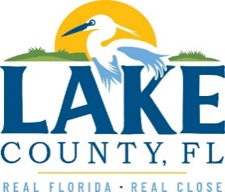

**Office of Procurement Services**

P.O. Box 7800 • 315 W. Main St., Suite 416 • Tavares, FL 32778

**SOLICTATION:** Demolition Services – 31587 4TH Street Sorrento, FL 04/02/2025

Vendors are responsible for the receipt and acknowledgement of all solicitation addenda. Submit an electronically signed copy with solicitation submission. Failure to acknowledge an addendum may prevent the submission from being considered for award.

THIS ADDENDUM DOES NOT CHANGE THE DATE FOR RECEIPT OF PROPOSALS.

**INFORMATION**

Due to an error in the bid documents, a third mandatory pre-bid meeting has been added for Thursday April 3, 2025.

Vendors shall attend one of the three Scheduled Mandatory Pre-Bid Conferences:

- Wednesday, March 26, 2025, at 2:00 p.m. sharp OR

- Thursday, April 02, 2025, at 10:00 a.m. sharp OR

- Thursday, April 03, 2025, at 10:00 a.m. sharp

**ACKNOWLEDGEMENT**

Firm Name: Click or tap here to enter text.

I hereby certify that my electronic signature has the same legal effect as if made under oath; that I am an authorized representative of this vendor and/or empowered to execute this submittal on behalf of the vendor.

Signature of Legal Representative Submitting this Bid: Click or tap here to enter text.

Date: Click or tap to enter a date.

Print Name: Click or tap here to enter text.

Title: Click or tap here to enter text.

Primary E-mail Address: Click or tap here to enter text.

Secondary E-mail Address: Click or tap here to enter text.