
Office of Procurement Services
P.O. Box 7800 • 315 W. Main St., Suite 416 • Tavares, FL 32778
SOLICTATION: Transportation and Engineering Services, On-Call 09/22/2025

Vendors are responsible for the receipt and acknowledgement of all solicitation addenda. Submit an electronically signed copy with solicitation submission. Failure to acknowledge an addendum may prevent the submission from being considered for award.
THIS ADDENDUM DOES NOT CHANGE THE DATE FOR RECEIPT OF PROPOSALS.
QUESTIONS/RESPONSES
Q3. We noticed the On Call Contract was advertised with a letter submittal date of 10/7/25, is there a proposed shortlisting/presentation date identified?
See Bid Document Section 7 – Procurement Schedule Estimate
Q4. I am trying to complete the Team Composition Form, but I have more personnel that I would like to add to the "Consultant" team than lines that are provided. Since this document is locked, is it possible to get an unlocked version that I can add/delete lines as necessary, or can you please add 7 more rows to the "Consultant" table?
A. The Team Composition form is a standardized form and cannot be altered. However, more than one form can be completed and submitted with the bid proposal.
Q5. May we please have a sample contract to review?
A. Refer to Addendum No. 1, Q2. There is no sample contract available or attached to this solicitation.
Q6. On page 2 of the RSQ package, section 2.0 Exhibits – Exhibit C, the County has updated the indemnification language to include a clause that states the Consultant will indemnify the County for defects in design, or errors or omissions that result in material cost increases to the County. The limitation of liability within statute 725.08 does not include this requirement and therefore makes this indemnification noncompliant with the Florida Statue 725.08. Would the County please make all indemnification requirements within this RSQ compliant with the Florida Statute 725.08? We suggest the following language which is directly from the Florida Statute 725.08 Design Professional Contracts; limitation in indemnification. “The design professional shall indemnify and hold harmless the agency, and its officers and employees, from liabilities, damages, losses, and costs, including, but not limited to, reasonable attorneys’ fees, to the extent caused by the negligence, recklessness, or intentionally wrongful conduct of the design professional and other persons employed or utilized by the design professional in the performance of the contract.”
A. The County acknowledges the indemnification language in Section 2.0, Exhibit C. As Florida Statute 725.08 applies to design professional contracts and Florida Statute 768.28 governs sovereign immunity for governmental entities, the indemnification provisions in this RSQ will remain as stated in the bid documents.
Q7. Would the County please remove the "Warranty" and "Deficiencies in Work to be Corrected by the Contractor" provisions on page 5 of Exhibit C? We believe those sections are not applicable to the services provided by design professionals. Design professionals providing professional services, unlike contractors who provide materials and goods, cannot warrant or guarantee their services as part of a contract, other than to warrant that the services will be conducted per the professional standard of care.
A. No. This is a standard contract provision and does not impose obligations beyond those required by applicable professional standards.
Q8. Would the County please remove the "Safety", “Clean-Up”, and “Protection of Property” provisions on pages 7 and 8 of Exhibit C? We believe those sections are not applicable to the services provided by design professionals. Design professionals providing professional services, unlike contractors who provide materials and goods and services on the project site, cannot be responsible for their safety, means, methods, and or site conditions.
A. No. This is a standard contract provision and does not impose obligations beyond those required by applicable professional standards.
Q9. Will resumes of only key staff fulfill the requirement listed under 8.5.2 "Subcontract/Joint Ventures" where the bullet states "Resumes or information about the proposed individuals may be attached." And may we place these in an appendix?
A. Refer to Addendum No. 1 – Additional Information. See Section 9.5 of the bid document.
Q10. Will copies of licenses or permits of only key staff fulfill the requirement listed under 8.5.2 "Subcontract/Joint Ventures" where the bullet states "Include copies of any required licenses or permits." And may we place these in an appendix?
A. Refer to Section 9.5 of the bid document. Licenses and permits shall be limited to the personnel listed on Attachment 2 – Team Composition and may be attached to the completed form.
Q11. May the forms listed under 8.5.3 "Forms" be placed in an appendix?
A. Refer to Addendum No. 1 – Additional Information. Refer to Section 9.5 of the bid document.
Q12. Being that we are proposing as a Prime for this on-call, and we are proposing to use a subconsultant(s), what information is required of the subconsultant within the body of the RSQ? Do they need to fill out any forms or present any licenses or permits for their business and individual staff?
A. Refer to Addendum No. 1 – Additional Information. Refer to Section 9.5 of the bid document.
Q13. Is there a page size requirement for the org chart? Can we use a 11x17?
A. No. 8x11 is preferred.
Q14. Is there a page number limit to the proposal?
A. Refer to bid document, Section 8 – Method of Award.
Q15. Do the example projects need to be completed, or can they be ongoing?
A. There are no example projects. Refer to the bid documents.
Q16. Is there a time frame limit for project examples?
A. Refer to Q15.
Q17. Does the proposing team as a whole need to demonstrate coverage of all Technical Requirements listed in Section 6 of the Solicitation, or is it acceptable for the prime proposer to specialize in certain categories while subcontractors provide the remaining expertise?
A. That is acceptable. However, the Prime Consultant at a minimum shall provide one professional engineer, registered with the Florida State Board of Professional Engineers.
Q18. Will the digital signature of the individual authorized to bind the firm be accepted?
A. Signatures will be accepted as identified in Attachment 1 – Submittal, Section 12.0
Q19. What type of contract will this be? T&M, FFP, or CPFF?
A. Refer to Attachment 1 – Submittal Section 1.0, Term of Contract.
Q20. In 9.0 Delivery and Submittal Requirements, 9.4 says:
Submission constitutes a binding offer to the County and acceptance of all terms and conditions specified in this Solicitation. Do not alter the content or format of any form without the County’s permission. Ensure all information is legible.
In Attachment 6 - Conflict of Interest the year 2004 is already entered where one would execute the form:

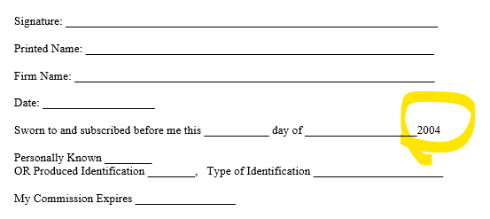
and in Attachment 9 - Byrd Anti-Lobbying Certification the year 2021 is already entered where one would execute this form:

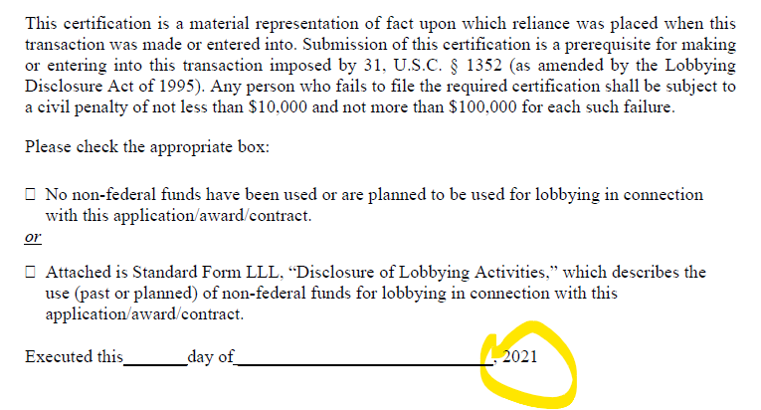

Will the County please advise if these forms may be altered or if these forms will be replaced?
A. Refer to the revised documents.

ADDITIONAL INFORMATION
Attachment 6 – Conflict of Interest has been revised.
Attachment 9 – Byrd Anti-Lobbying Certification has been revised.

ACKNOWLEDGEMENT

Firm Name: Click or tap here to enter text.
I hereby certify that my electronic signature has the same legal effect as if made under oath; that I am an authorized representative of this vendor and/or empowered to execute this submittal on behalf of the vendor.
Signature of Legal Representative Submitting this Bid: Click or tap here to enter text.
Date: Click or tap to enter a date.
Print Name: Click or tap here to enter text.
Title: Click or tap here to enter text.
Primary E-mail Address: Click or tap here to enter text.
Secondary E-mail Address: Click or tap here to enter text.

