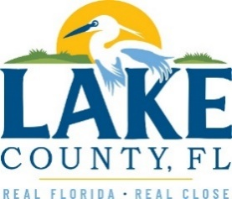
Office of Procurement Services
P.O. Box 7800 • 315 W. Main St., Suite 416 • Tavares, FL 32778
SOLICTATION: Environmental Studies and Assessments 10/14/25

Vendors are responsible for the receipt and acknowledgement of all solicitation addenda. Submit an electronically signed copy with solicitation submission. Failure to acknowledge an addendum may prevent the submission from being considered for award.
THIS ADDENDUM DOES NOT CHANGE THE DATE FOR RECEIPT OF PROPOSALS.
QUESTIONS/RESPONSES
Q16. In reference to the RSQ section 10.5.2, it mentions “Subcontractors with a County contract…”. Can you provide a list of contractors with a Lake County contract?
A. Refer to Q7 for information on how to view current contractors.
Q17. In the scope of services, 4.1.1.2, can you clarify what permits and licenses are required, as it is not included in ASTM E1527-21 Standards?
A. Section 4.1.1.2. is in reference to 40 CFR 312.10.

ADDITIONAL INFORMATION
N/A

ACKNOWLEDGEMENT

Firm Name: Click or tap here to enter text.
I hereby certify that my electronic signature has the same legal effect as if made under oath; that I am an authorized representative of this vendor and/or empowered to execute this submittal on behalf of the vendor.
Signature of Legal Representative Submitting this Bid: Click or tap here to enter text.
Date: Click or tap to enter a date.
Print Name: Click or tap here to enter text.
Title: Click or tap here to enter text.
Primary E-mail Address: Click or tap here to enter text.
Secondary E-mail Address: Click or tap here to enter text.

