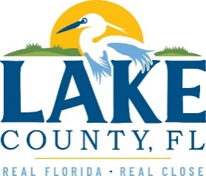

**Office of Procurement Services**

P.O. Box 7800 • 315 W. Main St., Suite 416 • Tavares, FL 32778

**SOLICTATION:** CDBG Funded Road Resurfacing 07/10/2025

Vendors are responsible for the receipt and acknowledgement of all solicitation addenda. Submit an electronically signed copy with solicitation submission. Failure to acknowledge an addendum may prevent the submission from being considered for award.

THIS ADDENDUM CHANGES THE LAST DAY OF QUESTIONS FROM 07/17/2025 TO 07/24/2025 AND THE BID OPENING DATE FROM 07/31/2025 AT 3:00 PM TO 08/07/2025 AT 3:00 PM.

An additional Mandatory Prebid meeting is scheduled for **07/22/2025 at 9:00 am** due to a systems glitch. Vendors that attended the previous Prebid meetings are noted and are not required to attend.

**ADDITIONAL INFORMATION**

Solicitation extended and an additional Prebid meeting to be held due to a systems glitch shown below.

**ACKNOWLEDGEMENT**

Firm Name: Click or tap here to enter text.

I hereby certify that my electronic signature has the same legal effect as if made under oath; that I am an authorized representative of this vendor and/or empowered to execute this submittal on behalf of the vendor.

Signature of Legal Representative Submitting this Bid: Click or tap here to enter text.

Date: Click or tap to enter a date.

Print Name: Click or tap here to enter text.

Title: Click or tap here to enter text.

Primary E-mail Address: Click or tap here to enter text.

Secondary E-mail Address: Click or tap here to enter text.