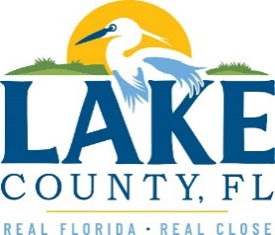

**Office of Procurement Services**

P.O. Box 7800 • 315 W. Main St., Suite 416 • Tavares, FL 32778

**SOLICTATION:** Right of Way Consultant Services 05/19/2025

Vendors are responsible for the receipt and acknowledgement of all solicitation addenda. Submit an electronically signed copy with solicitation submission. Failure to acknowledge an addendum may prevent the submission from being considered for award.

**This Addendum No.1 CANCELS solicitation 25-736 and replaces it with 25-748.**