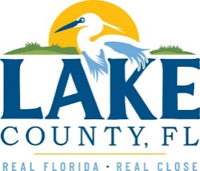

**Office of Procurement Services**

P.O. Box 7800 • 315 W. Main St., Suite 416 • Tavares, FL 32778

**SOLICTATION:** Grant Writing & Administrative Services 12/16/2024

Vendors are responsible for the receipt and acknowledgement of all solicitation addenda. Submit an electronically signed copy with solicitation submission. Failure to acknowledge an addendum may prevent the submission from being considered for award.

THIS ADDENDUM DOES NOT CHANGE THE DATE FOR RECEIPT OF PROPOSALS.

**QUESTIONS/RESPONSES**

1. Attachment 9 – Public Entity Crimes Statement Form 25-518 appears to be missing pages and does not contain a signature or notary block to be completed. Is there another form that they County can provide to potential respondents?
2. See attached Attachment 9 – Public Entity Crimes Statement Form 25-518 REVISED.

**ADDITIONAL INFORMATION**

REMINDER: Vendors are to include a signed copy of ALL addendums with their proposals.

**ACKNOWLEDGEMENT**

Firm Name: Click or tap here to enter text.

I hereby certify that my electronic signature has the same legal effect as if made under oath; that I am an authorized representative of this vendor and/or empowered to execute this submittal on behalf of the vendor.

Signature of Legal Representative Submitting this Bid: Click or tap here to enter text.

Date: Click or tap to enter a date.

Print Name: Click or tap here to enter text.

Title: Click or tap here to enter text.

Primary E-mail Address: Click or tap here to enter text.

Secondary E-mail Address: Click or tap here to enter text.