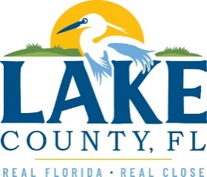

**Office of Procurement Services**

P.O. Box 7800 • 315 W. Main St., Suite 416 • Tavares, FL 32778

**SOLICTATION:** Unpaved Trail Maintenance for LCWA 07/09/2025

Vendors are responsible for the receipt and acknowledgement of all solicitation addenda. Submit an electronically signed copy with solicitation submission. Failure to acknowledge an addendum may prevent the submission from being considered for award.

THIS ADDENDUM DOES NOT CHANGE THE DATE FOR RECEIPT OF PROPOSALS.

**QUESTIONS/RESPONSES**

1. Does removing trash and supply trash bags include onsite trash cans? If so, approximately how many and what size?
2. To be sure all trash containers are accounted for, and as mentioned in Section 5.1 of the ITB, vendors are advised to visit the site of the proposed work and become familiar with conditions affecting the work to be done or the equipment, materials, and labor required.

Q5. The Sable Bluff Preserve measurements for the perimeter fire line seem incorrect. Can you verify that it is only 237’?

1. Please review the map detail which shows the perimeter fire line is 2,371 feet.

**ACKNOWLEDGEMENT**

Firm Name: Click or tap here to enter text.

I hereby certify that my electronic signature has the same legal effect as if made under oath; that I am an authorized representative of this vendor and/or empowered to execute this submittal on behalf of the vendor.

Signature of Legal Representative Submitting this Bid: Click or tap here to enter text.

Date: Click or tap to enter a date.

Print Name: Click or tap here to enter text.

Title: Click or tap here to enter text.

Primary E-mail Address: Click or tap here to enter text.

Secondary E-mail Address: Click or tap here to enter text.