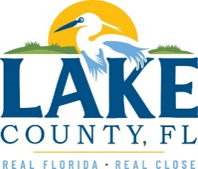

**Office of Procurement Services**

P.O. Box 7800 • 315 W. Main St., Suite 416 • Tavares, FL 32778

**SOLICTATION:** Unpaved Trail Maintenance for LCWA 06/18/2025

Vendors are responsible for the receipt and acknowledgement of all solicitation addenda. Submit an electronically signed copy with solicitation submission. Failure to acknowledge an addendum may prevent the submission from being considered for award.

THIS ADDENDUM DOES NOT CHANGE THE DATE FOR RECEIPT OF PROPOSALS.

**QUESTIONS/RESPONSES**

1. Does the Scrub Point Reserve location require a bush hog? When we went to see the site we noticed that what was being used.
2. Any current use of the brush hog is out of necessity and is not preferential. The intent of this bid is to facilitate some form of finish mowing instead of the rough cutting staff have conceded to perform.
3. Can you please provide an exact address for Treasure Island, or more detail, so we can find the exact location?
   1. Treasure Island Preserve is not a traditionally open preserve that has an address similar to the others in this solicitation. Helpful methods for finding this area could be, in DMS 28°51'36"N 81°50'01"W or in Lats & Longs 28.861618, -81.834950 or searching for ALTKEY(s): 1498601 and/or138899 on the Lake County Property Appraiser Interactive Map.

**ACKNOWLEDGEMENT**

Firm Name: Click or tap here to enter text.

I hereby certify that my electronic signature has the same legal effect as if made under oath; that I am an authorized representative of this vendor and/or empowered to execute this submittal on behalf of the vendor.

Signature of Legal Representative Submitting this Bid: Click or tap here to enter text.

Date: Click or tap to enter a date.

Print Name: Click or tap here to enter text.

Title: Click or tap here to enter text.

Primary E-mail Address: Click or tap here to enter text.

Secondary E-mail Address: Click or tap here to enter text.