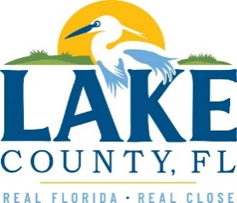

**Office of Procurement Services**

P.O. Box 7800 • 315 W. Main St., Suite 416 • Tavares, FL 32778

**SOLICTATION:** Geological and Hydrogeologic Services, On-Call for LCWA 06/25/2025

Vendors are responsible for the receipt and acknowledgement of all solicitation addenda. Submit an electronically signed copy with solicitation submission. Failure to acknowledge an addendum may prevent the submission from being considered for award.

THIS ADDENDUM DOES NOT CHANGE THE DATE FOR RECEIPT OF PROPOSALS.

**QUESTIONS/RESPONSES**

1. Why has the County issued this solicitation when awards were made in March 2025 for what appears to be the same services, under 25-409?
   1. **25-409 is for Geological and Hydrogeological Services for Lake County. 25-437 is for Geological and Hydrogeologic Services for the Lake County Water Authority.**
2. Is LCWA able to utilize the consultants who were issued contracts under Contract 25-409?
   1. **No, per Florida Statutes 287.055(2)(g), professional services, which encompasses the practice of architecture, professional engineering, landscape architecture, or surveying and mapping services, are subject to the Competitive Consultant Negotiation Act (CCNA), and are excluded from the authority to piggyback.**
3. Has LCWA received additional funding for projects or services that cannot be provided by the Contract 25-409 selected consultants?
   1. **No.**

Q4. Because the question submittal deadline is July 10th, the LCWA will consider extending the response deadline beyond July 22nd.

* 1. **No.**

**ACKNOWLEDGEMENT**

Firm Name: Click or tap here to enter text.

I hereby certify that my electronic signature has the same legal effect as if made under oath; that I am an authorized representative of this vendor and/or empowered to execute this submittal on behalf of the vendor.

Signature of Legal Representative Submitting this Bid: Click or tap here to enter text.

Date: Click or tap to enter a date.

Print Name: Click or tap here to enter text.

Title: Click or tap here to enter text.

Primary E-mail Address: Click or tap here to enter text.

Secondary E-mail Address: Click or tap here to enter text.