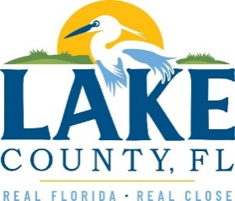

**Office of Procurement Services**

P.O. Box 7800 • 315 W. Main St., Suite 416 • Tavares, FL 32778

**SOLICTATION:** Provide and Deliver Custom Aluminum Barge and Trailer for LCWA 10/31/2024

Vendors are responsible for the receipt and acknowledgement of all solicitation addenda. Submit an electronically signed copy with solicitation submission. Failure to acknowledge an addendum may prevent the submission from being considered for award.

THIS ADDENDUM DOES NOT CHANGE THE DATE FOR RECEIPT OF PROPOSALS.

**QUESTIONS/RESPONSES**

Q3. Please let me know if these terms can be changed to a 50% down payment, 25% at completion of hull, and a final 25% within 15 days of delivery.

* 1. **Lake County Water Authority will consider 50% down payment, 25% at completion of hull, and the final 25% after acceptance, all with a 10% retainage until final acceptance, provided contractor provides and County accepts a payment/performance bond using Exhibit D – Payment and Performance Bond within 15 calendar days of contract. The Payment and Performance Bond is a guarantee the contractor completes the project according to contract terms and make payments to subcontractors and suppliers.**

**ACKNOWLEDGEMENT**

Firm Name: Click or tap here to enter text.

I hereby certify that my electronic signature has the same legal effect as if made under oath; that I am an authorized representative of this vendor and/or empowered to execute this submittal on behalf of the vendor.

Signature of Legal Representative Submitting this Bid: Click or tap here to enter text.

Date: Click or tap to enter a date.

Print Name: Click or tap here to enter text.

Title: Click or tap here to enter text.

Primary E-mail Address: Click or tap here to enter text.

Secondary E-mail Address: Click or tap here to enter text.