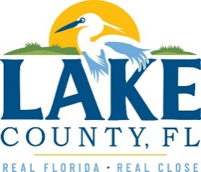

**Office of Procurement Services**

P.O. Box 7800 • 315 W. Main St., Suite 416 • Tavares, FL 32778

**SOLICTATION:** Provide and Deliver Custom Aluminum Barge and Trailer for LCWA 10/18/2024

Vendors are responsible for the receipt and acknowledgement of all solicitation addenda. Submit an electronically signed copy with solicitation submission. Failure to acknowledge an addendum may prevent the submission from being considered for award.

THIS ADDENDUM DOES NOT CHANGE THE DATE FOR RECEIPT OF PROPOSALS.

**QUESTIONS/RESPONSES**

1. We are a manufacturer and will be building this barge in our Florida facility and have insurance. Would there be any insurance requirements in additional wo what the company already has in place?
   1. **See Exhibit B. Insurance is required for any company that comes on Lake County Water Authority property.**
2. Our terms to custom build any barge is 50% down payment upon contract/order, the next 25% payment would be due upon completion of the hull, and the 25% balance is due upon completion. Since we never built a barge for your municipality before, are those terms an issue?
   1. **See Attachment 1, Section 2.0, Payment.**

**ACKNOWLEDGEMENT**

Firm Name: Click or tap here to enter text.

I hereby certify that my electronic signature has the same legal effect as if made under oath; that I am an authorized representative of this vendor and/or empowered to execute this submittal on behalf of the vendor.

Signature of Legal Representative Submitting this Bid: Click or tap here to enter text.

Date: Click or tap to enter a date.

Print Name: Click or tap here to enter text.

Title: Click or tap here to enter text.

Primary E-mail Address: Click or tap here to enter text.

Secondary E-mail Address: Click or tap here to enter text.