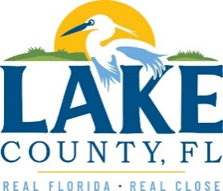

**Office of Procurement Services**

P.O. Box 7800 • 315 W. Main St., Suite 416 • Tavares, FL 32778

**SOLICTATION:** Janitorial Services for Hickory Point Recreational Complex Facilities and LCWA Preserve Locations  **1/16/2025**

**SOLICITATION 25-403, JANITORIAL SERVICES FOR HICKORY POINT RECREATIONAL COMPLEX FACILITIES AND LCWA PRESERVE LOCATIONS IS CANCELLED.**

THIS PROJECT WILL BE READVERTISED UNDER A NEW BID NUMBER WITH REVISED BID DOCUMENTS. INTERESTED VENDORS SHOULD MONITOR FOR THE UPCOMING RE-ISSUANCE OF THIS JANITORIAL SERVICES BID OPPORTUNITY.