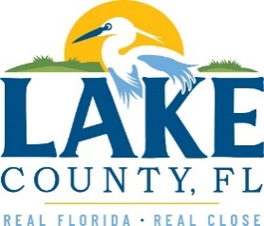

**Office of Procurement Services**

P.O. Box 7800 • 315 W. Main St., Suite 416 • Tavares, FL 32778

**SOLICTATION:** Janitorial Services for Hickory Point Recreational Complex Facilities and LCWA Preserve Locations 12/20/2024

Vendors are responsible for the receipt and acknowledgement of all solicitation addenda. Submit an electronically signed copy with solicitation submission. Failure to acknowledge an addendum may prevent the submission from being considered for award.

THIS ADDENDUM CHANGES THE DATE FOR RECEIPT OF PROPOSALS FROM 01/08/2025 TO 01/22/2025.

**CHANGES TO THE BID DOCUMENT**

1. Change ITB Closing Date: The last day for questions or requests for exceptions has now been changed from **01/08/2025** to **01/22/2025**.

**QUESTIONS/RESPONSES**

Q18.The bid submission requires three references from similar past projects. While I have not work on projects identical to this one, I have successfully handled local government contracts, including office buildings. Although I am limited in providing direct references fore similar projects, I am confident that my extensive experience and proven capabilities equipment me to deliver exceptional results for this and similar projects. Could you kindly advise if I would still be eligible to submit my bid under these circumstances?

1. See 7.0, Method of Award.

**ACKNOWLEDGEMENT**

Firm Name: Click or tap here to enter text.

I hereby certify that my electronic signature has the same legal effect as if made under oath; that I am an authorized representative of this vendor and/or empowered to execute this submittal on behalf of the vendor.

Signature of Legal Representative Submitting this Bid: Click or tap here to enter text.

Date: Click or tap to enter a date.

Print Name: Click or tap here to enter text.

Title: Click or tap here to enter text.

Primary E-mail Address: Click or tap here to enter text.

Secondary E-mail Address: Click or tap here to enter text.