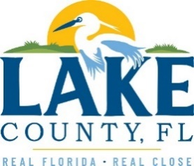

**Office of Procurement Services**

P.O. Box 7800 • 315 W. Main St., Suite 416 • Tavares, FL 32778

**SOLICTATION: HICKORY POINT RECREATION COMPLEX LANDSCAPE, BASIC PARK MAINTENANCE, AND RELATED SERVICES** 09/23/2024

Vendors are responsible for the receipt and acknowledgement of all addenda to a solicitation. Confirm acknowledgement by including an electronically completed copy of this addendum with submittal. Failure to acknowledge each addendum may prevent the submittal from being considered for award.

THIS ADDENDUM DOES NOT CHANGE THE DATE FOR RECEIPT OF PROPOSALS.

**QUESTIONS/RESPONSES**

Q1. Task 3 – Basic Park Maintenance mentions cleaning of amenities. Is this just the benches, tables, playground equipment, etc.? I want to clarify if there is or is not janitorial services for the restroom or the large screened pavilion.

R1. Under Task 3, the vendor will not be responsible for cleaning the pavilion or restroom, but they will be asked to blow the leaves off around them, and the sidewalks.

**ACKNOWLEDGMENT**

Firm Name: Click or tap here to enter text.

I hereby certify my electronic signature has the same legal effect as if made under oath; I am an authorized representative of the firm and/or empowered to execute this submittal on behalf of the firm.

Signature of Legal Representative Submitting this Bid: Click or tap here to enter text.

Date: Click or tap to enter a date.

Print Name: Click or tap here to enter text.

Title: Click or tap here to enter text.

Primary E-mail Address: Click or tap here to enter text.

Secondary E-mail Address: Click or tap here to enter text.