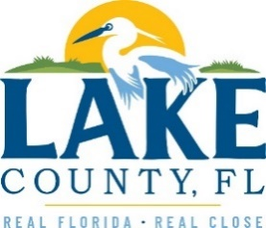

**Office of Procurement Services**

P.O. Box 7800 • 315 W. Main St., Suite 416 • Tavares, FL 32778

**SOLICTATION: Montverde Fire Station 85 Construction**  09/11/2024

Vendors are responsible for the receipt and acknowledgement of all addenda to a solicitation. Confirm acknowledgement by submitting an electronically completed copy of this addendum with submittal. Failure to acknowledge each addendum may prevent the submittal from being considered for award.

THIS ADDENDUM CHANGES THE DATE FOR RECEIPT OF PROPOSALS TO SEPTEMBER 23, 2024 @ 3:00PM (EST)

**QUESTIONS/RESPONSES**

1. Does the County want everything to be two (2) Cat 6 Data Jacks and one (1) Cat 3 Voice Jack?

**Response:** Cat 6 keystones are acceptable.

1. The legend says "Y = NOT USED" but looking at this I see a lot with numbers after the 2 for number of data jacks. Is this voice?

**Response:** Legend and symbols are clear. Half-filled triangle calls for a combine voice data jack, counts as listed in the annotations

**ACKNOWLEDGMENT**

Firm Name: Click or tap here to enter text.

I hereby certify my electronic signature has the same legal effect as if made under oath; I am an authorized representative of the firm and/or empowered to execute this submittal on behalf of the firm.

Signature of Legal Representative Submitting this Bid: Click or tap here to enter text.

Date: Click or tap to enter a date.

Print Name: Click or tap here to enter text.

Title: Click or tap here to enter text.

Primary E-mail Address: Click or tap here to enter text.

Secondary E-mail Address: Click or tap here to enter text.