

**Office of Procurement Services**

P.O. Box 7800 • 315 W. Main St., Suite 416 • Tavares, FL 32778

**SOLICTATION: Montverde Fire Station 85 Construction**  09/09/2024

Vendors are responsible for the receipt and acknowledgement of all addenda to a solicitation. Confirm acknowledgement by submitting an electronically completed copy of this addendum with submittal. Failure to acknowledge each addendum may prevent the submittal from being considered for award.

THIS ADDENDUM DOES NOT CHANGE THE DATE FOR RECEIPT OF PROPOSALS

**QUESTIONS/RESPONSES**

1. Do the technology drawings fall under electrical scope of work?

**Response:** The GC decides which division captures this scope. The owner expects technology drawings scope to be included in the bid price submitted.

1. Who is carrying the alert system and is the light controller part of the alert system. Does electrical need to provide the controller?

**Response:** The General contractor bidding the job decides under which division this task fall into. The Owner will provide the fire alarm antenna, system monitoring set up and contract for the CO inspection, all other equipment and costs associated with the installation, are to be included in the bid as scope is part of the contract documents.

1. On the signage detail on C.2, it does not show a typical room sign detail. Can you provide a detail for the typical room sign.

**Response:** All signage shown on C.2 will be provided by owner and installed by the contractor. Refer to Sign mounting location on C.2. There is no other room signage not shown on C.2.

1. Will a Project Manual be released for this project?

**Response:** Yes. See Addendum No. 1.

1. The plans state an R-38 in Spray Foam Insulation (not spec'd whether its open cell or closed cell) sprayed down upon the floor of the "attic". This is not where spray polyurethane foam insulation gets installed. It gets sprayed to the underside of the roof deck for a proper Closed Attic Assembly. Regarding this method, we only adhere to the Performance Based Method the FL Building Code which reflects an R-19 in either open or Closed Cell Foams. The costs would almost double here for this request of R-38. Please advise.

**Response:** The building was designed under the prescriptive method, per FBC. If the contractor decides to apply the performance-based method and reflect this in their bid price, he or she will be responsible for providing all necessary calculations to the county to prove compliance. If the county finds these calculations to not be compliant, the contractor is to apply the specified R-Value at their own expense.

1. The 2nd floor CMU seems to have both the Aminoplast foam injected into the block AND an R-6 in continuous spray foam. This would inform me that the chosen choice of materials here for the continuous spray foam is Closed Cell Spray Polyurethane Foam Insulation. Is this true? If so, is it throughout all the exterior CMU?

**Response:** Yes, closed cell. North and south wall of the apparatus bay (wall type 1) would not require insulation as there is no conditioned space on both adjacent sides.

1. MP-1 is shown on P3.1 Pressure Plan however it is not listed on the Plumbing Fixture Schedule. Please advise what this Fixture is. Can we please obtain the Septic Requirements and design parameters?

**Response:** The clip of sheet P3.1 does not look like the most up to date set of plumbing plans. Bidders should have the plans, dated August 26, 2024. This set has MP-1 scheduled.

1. Will Landscaping & Irrigation be required for this project? No drawings were issued for these scopes.

**Response:** Lake County will update price sheet to reflect $150,000 allowance for landscaping and irrigation.

1. Will the Hardie Siding gables require painting? If so, what color?

**Response:** Yes, the color will be selected by the owner.

1. Will the exterior stonework require water proofing?

**Response:** Refer to detail 3/6.4.

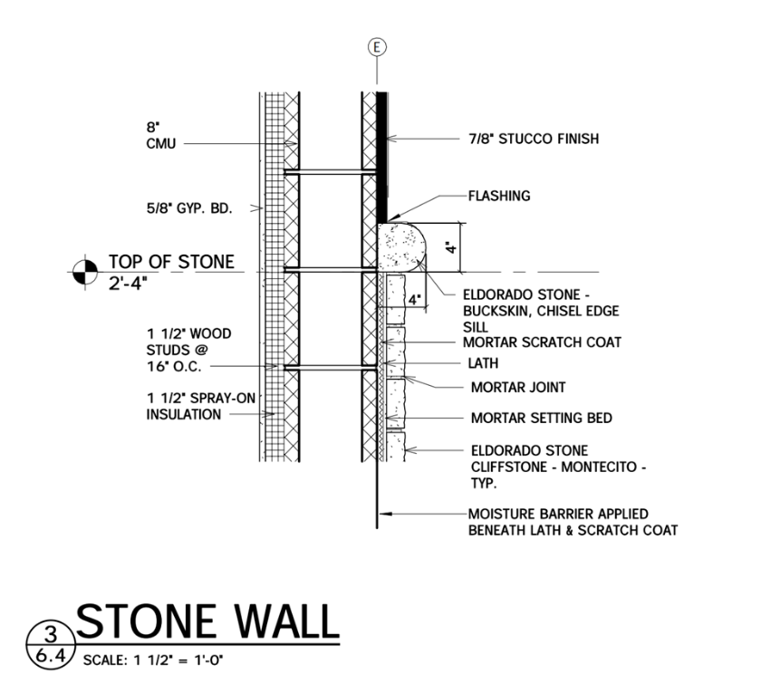

1. Will the staircase and/or handrails require painting?

**Respond:** Yes, for the handrails use same as door frames: COLORWHEEL CL3257N - 4/L33 "ECLIPSE' - SEMI-GLOSS FINISH Johnsonite 3.5’ Heavy Duty Square Nosed Vinyl Stair Tread – Color –– Moon Rock 7”x4’ Vinyl Riser – Color – Moon Rock.

1. Please confirm which supersedes, the plan finish schedule or the spec package. They are contradicting each other.

**Response:** Specs supersede. Omit finishes crossed out below.

**ADDITIONAL INFORMATION**

1. E4.1 – Electrical One-Line Diagram: CF1 description shall be changed to: “Adora 52” Outdoor ceiling fan, 52” diameter, 3 blade, stainless steel, midnight black housing, wet location listed. CF1 part number shall be changed to: Oxygen Lighting / 3-110-15.
2. E4.1 – Electrical One-Line Diagram: Panel L2, circuit breaker 48/50 for CU-2 shall be changed from 40-amps to 45-amps.
3. E4.1 – Electrical One-Line Diagram: One-Line Diagram, remove neutral and ground bonding shown at generator docking station and ATS-1. Move neutral and ground bonding and associated note from MDP to CB-MDP
4. Attachment 2 – Pricing Sheet has been removed and replaced with Attachment 2 – Pricing Sheet v.09.09.2024 to reflect a $150,000 allowance for landscaping and irrigation.

**ACKNOWLEDGMENT**

Firm Name: Click or tap here to enter text.

I hereby certify my electronic signature has the same legal effect as if made under oath; I am an authorized representative of the firm and/or empowered to execute this submittal on behalf of the firm.

Signature of Legal Representative Submitting this Bid: Click or tap here to enter text.

Date: Click or tap to enter a date.

Print Name: Click or tap here to enter text.

Title: Click or tap here to enter text.

Primary E-mail Address: Click or tap here to enter text.

Secondary E-mail Address: Click or tap here to enter text.