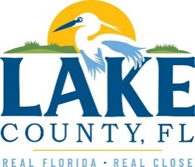
Office of Procurement Services
P.O. Box 7800 • 315 W. Main St., Suite 416 • Tavares, FL 32778
SOLICTATION: Vegetative Debris Grinding Services 04/11/2024.

Vendors are responsible for the receipt and acknowledgement of all addenda to a solicitation. Confirm acknowledgement by including an electronically completed copy of this addendum with submittal. Failure to acknowledge each addendum may prevent the submittal from being considered for award.
THIS ADDENDUM DOES NOT CHANGE THE DATE FOR RECEIPT OF PROPOSALS.
CLARIFICATION
This solicitation is only bidding the vegetative debris grinding services. There are no transportation requirements included within the scope of work for this solicitation. Grinding only occurs at the Lake County Central Solid Waste Facility in Tavares, Florida. Questions #1, #2 and #3 of Addendum No.2 shall be disregarded.

A separate contract shall exist for the transportation and disposal of vegetative debris.

ACKNOWLEDGEMENT

Firm Name: Click or tap here to enter text.
I hereby certify that my electronic signature has the same legal effect as if made under oath; that I am an authorized representative of this vendor and/or empowered to execute this submittal on behalf of the vendor.
Signature of Legal Representative Submitting this Bid: Click or tap here to enter text.
Date: Click or tap to enter a date.
Print Name: Click or tap here to enter text.
Title: Click or tap here to enter text.
Primary E-mail Address: Click or tap here to enter text.
Secondary E-mail Address: Click or tap here to enter text.

