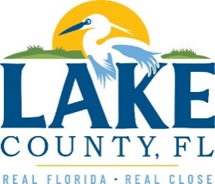
Office of Procurement Services
P.O. Box 7800 • 315 W. Main St., Suite 416 • Tavares, FL 32778
SOLICTATION: East Lake Sports & Community Complex – Phase #1 Lighting Improvements 03/25/2024

Vendors are responsible for the receipt and acknowledgement of all addenda to a solicitation. Confirm acknowledgement by including an electronically completed copy of this addendum with submittal. Failure to acknowledge each addendum may prevent the submittal from being considered for award.
THIS ADDENDUM DOES NOT CHANGE THE DATE FOR RECEIPT OF PROPOSALS

QUESTIONS/RESPONSES
- Question: I am currently working on the electrical proposal for the sports complex and on the plans, it says to provide a 100A breaker in existing panel. Are you able to tell me what brand the existing panel is?
Response: The panel manufacturer is “Square D”.

ACKNOWLEDGEMENT

Firm Name: Click or tap here to enter text.
I hereby certify that my electronic signature has the same legal effect as if made under oath; that I am an authorized representative of this vendor and/or empowered to execute this submittal on behalf of the vendor.
Signature of Legal Representative Submitting this Bid: Click or tap here to enter text.
Date: Click or tap to enter a date.
Print Name: Click or tap here to enter text.
Title: Click or tap here to enter text.
Primary E-mail Address: Click or tap here to enter text.
Secondary E-mail Address: Click or tap here to enter text.

