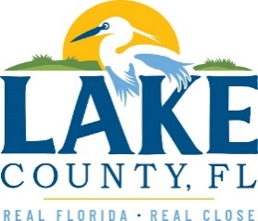
Office of Procurement Services
P.O. Box 7800 • 315 W. Main St., Suite 416 • Tavares, FL 32778
SOLICTATION: Vegetative Debris Transport & Disposal Services 04/09/2024

Vendors are responsible for the receipt and acknowledgement of all addenda to a solicitation. Confirm acknowledgement by including an electronically completed copy of this addendum with submittal. Failure to acknowledge each addendum may prevent the submittal from being considered for award.
THIS ADDENDUM DOES NOT CHANGE THE DATE FOR RECEIPT OF PROPOSALS.
QUESTIONS/RESPONSES
- Question: Is the Contractor only supplying trucking/hauling services?
Response: The contractor/hauler is also responsible for disposal of the yard waste being hauled out.
- Question: There are multiple site locations, does each site location provide a loader to load the debris into the dump trucks? Or would that responsibility be on the trucking company that is awarded project?
Response: Lake County does not supply any equipment to load the yard waste, it is the responsibility of the chosen contractor.
- Question: Does the County offer ACH payments and prompt 30 Net payments
Response: See Attachment 1, Section 2.0
ACKNOWLEDGEMENT

Firm Name: Click or tap here to enter text.
I hereby certify that my electronic signature has the same legal effect as if made under oath; that I am an authorized representative of this vendor and/or empowered to execute this submittal on behalf of the vendor.
Signature of Legal Representative Submitting this Bid: Click or tap here to enter text.
Date: Click or tap to enter a date.
Print Name: Click or tap here to enter text.
Title: Click or tap here to enter text.
Primary E-mail Address: Click or tap here to enter text.
Secondary E-mail Address: Click or tap here to enter text.

