

**Office of Procurement Services**

P.O. Box 7800 • 315 W. Main St., Suite 416 • Tavares, FL 32778

**SOLICTATION: Ferndale Preserve – Observation Tower, Fishing Pier & Canoe /Kayak Launch** 04/18/2024

Vendors are responsible for the receipt and acknowledgement of all addenda to a solicitation. Confirm acknowledgement by including an electronically completed copy of this addendum with submittal. Failure to acknowledge each addendum may prevent the submittal from being considered for award.

THIS ADDENDUM CHANGES THE DATE FOR RECEIPT OF PROPOSALS TO

MAY 1, 2024 @3:00 PM (EST)

**QUESTIONS/RESPONSES**

1. Question: What is the proposed thickness or gauge of the stainless mesh for the railing sections?

Response: Minimum .0120” wire type 304 stainless steel wire mesh.

1. Question: Can you provide the connection details between the stainless-steel mesh and aluminum railing?

Response: Please utilize the following railing connection detail as the basis of design. Final railing fabrication shall be by railing designer.

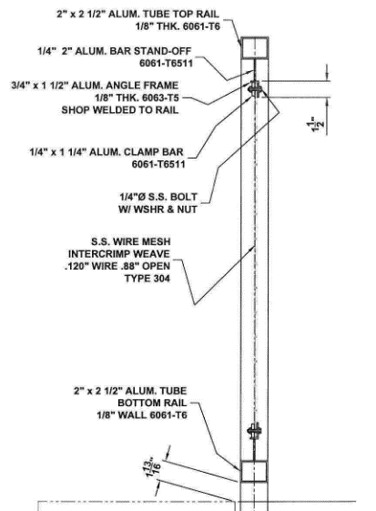

1. Question: Is it the Counties intent to fabricate the rail in approximately 8’ sections?

Response: No, 8’-0” is the spacing between columns, which is to far of a span between railing panels. Railing panels are anticipated to be fabricated in 4’-0” sections, or two (2) sections per bay. It is understood that this may fluctuate in certain areas, for instance, between column grid lines 8 & 9.

1. Question: While speaking with a few different fabricators regarding the railing, we had the following comments and/or concerns expressed. The first fabricator’s engineer is concerned that the wire mesh isn’t strong enough to keep a pedestrian from through the mesh should they fall into the rail section. They have provided another option which is to use stainless steel perforated screen. An example is attached for consideration.

Response: The design intent is to match the railing which was utilized at the Green Mountain Scenic Overlook & Trailhead, located at 20700 County Road 455, Minneola, Florida 34715.

1. Question: The second fabricator had concerns of differing metals and the stainless-steel mesh significantly staining the aluminum rails due to oxidation. They are proposing the aluminum railing with a powder coated 2” x 2” aluminum mesh in lieu of stainless steel. Would this option be acceptable?

Response: Please refer to the detail below (same detail provided in response to previous question above). The mesh is separated from the powder coated aluminum railing by an aluminum bar stand-off & angle frame which is shop welded to the rail. Stainless steel mesh is preferred.



**ACKNOWLEDGEMENT**

Firm Name: Click or tap here to enter text.

I hereby certify that my electronic signature has the same legal effect as if made under oath; that I am an authorized representative of this vendor and/or empowered to execute this submittal on behalf of the vendor.

Signature of Legal Representative Submitting this Bid: Click or tap here to enter text.

Date: Click or tap to enter a date.

Print Name: Click or tap here to enter text.

Title: Click or tap here to enter text.

Primary E-mail Address: Click or tap here to enter text.

Secondary E-mail Address: Click or tap here to enter text.