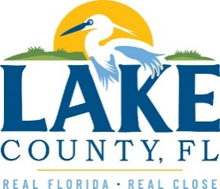
Office of Procurement Services
P.O. Box 7800 • 315 W. Main St., Suite 416 • Tavares, FL 32778
SOLICTATION: Fire Station 72 Mold Remediation 01/10/2024

Vendors are responsible for the receipt and acknowledgement of all addenda to a solicitation. Confirm acknowledgement by including an electronically completed copy of this addendum with submittal. Failure to acknowledge each addendum may prevent the submittal from being considered for award.
THIS ADDENDUM DOES NOT CHANGE THE DATE FOR RECEIPT OF PROPOSALS.
ADDITIONAL INFORMATION
- Aptim Environmental & Infrastructure, Inc. (APTIM) has completed the limited survey to identify Asbestos-Containing Materials (ACMs) in the anticipated mold remediation areas at Fire Station 72, located at 12340 County Road 44, Leesburg, Lake County, Florida 34748. The following materials were sampled as part of this endeavor:
- 2’x2’ Ceiling Tiles (four types)
- Ceiling Treatment (two types)
- Drywall/tape
- HVAC Tape and Mastic
- Insulation Paper Backing

Laboratory results indicated that none of the samples contained asbestos at detectable concentrations. Laboratory results have been attached to this summary. The survey was performed in general accordance with Florida Statutes and 40 CFR Part 61 Subpart M regarding renovation requirements.

ACKNOWLEDGEMENT

Firm Name: Click or tap here to enter text.
I hereby certify that my electronic signature has the same legal effect as if made under oath; that I am an authorized representative of this vendor and/or empowered to execute this submittal on behalf of the vendor.
Signature of Legal Representative Submitting this Bid: Click or tap here to enter text.
Date: Click or tap to enter a date.
Print Name: Click or tap here to enter text.
Title: Click or tap here to enter text.
Primary E-mail Address: Click or tap here to enter text.
Secondary E-mail Address: Click or tap here to enter text.

