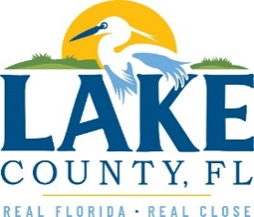
Office of Procurement Services
P.O. Box 7800 • 315 W. Main St., Suite 416 • Tavares, FL 32778
SOLICTATION: Fire Station 72 Mold Remediation 12/12/2023

Vendors are responsible for the receipt and acknowledgement of all addenda to a solicitation. Confirm acknowledgement by including an electronically completed copy of this addendum with submittal. Failure to acknowledge each addendum may prevent the submittal from being considered for award.
THIS ADDENDUM DOES NOT CHANGE THE DATE FOR RECEIPT OF PROPOSALS.
QUESTIONS/RESPONSES
- Question: Would you like the Certificate of Insurance (COI) in advance of bid submission or with bid submission?
Response: Bidders shall only provide a sample COI with their bid submittal that matches the amounts noted in Exhibit B – Insurance Requirements.
- Question: Has asbestos testing been done? If so, can you send me the results?
Response: It is currently being done.
- Question: Shall we include a line item for asbestos testing or submit a change order?
Response: No
- Question: What areas are going to be tested for asbestos?
Response: Materials that may be damaged/disturbed during the renovation
- Question: Do we need to submit Addendum No. 1 to you today or with the bid proposal?
Response: With the bid proposal
ACKNOWLEDGEMENT
Firm Name: Click or tap here to enter text.
I hereby certify that my electronic signature has the same legal effect as if made under oath; that I am an authorized representative of this vendor and/or empowered to execute this submittal on behalf of the vendor.
Signature of Legal Representative Submitting this Bid: Click or tap here to enter text.
Date: Click or tap to enter a date.
Print Name: Click or tap here to enter text.
Title: Click or tap here to enter text.
Primary E-mail Address: Click or tap here to enter text.
Secondary E-mail Address: Click or tap here to enter text.

