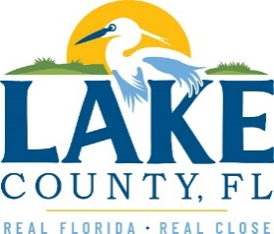
Office of Procurement Services
P.O. Box 7800 • 315 W. Main St., Suite 416 • Tavares, FL 32778
SOLICTATION: Fire Station 72 Mold Remediation 11/15/2023

Vendors are responsible for the receipt and acknowledgement of all addenda to a solicitation. Confirm acknowledgement by including an electronically completed copy of this addendum with submittal. Failure to acknowledge each addendum may prevent the submittal from being considered for award.
THIS ADDENDUM CHANGES THE DATE FOR RECEIPT OF PROPOSALS TO WEDNESDAY, DECEMBER 13, 2023, AT 3;00PM (EST)
ADDITIONAL INFORMATION
1. A Non-Mandatory Pre-Bid Conference and Site Visit will be held on Wednesday, November 29, 2023, at 10:00 a.m. (EST) at:
Fire Station 72
12340 County Road 44
Leesburg, Florida 34788.

2. The Last Day for Questions is hereby moved to Wednesday, December 6, 2023.

ACKNOWLEDGEMENT

Firm Name: Click or tap here to enter text.
I hereby certify that my electronic signature has the same legal effect as if made under oath; that I am an authorized representative of this vendor and/or empowered to execute this submittal on behalf of the vendor.
Signature of Legal Representative Submitting this Bid: Click or tap here to enter text.
Date: Click or tap to enter a date.
Print Name: Click or tap here to enter text.
Title: Click or tap here to enter text.
Primary E-mail Address: Click or tap here to enter text.
Secondary E-mail Address: Click or tap here to enter text.

