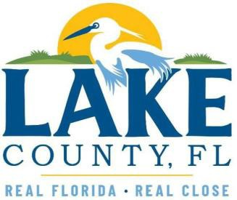

AFFIDAVIT OF COMPLIANCE WITH SECTION 288.0071, FLORIDA STATUTES, ECONOMIC INCENTIVES TO FOREIGN ENTITIES OF CONCERN

Before me, a notary public, in and for the State of Florida – at large, personally appeared,
, and having first made due oath or affirmation, states:
(Write Name Here)
- My name is .
(Write Name Here)
- I am the of .
(Insert Job Title) (Insert Company Name)
- The Company was formed in and is a .
(Country and State) (List the Type of Entity (ex.: LLC, Inc., etc.)
- I am duly authorized and empowered and have sufficient knowledge to execute and deliver this Affidavit.
- I affirm that the Company is not:
  - Owned or controlled by the government of the People’s Republic of China, the Russian Federation, the Islamic Republic of Iran, the Democratic People’s Republic of Korea, the Republic of Cuba, the Venezuelan regime of Nicolás Maduro, or the Syrian Arab Republic (collectively and individually, a Foreign Country of Concern), including any agency of or any other entity of significant control of such Foreign Country of Concern. Where ‘controlled by’ means having possession of the power to direct or cause the direction of the management or policies of a company, whether through ownership of securities, by contract, or otherwise; or a person or entity that directly or indirectly has the right to vote 25 percent or more of the voting interests of the company or that is entitled to 25 percent or more of its profits is presumed to control the foreign entity; or
  - A partnership, association, corporation, organization, or other combination of persons organized under the laws of or having its principal place of business in a Foreign Country of Concern, or a subsidiary of such entity.

Under penalties of perjury, I declare that I have read the foregoing Affidavit and that the facts stated in it are true. Signed and Delivered on this day of , 202 .

BY:
Signature of Affiant

Printed Name
STATE OF FLORIDA COUNTY OF

Sworn to (or affirmed) and subscribed before me by means of physical presence or online notarization, this
day of , 20 , by .
Personally Known OR Produced Identification
Type of Identification Produced
(Notary Signature) (SEAL)

