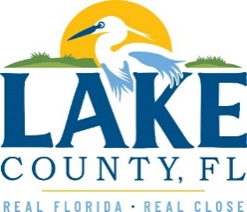
Office of Procurement Services
P.O. Box 7800 • 315 W. Main St., Suite 416 • Tavares, FL 32778
SOLICTATION: Basic Park Maintenance and Related Services 04/24/2024

Vendors are responsible for the receipt and acknowledgement of all addenda to a solicitation. Confirm acknowledgement by including an electronically completed copy of this addendum with submittal. Failure to acknowledge each addendum may prevent the submittal from being considered for award.
THIS ADDENDUM DOES NOT CHANGE THE DATE FOR RECEIPT OF PROPOSALS.
QUESTIONS/RESPONSES
Q1. Who is the incumbent and what is the annual cost to the government at this present time?
R1. The solicitation does not replace a previous contract, current budgeted amount for services is $305,760.
Q2. Is there a mandatory pre-bid meeting?
R2. Refer to Master ITB document, Section 5, Pre-Bid Conference
Q3. Is any form of bonding required?
R3. Refer to Master ITB document, Section 8, Delivery and Submittal Requirements.
Q4. Do you require a local vendor preference?
R4. Refer to Attachment 1 – Submittal, Section 10
Q5. Will the award be made based on lowest price and based on the vendor demonstrating he/she is the most responsible bidder?
R5. Refer to Master ITB document, Section 7, Method of Award

ADDITIONAL INFORMATION
N/A

ACKNOWLEDGEMENT

Firm Name: Click or tap here to enter text.
I hereby certify that my electronic signature has the same legal effect as if made under oath; that I am an authorized representative of this vendor and/or empowered to execute this submittal on behalf of the vendor.
Signature of Legal Representative Submitting this Bid: Click or tap here to enter text.
Date: Click or tap to enter a date.
Print Name: Click or tap here to enter text.
Title: Click or tap here to enter text.
Primary E-mail Address: Click or tap here to enter text.
Secondary E-mail Address: Click or tap here to enter text.

