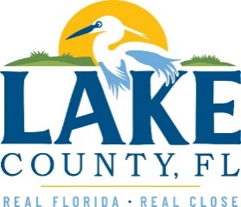
Office of Procurement Services
P.O. Box 7800 • 315 W. Main St., Suite 416 • Tavares, FL 32778
SOLICTATION: Countywide Hazard Vulnerability Assessment 04/17/2024

Vendors are responsible for the receipt and acknowledgement of all addenda to a solicitation. Confirm acknowledgement by including an electronically completed copy of this addendum with submittal. Failure to acknowledge each addendum may prevent the submittal from being considered for award.
THIS ADDENDUM CANCELS THIS SOLICITATION.
The Addendum No.2 cancels this solicitation. A replacement solicitation will be issued no later than April 24th with a closing date of May 23, 2024.

ACKNOWLEDGEMENT

Firm Name: Click or tap here to enter text.
I hereby certify that my electronic signature has the same legal effect as if made under oath; that I am an authorized representative of this vendor and/or empowered to execute this submittal on behalf of the vendor.
Signature of Legal Representative Submitting this Bid: Click or tap here to enter text.
Date: Click or tap to enter a date.
Print Name: Click or tap here to enter text.
Title: Click or tap here to enter text.
Primary E-mail Address: Click or tap here to enter text.
Secondary E-mail Address: Click or tap here to enter text.

