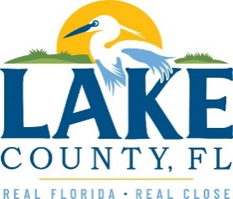
Office of Procurement Services
P.O. Box 7800 • 315 W. Main St., Suite 416 • Tavares, FL 32778
SOLICTATION: Name 04/15/2023

Vendors are responsible for the receipt and acknowledgement of all addenda to a solicitation. Confirm acknowledgement by including an electronically completed copy of this addendum with submittal. Failure to acknowledge each addendum may prevent the submittal from being considered for award.
THIS ADDENDUM DOES NOT CHANGE THE DATE FOR RECEIPT OF PROPOSALS.
QUESTIONS/RESPONSES
Q1. Would like to request clarification to task 3.12.3 on page 6 of 6 of Exhibit A Scope of Work. Does the County anticipate that this scope of work under this task to include the vendor updating the LMS?
R1. The vendor will not be expected to update the LMS as part of this scope of work.
Q2. What is the date of the County’s most recent adopted LMS?
R.2 The most recent LMS for Lake County was adopted in March of 2021.
Q3. Does Lake County participate in the CRS program and is the County looking for credit under Activity 510?
R3. Yes, the County does and yes, the County will.
Q4. Would the County consider an extension to the solicitation deadline?
R4. No extension will be granted as this project needs to get started.
ADDITIONAL INFORMATION

ACKNOWLEDGEMENT

Firm Name: Click or tap here to enter text.
I hereby certify that my electronic signature has the same legal effect as if made under oath; that I am an authorized representative of this vendor and/or empowered to execute this submittal on behalf of the vendor.
Signature of Legal Representative Submitting this Bid: Click or tap here to enter text.
Date: Click or tap to enter a date.
Print Name: Click or tap here to enter text.
Title: Click or tap here to enter text.
Primary E-mail Address: Click or tap here to enter text.
Secondary E-mail Address: Click or tap here to enter text.

