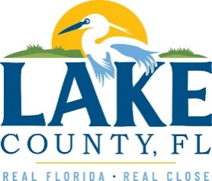
Office of Procurement Services
P.O. Box 7800 • 315 W. Main St., Suite 416 • Tavares, FL 32778
SOLICTATION: CAGAN CROSSINGS LIBRARY SECOND FLOOR DESIGN SERVICES
06/03/2024

Vendors are responsible for the receipt and acknowledgement of all addenda to a solicitation. Confirm acknowledgement by including an electronically completed copy of this addendum with submittal. Failure to acknowledge each addendum may prevent the submittal from being considered for award.
THIS ADDENDUM DOES NOT CHANGE THE DATE FOR RECEIPT OF PROPOSALS.
QUESTIONS/RESPONSES
Q1. What is the anticipated budget for this project?
R1. $350,000.
Q2. Would the County consider expending the five-year part project experience to ten-years?
R2. No.
Q3. We are a MEP firm and would like to submit for this. We are not currently partnered with an Architectural team. Are you considering MEP firms without an Architectural partner?
R3. The County is looking for a firm capable of providing 100% Construction Documents to include all MEPs, Civil, Structural, and Architectural. MEP stand alone would not be considered.

ACKNOWLEDGEMENT

Firm Name: Click or tap here to enter text.
I hereby certify that my electronic signature has the same legal effect as if made under oath; that I am an authorized representative of this vendor and/or empowered to execute this submittal on behalf of the vendor.
Signature of Legal Representative Submitting this Bid: Click or tap here to enter text.
Date: Click or tap to enter a date.
Print Name: Click or tap here to enter text.
Title: Click or tap here to enter text.
Primary E-mail Address: Click or tap here to enter text.
Secondary E-mail Address: Click or tap here to enter text.

