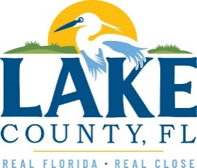
Office of Procurement Services
P.O. Box 7800 • 315 W. Main St., Suite 416 • Tavares, FL 32778
SOLICTATION: CAGAN CROSSINGS LIBRARY SECOND FLOOR DESIGN SERVICES
05/24/2024

Vendors are responsible for the receipt and acknowledgement of all addenda to a solicitation. Confirm acknowledgement by including an electronically completed copy of this addendum with submittal. Failure to acknowledge each addendum may prevent the submittal from being considered for award.
THIS ADDENDUM DOES NOT CHANGE THE DATE FOR RECEIPT OF PROPOSALS.
QUESTIONS/RESPONSES
Q1. We have a continuing contract with Lake County. Would the services under this solicitation fall under the continuing contracts, or would it be a stand-alone contract?
R1. This solicitation would be a stand-alone contract and is being solicited due to the anticipated spend.
ADDITIONAL COMMENTS:
- Firms shall replace the following documents:
  - 24-473 Cagan Crossings Library Second Floor Design Services shall be replaced with REVISED 24-473 Cagan Crossings Library Second Floor Design Services.
  - Exhibit A – Scope of Work shall be replaced with REVISED Exhibit A – Scope of Work.

ACKNOWLEDGEMENT

Firm Name: Click or tap here to enter text.
I hereby certify that my electronic signature has the same legal effect as if made under oath; that I am an authorized representative of this vendor and/or empowered to execute this submittal on behalf of the vendor.
Signature of Legal Representative Submitting this Bid: Click or tap here to enter text.
Date: Click or tap to enter a date.
Print Name: Click or tap here to enter text.
Title: Click or tap here to enter text.
Primary E-mail Address: Click or tap here to enter text.
Secondary E-mail Address: Click or tap here to enter text.

