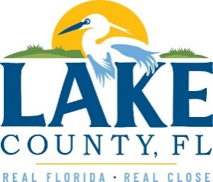
Office of Procurement Services
P.O. Box 7800 • 315 W. Main St., Suite 416 • Tavares, FL 32778
NOTICE OF INTENT TO SOLE SOURCE

PUBLIC NOTICE
This information informs the public and supplier community Lake County intends to enter into a non-competitive agreement to purchase a product/service as research indicates it is available from no other source.
If a qualified supplier can provide the same type of product/service, submit a statement of qualifications, product information and capabilities to the Point of Contact (Section 4.0) by 3:00 P.M. Eastern on Friday, January 5th, 2024. Submittals received after this specified time and date will not be considered. Any responses received shall be considered solely for determining whether bona fide competition exists.
- PRODUCT/SERVICE
Provide restorative services of Historical Courthouse terra cotta exterior columns which are showing evidence of possible deterioration and failure (vertical cracking) due to age and weather. Contractor is required to disassembly of the decorative clay tiles that make up the exterior of each of the columns,
Ambach Masonry Construction, Inc, through County’s Architectural Services contract, provided an extensive investigation of the sixteen Historical Courthouse structural columns, and is familiar with the findings and corrective action needed.
Contractor previously was awarded a contract for restorative work on the exterior of the Historical Courthouse in the past and have knowledge of the facility and the qualifications to work on Historical buildings.
3.0 PROVIDER INFORMATION
Ambach Masonry Construction, Inc. is the only known provider offering the described in its entirety.

POINT OF CONTACT
Sandra Rogers, Procurement Services Manager
E-mail: Sandra.Rogers@LakeCountyFL.gov

[The remainder of this page intentionally left blank]

