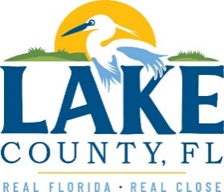
Office of Procurement Services
P.O. Box 7800 • 315 W. Main St., Suite 416 • Tavares, FL 32778
NOTICE OF INTENT TO SOLE SOURCE

PUBLIC NOTICE
This information informs the public and supplier community Lake County intends to enter into a non-competitive agreement to purchase a product/service as research indicates it is available from no other source.
If a qualified supplier can provide the same type of product/service, submit a statement of qualifications, product information and capabilities to the Point of Contact (Section 4.0) by 3:00 P.M. Eastern on Friday, April 9th, 2021. Submittals received after this specified time and date will not be considered. Any responses received shall be considered solely for determining whether bona fide competition exists.
- PRODUCT/SERVICE
Provide Peplink devices, accessories, and extended warranty (services). These devices are used in conjunction with InControl2 to provide both AVL (Automated Vehicle Location) for dispatching and as cellular modems for connectivity with the various devices utilized by first responders.
The County’s initial purchase of Peplink products was in 2014. Since this time, County staff have conducted informal quotes for the equipment and support which includes installation, testing, and certification as required.
3.0 PROVIDER INFORMATION
West Networks, LLC is the only known provider offering the described in its entirety.

POINT OF CONTACT
Sandra Rogers, Procurement Services Manager
E-mail: Sandra.Rogers@LakeCountyFL.gov

[The remainder of this page intentionally left blank]

