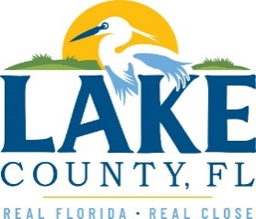
Office of Procurement Services
P.O. Box 7800 • 315 W. Main St., Suite 416 • Tavares, FL 32778
SOLICTATION: Emergency Debris Removal Services 03/02/2023

Vendors are responsible for the receipt and acknowledgement of all addenda to a solicitation. Confirm acknowledgement by including an electronically completed copy of this addendum with submittal. Failure to acknowledge each addendum may prevent the submittal from being considered for award.
THIS ADDENDUM DOES NOT CHANGE THE DATE FOR RECEIPT OF PROPOSALS.
QUESTIONS/RESPONSES
- Can the county confirm that there is no option for C&D debris to be taken to a DMS site?
Response: There is no option for C&D at a DMS site.
- Could the county provide a list of any pre-designated DMS sites and their addresses?
Response: Central Facility, other locations will be available once the contract is awarded.
- Can the county confirm if landfill tipping fees will be a passthrough expense?
Response: Confirmed
ADDITIONAL INFORMATION
Remove and replace Attachment 2 – Pricing Sheet with the revised Attachment 2 – Pricing Sheet dated 03/02/2023

ACKNOWLEDGEMENT

Firm Name: Click or tap here to enter text.
I hereby certify that my electronic signature has the same legal effect as if made under oath; that I am an authorized representative of this vendor and/or empowered to execute this submittal on behalf of the vendor.
Signature of Legal Representative Submitting this Bid: Click or tap here to enter text.
Date: Click or tap to enter a date.
Print Name: Click or tap here to enter text.
Title: Click or tap here to enter text.
Primary E-mail Address: Click or tap here to enter text.
Secondary E-mail Address: Click or tap here to enter text.

