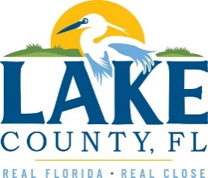
Office of Procurement Services
P.O. Box 7800 • 315 W. Main St., Suite 416 • Tavares, FL 32778
SOLICTATION: Pest Control for Lake County Facilities 11/15/2022

Vendors are responsible for the receipt and acknowledgement of all addenda to a solicitation. Confirm acknowledgement by including an electronically completed copy of this addendum with submittal. Failure to acknowledge each addendum may prevent the submittal from being considered for award.
THIS ADDENDUM DOES NOT CHANGE THE DATE FOR RECEIPT OF PROPOSALS.
Question 1: Would the provision of a rodent control device meet your bid's requirements, or are you purely looking for a service provider?

Response 1: The pest control is for providing services. This includes rodents as well as insects. The vendor would need to be able to do pest treatment as far as spraying indoors and outdoors. As well as putting out bait traps and other traps for pests.

ACKNOWLEDGEMENT

Firm Name: Click or tap here to enter text.
I hereby certify that my electronic signature has the same legal effect as if made under oath; that I am an authorized representative of this vendor and/or empowered to execute this submittal on behalf of the vendor.
Signature of Legal Representative Submitting this Bid: Click or tap here to enter text.
Date: Click or tap to enter a date.
Print Name: Click or tap here to enter text.
Title: Click or tap here to enter text.
Primary E-mail Address: Click or tap here to enter text.
Secondary E-mail Address: Click or tap here to enter text.

