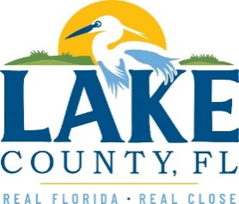
Office of Procurement Services
P.O. Box 7800 • 315 W. Main St., Suite 416 • Tavares, FL 32778
SOLICTATION: East Lake Library Design Services 09/09/2022

Vendors are responsible for the receipt and acknowledgement of all addenda to a solicitation. Confirm acknowledgement by including an electronically completed copy of this addendum with submittal. Failure to acknowledge each addendum may prevent the submittal from being considered for award.
THIS ADDENDUM DOES NOT CHANGE THE DATE FOR RECEIPT OF PROPOSALS.
QUESTIONS/RESPONSES
Q1. What is the budget for this Project?
R1. The Construction Budget is approximately $4 Million.
Q2. What are the building standards being used for Fire Station #39? Will these same standards be a requirement for the library? If so, will you be sharing these requirements?
R2. Building standards are those applied by the most recent building codes. Building facade and general design to match colors and blend in harmony with existing structures. The mixes of stucco, siding wood, and stone finishes to be considered could be equal or similar to the following:
Accent Color: SW 7565 Oyster Bar (Sherwin)
Deep Color: SW 6235 Foggy Day (Sherwin
Stone: Montecito (Cliffstone from El Dorado)
No preference with regards to manufacturer or supplier at this point.
ACKNOWLEDGEMENT

Firm Name: Click or tap here to enter text.
I hereby certify that my electronic signature has the same legal effect as if made under oath; that I am an authorized representative of this vendor and/or empowered to execute this submittal on behalf of the vendor.
Signature of Legal Representative Submitting this Bid: Click or tap here to enter text.
Date: Click or tap to enter a date.
Print Name: Click or tap here to enter text.
Title: Click or tap here to enter text.
Primary E-mail Address: Click or tap here to enter text.
Secondary E-mail Address: Click or tap here to enter text.

